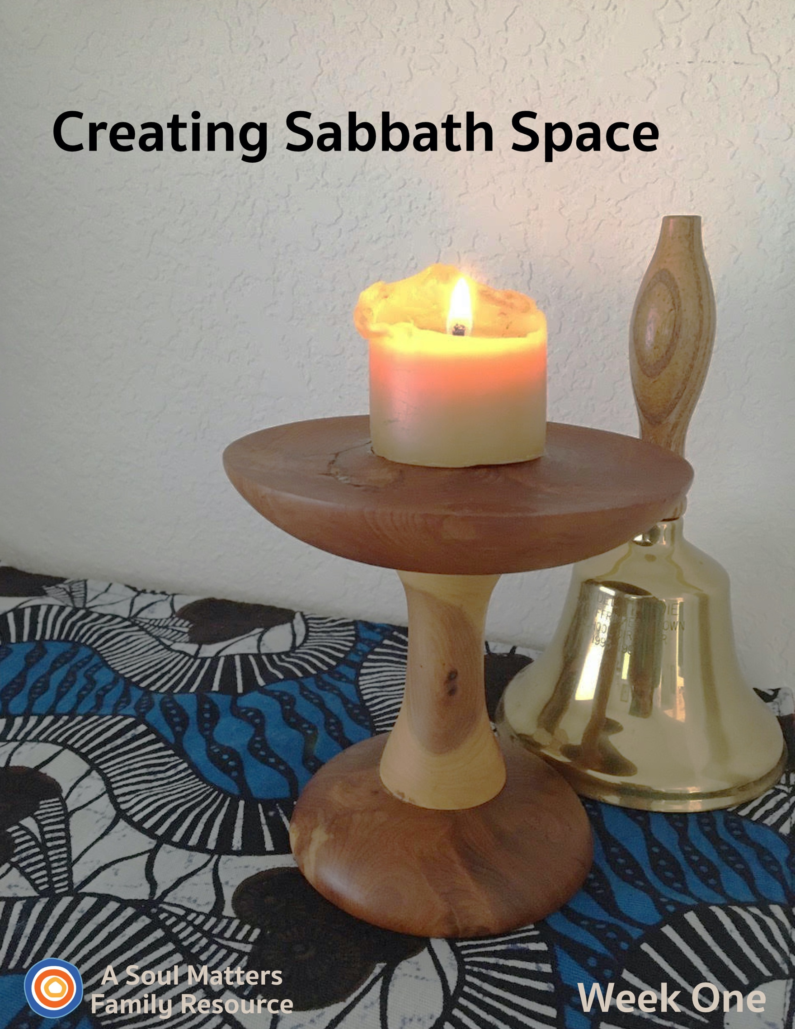

Welcome to Creating Sabbath Space

What do families need most right now?

There are a lot of answers to that question. So many that it makes your head spin. Stay healthy. Keep active. Check in with family by Skype or Zoom. Wash your hands. Donate. Watch Netflix.

In the midst of all this advice, the voice of religion can sound a bit odd. Here’s its answer: “In times of trouble, be extra sure to keep the Sabbath.”

In other words, “Be sure to set aside time and a space for worship, rest and connection.”

Simply put, that’s what this resource is all about. We want to help families carve out “sabbath space” in their homes and weekly schedules. We want to honor ancient spiritual wisdom that says worship, rest and connection are a must, not “extras” to be fit as we can. Especially during trying times.

But what does that look like when we’re cut off from our church buildings? “Well,” says the voice of religion with a smile, “Who says you can’t build a space for the sacred in your home?” In fact, home worship and home altars are a central part of family life for so many religious traditions. Catholics call them “home shrines.” Hindus fill them with their favorite Gods and Goddesses. Buddhists sometimes set aside entire rooms for theirs. Muslims place their prayer rugs in front of theirs. Some UUs, too, have home altars.

While all different, they also share a common goal: To create a space that helps one stay connected to what is sacred and nourishing. And who of us doesn’t need that right now?!

So, what might your Unitarian Universalist home altar look like? Well that’s what we are going to discover and create together.

Each week, you’ll get a Sabbath Toolkit with instructions for adding a new piece to your home altar, a family worship service to celebrate that addition and some “after worship activities” to help your family lean into Sabbath rest and connection together.

And here’s the super cool thing: Other UU families from across the country will be doing this too! Just like you, UU families from Massachusetts to Indiana to Oklahoma to Oregon will be carving out room in their homes for family altars and weekly Sabbath experiences. Even though we will be physically apart, we’ll be spiritually connected.

What an adventure it will be!
Creating UU Sabbath Space
Week One

Introduction

Welcome to week one of our “Sabbath Space” adventure. Each week you will get a packet that includes:
- Guidance for adding 1-2 new pieces of your family home altar, or “Chalice Home” as we also like to call it
- A family worship guide that developed around those additions to your altar
- A couple of “after-worship” activities to continue your family Sabbath time of connecting and relaxing together

This first week we start with the basics, the core building blocks of any UU home altar:
- A family chalice
- An altar table or space
- A sounding instrument to signal the movement from regular time into sacred time

The family chalice gives parents a great opportunity for parents to explain to their children what this project is all about. The chalice represents our UU faith and, in a nutshell, bringing our UU faith into our homes is what this is all about. Instead of going to church, we are building and bringing church into our homes! It’s also a reminder that church isn’t just a place we go to but a place and community we carry wherever we go.

The altar table or sacred corner can be explained as holding and helping us remember what is important, nourishing and sacred in our lives. Over the coming weeks we will fill the table/space with physical reminders of those important things. Keeping these important things in front of us is especially important during this time of sickness, separation and uncertainty. It’s a reminder that even though we may be cut off from the people and activities we love, we remain spiritually connected to them all the time.

The sound instrument is a great opportunity for you to explain to your children that bells, chimes or ringing bowls help us create and move into sacred space. The sound signals “special time” and a movement from “normal time” into “sacred time.”

After creating your altar space and then having family worship, you are invited to continue your “family Sabbath” with the activities we’ve recommended.

Building Our Home Altar: The Work Begins!

Week 1: Creating the Core Pieces of Our Chalice Home

Item One: Your Family Chalice

Don’t worry about making your chalice perfect this first week. As the weeks progress, there will be plenty of time to work on it and fancy it up.
- View the Chalice Challenge video for creative ideas from Jenn Blosser and her kids, DRE in Fort Myers, FLA, used with permission. We especially like their dog chalice!
- The simplest way is to make a stem and a cup. Two clay flowerpots or a goblet works. What about Legos? Check out Katie’s Chalice Compendium on Pinterest. Everyone in the family can experiment with chalice making.
- If you don’t have a
- LED or votive candle, make a little flame from something orange, red, or yellow. A bit of tissue, a red pepper, a piece of paper colored with flame colors.

Item Two: The Altar

You have a chalice, now make a home for it. Many religious families, especially Buddhist and Hindu, have a shrine in their homes. It serves as something to gaze upon while meditating and as a centering for remembering what is important.
- Find a corner, a small table or a shelf where your chalice can have a home. Here are some photos to get your creative juices flowing: https://www.cucmatters.org/2015/08/create-home-altar.html
- It’s great to leave your home altar in place throughout the week, but if you are a family with a toddler who likes to grab things or have a busy or smaller living space, consider making a box to store your chalice and the items which can be brought out each week.
- Decorate it with a covering, a pretty cloth or paper. Think about pieces of cloth that have a special meaning to your family.
- Finally, place your chalice into its home.

Item Three: Your “Ringing Instrument”
- This can be any number of things: A small bell, ringing bowl, a chime, a spoon and a water glass or a crystal wine goblet for rubbing. Again, try to find something that has special meaning attached to it.

Share Your Chalice Home with Other Families
Each week, you will be invited to share your ever-growing family altar/chalice home with the other UU families who are building one too. All you have to do is take a picture of your altar and then post it to Facebook or Instagram with the hashtag “#uuchalicehome.” Your church may also be collecting pictures online of the “chalice homes” of your church families. Be sure to ask your RE leader about that.

Using your Chalice Home: Not just for Sundays or Family worship.
1. Besides using it for Sunday morning as a Sabbath worship, consider using it to begin your day. It can be something as simple as lighting the chalice and reading a poem before or after breakfast.
2. Or try it as a bedtime ritual, closing the day together.
3. Each person can visit it whenever they feel the need to center themselves.

Now that your Chalice Home is set up, it’s time for Family Worship!
Family Worship: Week #1

Use this Worship Guide as is or tweak it to give it your own unique stamp. The ultimate goal is to foster family connection, so think of some creative ways to divide up the worship components. For instance:
- Have the youngest, who is able, light the chalice.
- Have the oldest offer the words of blessing.
- Take turns reading the meditation each week.
- Have the quietest family member ring the centering bell.

Centering Sound
Move from “regular time” to “sacred time” by sounding your bell, chimes, ringing bowl or ringing glass.

Optional words to go with the sound:

“To this quiet place of beauty, we come from busy things
Pausing for a moment for the thoughts that quiet brings.”

Centering Music or Silence

- Option #1 for singing families: STLT #123 Spirit of Life
- Option #2 for families who prefer to listen: Play some quiet music (we love Spotify’s Classic Yoga playlist and our own Soul Matters playlist for coping with Covid-19) or this: STLT #123 Spirit of Life on YouTube.
- Option #3 Silence for 30 Seconds.

Chalice Lighting

“We light this chalice for the warmth of love, the light of truth and the energy of action.”
- Mary Ann Moore
Or use your own or your congregation’s words.

Sharing of Gratitudes and Grace

“We listen to each other, it is a holy act
To share our joys and sorrows,
with grace it flows on back.”

Do two rounds of sharing. First invite each family member to share something they are thankful for. The aim here is to make room to notice the good things all around us even though times are hard. After this first round of joys and gratitudes, share something or someone you have a concern for - someone or something you are holding in your hearts and prayers. This is a way to bring the struggles of others into our hearts, maybe a grandparent who is in danger of getting sick or hospital workers who are putting their health at risk for the sake of the rest of us.

Meditation

For the reader: Pause for a few moments after each sentence, allowing enough time for your family members to fully complete the action you are asking of them.)

Before beginning the meditation: Find a comfortable place to sit, in a chair, or on the ground if you prefer, or maybe even on a cushion.

First Week Meditation

Begin by taking a deep breath, breathe in for the count of 3 and then release at any pace that is comfortable.
Repeat.

Take a moment to look at the chalice, focusing on the flame.
Notice the way the flame dances, the way it grows large and then small, the way it casts light on the wall behind it and the table beneath it.
Now close your eyes and imagine a flame just glowing inside your heart.
Imagine it slowly filling the darkness of the space in which it sits.
As the space grows brighter, picture the flame casting a light and illuminating faces of some of the people you care about but haven’t been able to see for a while. Maybe a grandparent, or a neighbor or a friend.
Pretend that you could say something to them. What would that be? [long pause]

Now with your eyes still closed, try to remember the sound that we started worship with.
Did you hear it just with your ears? Or did you feel its vibrations in your body as well?
Now think about the other sounds you love. The wind maybe. Or birds chirping in your backyard or those frogs that croak in the spring and summer.
Take your time. Listen until you can hear them clearly.

Now open your eyes, only a little bit, just enough to sneak a peek at the cloth that covers the altar we built earlier today.
Once you’ve got a good look, shut your eyes again.
Now think of a favorite blanket of yours or imagine being wrapped up in the most comfortable blanket in the world.
Doesn’t it feel good? Imagine how warm it feels. How soft. Just like when someone gives you a great big hug. Just like when a friend is kind to you, or you are kind to a friend.
Who around you needs a little extra kindness? Do you know someone who is worried or sick? Or sad or alone?
Spend some time thinking about something you wish you could do for them or say to them.

Now turn your attention back to your breathing. Notice how your breath makes your chest go out and then come back in, out and in, out and in.

As you are following your breath, allow yourself to smile. It can be a big smile or small one. Whatever feels good to you. Let the happiness of that smile flow down into your whole body.

Now slowly open your eyes again. Look around at your family.
And on the count of three, say together three times “It’s good to be together”
1,2, 3… “It’s good to be together.” “It’s good to be together.” “It’s good to be together.”

Building the Chalice Home

In the weeks ahead, this will be the time in our family worship when we will grow our family altars by adding a new item to the table. Since this was the first week, we “added” those key pieces before worship (bell, chalice, table). So use this time to simply have each family member share one thing they liked most about the meditation, one thing that they saw in their “mind’s eye” or one thing that the meditation made them think of or feel.

Setting an Intention

As you bring worship to a close, pause for a moment to think ahead about the coming week and make an intention/promise for how you want to act, what you want to remember or how you want to treat others.

Here’s this week’s prompt for your intention/promise:

“In the coming week, I will ___________________ to take care of myself.”

Have each family member take a turn filling in the blank to the sentence.

Words of Blessing

We pause to say thanks
for all that leads us forward,
for all that leans down and helps us up after we fall,
for all that reminds us we can make it when times are tough.
May this chalice home and its reminders of precious connection
help us feel the love of those close and far away.
May we remember
there is always room
to make space
for hope and happiness
right in the middle of our lives.

- The Soul Matters Team

Extinguishing the Chalice

“We gather the warmth of love, the light of truth, and the energy of action into our hearts.
Back into the world of do and say, carry it forward into the dawning day.
Go Now in Peace, Amen.”

View Katie’s YouTube video demonstrating how to add gesture to these words: https://youtu.be/GEF4Hdm08oM
Instructions: Use your hands in a gather/cupping gesture and bring them to your heart. Repeat after the “warmth of love,” “the light of truth,” and the “energy of action.”
Family Sabbath Activities
Sabbath is the idea of setting aside time for rest and connection with each other. It is a time of remembering and paying attention to what really matters, and the people in your life that really matter. So here are some activities to help you lean into the joy of just being together!
Sabbath Activity One

There are many ways to restore our spirits as a family. Home-wide, gentle quiet can do it. Sharing a delicious and nourishing meal can do it. And laughing together does it, too. For this activity, we’re going to bring a favorite youth group activity into the family group--it’s called the “Ha! Game.” If you have a teen who knows this game, invite them to explain and demonstrate how it works.

Each member of the family lays on the ground or on your biggest bed--whatever surface is easy and comfortable for you all--perpendicular to the next person, with one’s head on another’s stomach. If there are three or more people in your family, join into a triangle or circle of sorts. If there are two people, you’ll go back and forth. The person who begins says, “Ha!” The next person says, “Ha, ha!” Next, “Ha, ha, ha!”

Here’s a video showing how it’s done: https://www.youtube.com/watch?v=EHDGQDXi4aY

What usually happens is that the absurdity of the whole thing, the silliness of feeling one’s head bounce against another’s stomach as they try to straight-facedly speak the words of laughter, creates a bubbling over of REAL laughter for the whole group. And of course, neurochemically, your brain relaxes and releases feel-good chemicals as a result of all that giggling. The challenge of getting through as many “Ha’s” as possible is bravely attempted for a few rounds and abandoned, but the real goal of having sweet fun and experiencing rejuvenation together is accomplished!

Other ideas for making space for laughter-rest on your Sabbath include laughter yoga, or laughter meditation, both of which include inside-friendly, fun movements as part of the activity.

Sabbath Activity Two

Explore how families of other faiths use an altar, shrine or Sabbath to create rest and connection.
- Hindu: Many Hindu children grow up with a shrine in their home. To see an example of one Hindu family’s shrine, visit A Hindu Shrine https://www.youtube.com/watch?v=iyw5EJRKEXU
Watch the award winning Pixar short about a Hindu family shrine “Sanjay’s Super Team. “In “Sanjay's Super Team” accomplished artist Sanjay Patel uses his own experience to tell the story of a young, first-generation Indian-American boy whose love for western pop culture comes into conflict with his father’s traditions.” - https://www.pixar.com/sanjays-super-team. You can view an abbreviated version (2:52 min) on Vimeo at https://vimeo.com/192890745 or you can view it with Prime on Amazon (7 min) at https://www.amazon.com/Sanjays-Super-Team-Brenton-Schraff/dp/B01CGX7RDG. The short is rated PG, with a very scary demon who is vanquished by the good guys, so we don’t recommend this for young children.
- Catholic: Making a Catholic Home Altar https://www.youtube.com/watch?v=j1aAWi2LLdA
- Jewish: Shabbat https://www.youtube.com/watch?v=bqe3uOjs0Bo
- Buddhist: Setting Up Your Altar, Pt.1 - BBCorner https://www.youtube.com/watch?v=3QNL7Z_AqZ8

Sabbath Extras
- Check out this Chalice Sunburst Coloring Page by Rev. Cynthia Landrum
- Watch/listen to this online story about the chalice: Terrina Carter, religious educator reads A Cup of Light by Pamela Baxter. Read for Religious Education at the UU Church of Bloomington-Normal during the 2020 Coronavirus Quarantine.

Cover photo is of Katie Covey’s personal chalice made for her by her father, Del Tweedie, from a Juniper branch and the school bell given to her father for his service on the Tredyffrin/Easttown School Board in Devon, PA.

Share This Packet!
Feel free to share this packet as our gift to any UU congregation or other faith community to support their work of caring for so many during this pandemic.

Sabbath Space Authors
This packet was joyfully created by the Soul Matters RE team, including:
Katie Covey, Soul Matters DRE
Teresa Honey Youngblood, Soul Matters Family Ministry Coordinator
Rev. Scott Tayler, Soul Matters Team Lead

© 2019-20 Soul Matters ALL RIGHTS RESERVED

Learn more about Soul Matters Congregational resources at
https://www.soulmatterssharingcircle.com/

Check us out on Facebook or Instagram.
We also have song playlists on Spotify and YouTube

