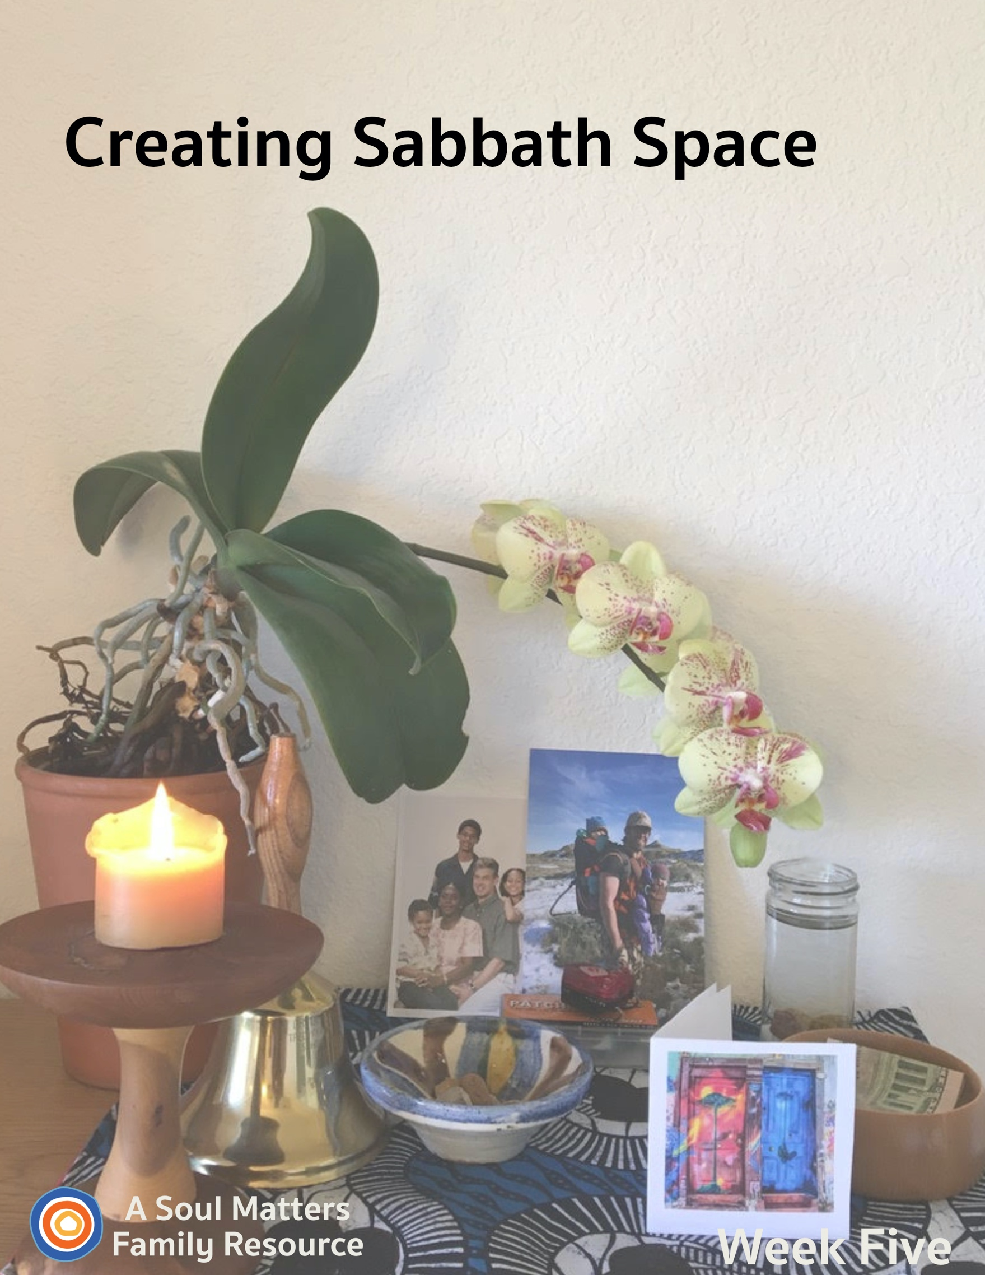

Sabbath Space
Week Five

Goodbye to Our Weekly Sessions & Hello to a New Family Practice

Week Five is the final packet of “Creating Sabbath Spaces” from Soul Matters Sharing Circle. We have been enriched by hearing from those of you who have been able to use this gift to create warmth and beauty for your family members who are isolated in this time of uncertainty and sickness.

As this is the last of our sessions, we are saying a goodbye of sorts. And yet we also hope this packet represents a hello to a new and additional way of practicing your Unitarian Universalism. It is our hope that a Chalice Home and a weekly family sabbath experience become a regular part of your family life. We especially hope that you keep your Chalice Home in place and continue to add symbolic tokens and objects to it, such as symbols for:
- hobbies and projects you are undertaking during this time. Katie, for instance, is becoming a Sourdough Scientist and imagines her Chalice Home with the addition of the wild yeast starter she is nurturing.
- the addition of new family members, such as a birth, a new pet, or a marriage. For instance, Scott’s family is welcoming chickens to their backyard and is planning to add a little bowl of chicken feed to their home altar.
- favorite stories and books which have become part of your family life. For instance, Teresa found an old, illustrated copy of Charlotte’s Web, and as she’s reading it aloud to her younger children, together they are adding Charlotte’s web-messages to their altar on a small chalkboard--”Some Pig” will be this week, followed by “Terrific,” “Radiant,” and “Humble.”

And remember, adding objects is only one way to engage your Chalice Home. You can simply leave it as it is and use it as your focal point or gathering place for your weekly family worship or daily family check in time. We hope this experience inspires you to imagine what a daily devotional time might look like for your family.

The overarching aim of our Sabbath Space journey has been to build a place that helps us remember what is important, nourishing and sacred in our lives. This work of keeping close to what really matters doesn’t end when the pandemic ends. We are reminded of the home centered element of the Jewish faith, developed after their temples were destroyed during the Persian Diaspora. Without a temple, Judaism grew in new ways and wove their faith life more deeply into their family life. We hope that your Unitarian Universalist faith will grow in new ways, too. May your home continue to be a Chalice Home!

Katie Covey, Teresa Honey Youngblood and Rev. Scott Tayler
Soul Matters Sharing Circle Team
www.soulmatterssharingcircle.com

Introduction

Welcome to Week Five and the last packet of our “Creating Sabbath Space” adventure.

This fifth week and last week, our focus turns to adding a picture of the door of your congregation to your Chalice Home.

This element reminds us that church homes are not just a building we go to but also communities we take with us wherever we go. This is especially important to remember during this time of not getting to gather inside our physical buildings.

This week will also be a time to remember that we are not just welcomed in by the “doors” of our churches; we are also sent out. To honor this we will celebrate the many gifts our congregations give us as well as the many ways our church communities inspire us to give ourselves to others.

As usual, after preparing for and then holding family worship, you are invited to continue your “family Sabbath” with the activities we’ve recommended.

May this session bring you hope as you imagine the future return to your congregation. May it also help you notice the many ways your church is alive and well in your daily living!

Building Our Home Altar:
Week #5 - Celebrating Your Spiritual Community

Preparing to Add a “Threshold” (i.e. a door or window of your home congregation)

This week we will place a symbol of a threshold from your church into the Chalice Home. We say “threshold” because while many will choose to focus on the doors of their congregation, others may want to lift up a beloved window that is a special part of your congregation's identity.

You will be creating your door/window representation as part of the worship. So give some thought to what you need to gather ahead of time. If you want to draw a picture of it, make sure paper and pens/crayons are ready. If you are using a photo, you will want to do a test run of printing it off of your congregation’s website. It might even be a sculpture of the door or window. If so, gather popsicle sticks, a shoebox, or Legos. You might even create something that opens like a real door.

Adding a symbol of the doors to your church reminds us of the many ways your home congregation has played an important role in your family’s lives. Those doors welcome us as we are and all of who we are. Those doors lead us to deep friendships and inspiring life lessons. We are also sent out through those doors, to help others and to live out the values we celebrate inside the church walls. They are “wide” doors, holding many meanings. Keep this in mind as you create your representation of them.

Share Your Chalice Home with Other Families
Each week, we encourage you to share your ever-growing family altar/chalice home with the other UU families who are building one too. All you have to do is take a picture of your altar and then post it to Facebook or Instagram with the hashtag “#uuchalicehome.” Your church may also be collecting pictures online of the “chalice homes” of your church’s families. Be sure to ask your RE leader about that.

Using Your Chalice Home: Not Just for Sundays or Family Worship
Besides using it for Sunday morning as the focal point for Sabbath worship, consider:
- using your altar to begin your day. It can be something as simple as lighting the chalice and reading a poem before or after breakfast.
- Or try it as a bedtime ritual, closing the day together.
- And each person can always visit it whenever they feel the need to center themselves.

Now, it’s time for Family Worship!
Family Worship: Week #5

Use this Worship Guide as is or tweak it to give it your own unique stamp. The ultimate goal is to foster family connection, so think of some creative ways to divide up the worship components. For instance:
- Have the youngest, who is able, light the chalice.
- Have the oldest offer the words of blessing.
- Take turns reading the meditation each week.
- Have the quietest family member ring the centering bell.

Centering Sound
Move from “regular time” to “sacred time” by sounding your bell, chimes, ringing bowl or ringing glass.

Optional words to go with your centering sound:

“To this quiet place of beauty, we come from busy things
Pausing for a moment for the deeper thoughts that quiet brings.”

Centering Music or Silence

- Option #1 for singing families: STLT #123 Spirit of Life or STJ #1011 “Return Again” by Rabbi Schlomo Carlebach
- Option #2 for families who prefer to listen: Spirit of Life, All Souls Virtual Choir https://www.youtube.com/watch?v=LikvoIiN_bU or the Supremes’ “Someday We’ll Be Together” or STJ #1011 “Return Again” by Rabbi Schlomo Carlebach (on YouTube https://www.youtube.com/watch?v=aDnGOpRYhwo)
- Option #3: Play some quiet music (we love Spotify’s Classic Yoga playlist and our own Soul Matters Playlist for coping with Covid-19)
- Option #4: Silence for 30 Seconds.

Chalice Lighting

“We light this chalice for the warmth of love, the light of truth and the energy of action.”
- Mary Ann Moore

Or use your own or your congregation’s words.

The Giving Bowl
“We drop our coins (papers) in and fill the bowl. Serving others makes us whole.”

Add your monetary contribution for the group or organization you decided to give to (or provide slips of paper and invite family members to write or draw their way to help others on it.)

Adding the Threshold of Your Spiritual Community

Introduce this activity by reminding your child(ren) that the aim of our Chalice Home is to celebrate and keep us close to the things in our lives that nourish us. One of those important things is our church community. But that is not available to us now, so we remember it by making a special space in our Chalice Home. Then, using your own congregation’s name, say the following words:

“We are part of the [Name of your congregation].
We place this [door/window] to remind us of our spiritual community.
We have to stay isolated from it now, but someday we will return and be together again.”

Next, find, create and place the threshold/door/ window on the Chalice Home.

Finally, invite family members to share a part of the congregation which they love and miss. It might be a special chalice or banner. It might be a special group, such as the choir. It might be special friends they know from church. Or a special part of the playground.

Sharing of Gratitudes and Grace

“We listen to each other; it is a holy act.
To share our joys and sorrows, with grace it flows on back.”

Invite each family member to pick up a rock and share something they are thankful for about the past week while dropping the rock into the bowl of water. The aim here is to make room to notice the good things all around us even though times are hard.

After this first round of joys and gratitudes, have each family member choose another rock and share something or someone they have a concern for - someone or something they are holding in their hearts and prayers. This is a way to bring the struggles of others into our hearts, maybe a grandparent who is in danger of getting sick or hospital workers who are putting their health at risk for the sake of the rest of us or a group of people around the world who are also getting sick from the Covid-19 virus.

Be sure to include those whose photos you placed in previous weeks in your sharing, to keep them in your hearts and prayers.

And don’t forget the rocks love being used in this ritual and they can be pulled out of the water and used as “double rocks” if there are more gratitudes and thoughts.

Meditation

For the reader: Pause for a few moments after each sentence, allowing enough time for your family members to fully complete the action you are asking of them or the thought you are offering them.

Adaptations: Also, note that this meditation involves imagining the sights and sounds you might experience when in your congregation’s facility. We’ve tried to be sensitive to those for whom seeing and/or hearing are a challenge but depending on your family further adaptations might be needed.

Fifth Week Meditation

Let’s begin by finding a comfortable place to sit.
Once seated, close your eyes and take a few deep breaths. Breathing in on the count of 2 and breathing out on the count of 3.

Today we’ve been remembering our church home and thinking about how sad it is that we can’t go into the building and see all the people we care so much about, and that care so much about us.

Even though we can’t go there in person, we can go there in our imagination. Let’s do that now.

So in your mind, picture yourself outside walking toward your church. What’s the first thing you notice about it? Is it the church’s steeple? Is it a special pretty window? Is it the sign that sits in front of the church by the road? Is there a beautiful garden or flower bed nearby? Is it the front door?

Now picture yourself moving into your church. Go slowly. Imagine yourself looking around. Picture the crowd of people inside.
Who are you especially searching for? Who are some of the people you miss most? Imagine finding them in the crowd. Picture yourself going up and saying hello.

Let’s all take a moment to say their name(s) out loud. [PAUSE TO ALLOW FAMILY MEMBERS TO SPEAK]

Now, instead of looking around, imagine what sounds you are hearing. Which sound from church do you miss the most? All the people talking and laughing? People singing songs? Teachers reading a story? People reading the chalice lighting words?

Let’s all take a moment to name the sound we are hearing out loud. [PAUSE TO ALLOW FAMILY MEMBERS TO SPEAK]

Now using your imagination, take these things you are seeing and hearing in your mind and put them one by one into a little box. I know that seems silly, but our imaginations allow us to do all sorts of amazing things.
So put those images of people from our church into your little box.
Now put those sounds you heard in the box.
What about the life lessons and stories you’ve experienced in church? Put those in the box too.
Now take that little box and imagine tucking it away in your heart. Because we know that even though we can’t physically go to our congregation right now, we can carry everything we love about it in our memory and in our hearts. Church is a place we go to, but it is also something we carry inside us.

So, now as we end, put your hands on your heart. Take a moment to feel your heartbeat.
Now take one last deep breath. Breathe in slowly. Hold it for a second. Now breathe out.

Slowly open your eyes.
And as we end, on the count of three, let’s repeat three times: “Until we can go back, we carry our congregation in our hearts.”
1,2, 3… “Until we can go back, we carry our congregation in our hearts.” “Until we can go back, we carry our congregation in our hearts.” “Until we can go back, we carry our congregation in our hearts.”

Blessed Be. Amen

Setting an Intention

As you bring worship to a close, pause for a moment to think ahead about the coming week and make an intention/promise for how you want to act, what you want to remember or how you want to treat others.

Here’s the last intention/promise statement, for everyone to say together. Have one person state each phrase, with the rest of the family repeating it after them:

“In the coming week, I will imagine returning to [Name of Congregation]
and [something you will do when you return.]

Words of Blessing

Spirit of Life,
We have been separated from our spiritual community.
We yearn to walk through the doors into that welcoming place.
We have grown our Chalice Home into a center of spiritual nourishment for this family.
We enjoy the blessing of time together as a family.
We hold our wishes for the return to time together as a church family.
When this is over, may this family journey on two paths - that of our Chalice Home and that of our beloved congregation.
May we be safe and well for that return.
Blessed be. Amen.

Extinguishing the Chalice

“We gather the warmth of love, the light of truth, and the energy of action into our hearts.
Back into the world of do and say, carry it forward into the dawning day.
Go Now in Peace, Amen.”

Instructions: Use your hands in a gather/cupping gesture and bring them to your heart. Repeat after the “warmth of love,” “the light of truth,” and the “energy of action.” View Katie’s YouTube video demonstrating how to add gesture to these words: https://youtu.be/GEF4Hdm08oM
Family Sabbath Activities
Sabbath is the idea of setting aside time for rest and connection with each other. It is a time of remembering and paying attention to what really matters, and the people in your life that really matter. So here are some activities to help you lean into the joy of just being together!
Option 1: Light Through Many Windows

A metaphor that resonates with many Unitarian Universalists about the Holy is that it is like light shining through many windows. There is one source of Life and Truth, but the way people of different religions see and feel it is different, depending on the size, shape, color, etc. of their “window,” or their faith tradition.

In an age of news that sounds like noise and truth that sounds like fiction, it can be a great comfort to think of a truth that is beyond all distortion--the Love that is at the heart of all creation.

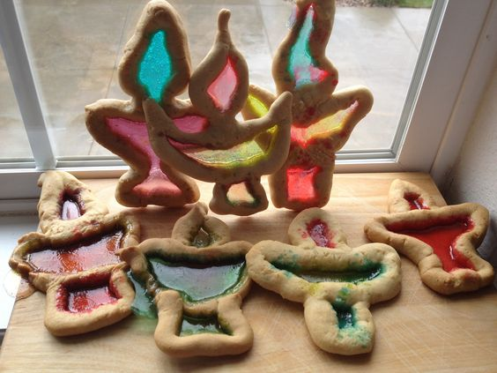
There are different ways to make “faux stained glass” using a few basic art supplies and household items like old crayons and wax paper, cooking oil, Sharpies and clear glass jars, or colored tissue paper and liquid starch. Make a colorful piece of stained-glass art to hang in a window, and tell your child your ideas about the source of life and love. Then, ask them their ideas.

You could also make stained glass chalice cookies. Use regular cookie dough to shape the chalice then use Jolly Ranchers or Lifesavers to create the “glass.” Here’s a recipe: https://www.foodnetwork.com/recipes/food-network-kitchen/stained-glass-cookies-recipe-2109969

Option 2: Mapping Your Church Home

Maybe when you placed the door on your altar to remind you of your church home, you pictured opening that door to enter, like you’ve done so many times before.

As a family, see if you can make a map, or floorplan, of your church. It doesn’t need to be exact, or to scale. Is there a table when you first walk in, or a bulletin board? Where are the chairs or pews in the sanctuary? Where are the aisles? Where do people who use wheelchairs sit? Where’s the pulpit? Are there windows? What about other rooms--classrooms? An office? A minister’s study, maybe, or a library? As the memories come back to you, draw them in.

Call to mind a favorite memory that took place in each of the spaces you drew and share those memories with your family members. “Here’s the chancel where Robin tripped when she was playing Mary in the Christmas pageant, remember?” “This is the bathroom where we put up our new all-genders sign.” “There’s Reverend Sue’s office, where we signed the membership book.” “There’s the kitchen, and there’s the cabinet with all the cookies!”

If the memory includes other congregants, you might email or text those people your picture and share the memory with them, too, letting them know you’re thinking about them and missing them.

If the idea of a familiar church home doesn’t resonate with you, consider doing this exercise with a past home of your own, or a dear friend or grandparent’s home, or have your child describe their favorite teacher’s classroom to make into a map. (Teachers would love to know they are being thought of and missed, too!)

Sabbath Extras
- Visit the site of your congregation with a drive or walk and see how it is doing. Does it seem lonely? Blow some kisses and tell it you will be back someday.
- Visit the website of your congregation and find something new to you!
- Go on a hunt around your house for old keys; they might be in “junk drawers,” on the tops of cupboards or shelves, or even on your keyrings! Do you remember what all those old keys open? If not, make up a story together about what the key could open...

Cover Photo: The Inside Scoop

This packet’s cover photo is of Katie Covey’s personal Chalice Home.

The playful doors are an imaginary congregational threshold which she hopes will open to a bright future for all the UU families creating a Chalice Home.

Her orchid was a birthday gift 7 years ago from Rev. Emily Conger and Rev. Jaelyn Pema Scott, back in the “old days” of SpiritJam and Day Camp at Boulder Valley UU Fellowship, Lafayette, CO. It has bloomed twice a year ever since.

The photos are of her son, Brett, who is an ER nurse and of her brother, Ian, who was evacuated from Nigeria and is home safe.

The bike light and patch kit represent the cycle tours she and her husband love to ride together, since they met online on Cycling Singles.com.

The chalice was made for Katie by her father, Del Tweedie, from a Juniper branch.

The wooden Giving Bowl is another of Del’s creations on the lathe.

The glass container is a recycled spice bottle! The striped rock bowl is an olive oil dish from Barcelona which their daughter brought home for them.

The school bell was given to her father for his service on the Tredyffrin/Easttown School Board in Devon, PA.

Share This Packet!
Feel free to share this packet as our gift to any UU congregation or other faith community to support their work of caring for so many during this pandemic.

© 2019-20 Soul Matters ALL RIGHTS RESERVED

Learn more about Soul Matters Congregational resources at
https://www.soulmatterssharingcircle.com
Check us out on Facebook or Instagram.
We also have song playlists on Spotify and YouTube

