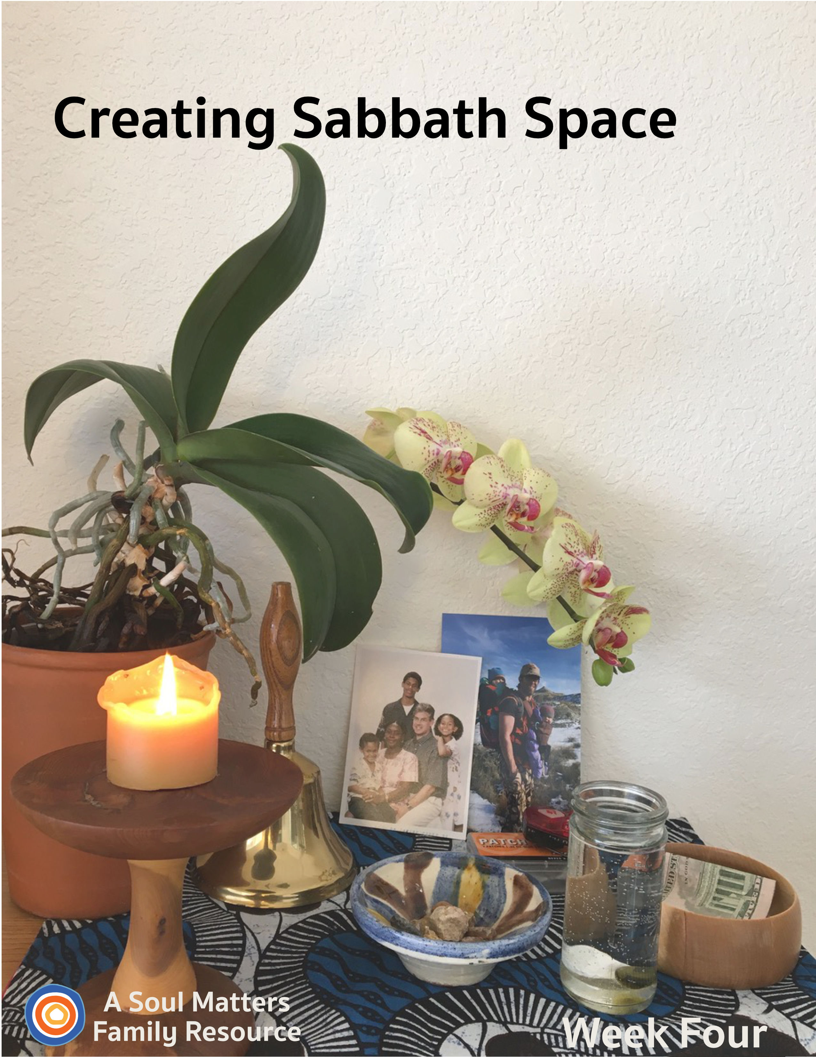
.
Sabbath Space
Week Four

Introduction

Welcome to Week Four of our “Creating Sabbath Space” adventure.

Each week you receive a packet that includes:
- Guidance for adding 1-2 new pieces to your family home altar, or “Chalice Home” as we like to call it.
- A family worship guide developed to celebrate and deepen your connection to those additions to your Chalice Home.
- A couple of “after-worship” activities to continue your family Sabbath time of connecting and relaxing together.

This fourth week our focus turns to adding a bit of nature to our home altars/chalice homes.

This element honors the wider web of which we are a part. It is also a way to remind ourselves that nature nourishes us in a way that little else can.

We encourage you to find your own special way to lift up this reminder about staying close to the natural world. It’s also an opportunity to remind your children about the overarching aim of our Chalice Home journey: To build a place that helps us remember and what is important, nourishing and sacred in our lives. Keeping these important things in front of us is especially vital during this time of sickness, separation and uncertainty.

After preparing for and then holding family worship, you are invited to continue your “family Sabbath” with the activities we’ve recommended.

Blessings as you celebrate the beauty of nature and the beauty of which we are a part.

Building Our Home Altar:
Week #4 - Honoring the Natural World

Preparing to Add a Piece of Nature

This week we will place a piece of nature into the Chalice Home. As UU’s, we celebrate the seven Principles of which the seventh Principle reads: Respect for the interdependent web of all existence of which we are a part. Nature also reminds us of our Sixth Source - Spiritual teachings of Earth-centered traditions which celebrate the sacred circle of life and instruct us to live in harmony with the rhythms of nature. Pagan altars and Native American altars have much to teach us about opening ourselves to nature’s healing power. With this as inspiration, this week’s additions to the Chalice Home will remind us of the healing harmony of nature and that we are all part of a greater whole.

Our family worship includes a time for you and your children to find one or more pieces from the natural world. So if you’d like to go outside, you will want to prepare for that. However, don’t shrink at adding a favorite houseplant. Simple is fine. A twisted twig may appear. Pinecones count too. Dandelions count, although they won’t last past the end of the worship time, so prepare for that eventuality. Celebrate imperfection. Remember, nature is beautiful but it can also be messy and wild. So reflecting that wild beauty is a good thing!

Share Your Chalice Home with Other Families
Each week, we encourage you to share your ever-growing family altar/chalice home with the other UU families who are building one too. All you have to do is take a picture of your altar and then post it to Facebook or Instagram with the hashtag “#uuchalicehome.” Your church may also be collecting pictures online of the “chalice homes” of your church’s families. Be sure to ask your RE leader about that.

Using Your Chalice Home: Not Just for Sundays or Family Worship
Besides using it for Sunday morning as the focal point for Sabbath worship, consider:
- using your altar to begin your day. It can be something as simple as lighting the chalice and reading a poem before or after breakfast.
- Or try it as a bedtime ritual, closing the day together.
- And each person can always visit it whenever they feel the need to center themselves.

Now, it’s time for Family Worship!
Family Worship: Week #4

Use this Worship Guide as is or tweak it to give it your own unique stamp. The ultimate goal is to foster family connection, so think of some creative ways to divide up the worship components. For instance:
- Have the youngest, who is able, light the chalice.
- Have the oldest offer the words of blessing.
- Take turns reading the meditation each week.
- Have the quietest family member ring the centering bell.

Centering Sound
Move from “regular time” to “sacred time” by sounding your bell, chimes, ringing bowl or ringing glass.

Optional words to go with your centering sound:

“To this quiet place of beauty, we come from busy things
Pausing for a moment for the deeper thoughts that quiet brings.”

Centering Music or Silence

- Option #1 for singing families: Earth My Body (Lyrics at https://www.youtube.com/watch?v=Gpdn13HL9vI) (View Katie’s Hand Gestures to go with the chant at https://youtu.be/Hn5NLMQGwas)
- Option #2 for families who prefer to listen: Play some quiet music (we love Spotify’s Classic Yoga playlist and our own Soul Matters Playlist for coping with Covid-19)
- Option #3: What a Wonderful World | Playing For Change | Song Around The World What a Wonderful World on YouTube
- Option #4: Silence for 30 Seconds.

Chalice Lighting

“We light this chalice for the warmth of love, the light of truth and the energy of action.”
- Mary Ann Moore

Or use your own or your congregation’s words.

The Giving Bowl
“We drop our coins (papers) in and fill the bowl. Serving others makes us whole.”

Add your monetary contribution for the group or organization you decided to give to (or provide slips of paper and invite family members to write or draw their way to help others on it.)

Adding Elements from the Natural World

Introduce this activity by reminding your child(ren) that the aim of our Chalice Home is to celebrate and keep us close to the things in our lives that nourish us. Then, using your own particular beliefs or a personal story, talk briefly about how nature is one of the most powerful sources of human nourishment. Consider using these centering words as part of your introduction:
“We are part of the natural world. When we center nature, we become grounded and supported.”
Next, invite family members to go find something from nature that they especially love or are especially nourished by to add to your Chalice Home. Remember, going outside is always great, but if that’s not an option for you, there are plenty of natural elements to be found around the house. You might also want to keep in mind the Pagan practice of finding objects that represent the four “elements”: earth, air, fire and water.
After everyone has gathered their piece or pieces of nature, place them on your Chalice home and share why you chose it/them and why they have special meaning to you.
Don’t forget to call attention to the elements of nature already present on your altar; the rocks and water, and any other natural elements that are part of your Chalice Home, such as the wood of the table or shelf or a window. These elements bring the web of life into your sacred time.

Sharing of Gratitudes and Grace

“We listen to each other; it is a holy act.
To share our joys and sorrows, with grace it flows on back.”

Invite each family member to pick up a rock and share something they are thankful for while dropping the rock into the bowl of water. The aim here is to make room to notice the good things all around us even though times are hard.

After this first round of joys and gratitudes, have each family member choose another rock and share something or someone they have a concern for - someone or something they are holding in their hearts and prayers. This is a way to bring the struggles of others into our hearts, maybe a grandparent who is in danger of getting sick or hospital workers who are putting their health at risk for the sake of the rest of us or a group of people around the world who are also getting sick from the covid-19 virus.

Be sure to include those whose photos you placed last week in your sharing, to keep them in your hearts and prayers.

And don’t forget the rocks love being used in this ritual and they can be pulled out of the water and used as “double rocks” if there are more gratitudes and thoughts.

Meditation

For the reader: Pause for a few moments after each sentence, allowing enough time for your family members to fully complete the action you are asking of them or the thought you are offering them.

Fourth Week Meditation

This week we are doing a standing meditation. So everyone stand up.
Close your eyes.
Plant your feet on the floor.
Pull your shoulders back and take one giant breath in. Hold it for a moment. Then blow it out.
Let your arms hang comfortably at your side.

Let’s begin by honoring the earth and all the ways it helps things grow.
Imagine you are a tree.
Begin by focusing on your toes. Wiggle them as fast as you can.
Feel each toe touching the floor.
Now pretend that roots start to come out of your toes.
You are a tree after all, and trees need deep roots to live and grow.
Can you feel your roots pushing down into the ground?
Can you feel the cool and moist soil as your roots go deeper and deeper into the earth?
Now with a whisper voice, repeat after me:
“Thank you soil and dirt [REPEAT]
for helping everything grow, [REPEAT]
For trees and grass, [REPEAT]
flowers and vegetables [REPEAT]
We say thanks over and over again.” [REPEAT]

Now what about the air and everything that makes its home in the sky?
Let’s honor that by lifting our hands above our heads and out in front of us a little, like we are a super hero flying through the sky.
Can you feel the wind on your face as you fly? Is it blowing back your hair? Take a moment to imagine that and to feel how good it feels.
Now as you imagine yourself flying, look around.
Can you see those geese flying in a V-shaped line?
What about that eagle to your left? Can you see it too?
Now imagine a cloud in front of you. Do you fly around it? Or do you speed up and fly right through it?
Now with a whisper voice, repeat after me:
“Thank you sky and wind [REPEAT]
for making all of us feel so free. [REPEAT]
For blue skies that make us feel happy and hopeful, [REPEAT]
For all the birds that make us forget about limits, [REPEAT]
We say thanks over and over again.” [REPEAT]
Now drop to the floor and curl up like a seed in the ground.
Can you picture yourself planted in the dirt?
Now with your imagination picture yourself starting to grow. As you do so, push your legs out and sit up, either with your knees on the floor or in a squatting position.
You are now a seed pushing through the ground.
Just like a sprout, slowly start to stand.
As you spread your arms out and pretend they are petals of a flower.
What flower are you? What color are your petals? Red? Yellow? Pink?
Now with your arms out and petals fully grown, tilt your head back and imagine feeling the sun on you.
Do you feel its warmth? Do you feel the sun tempting you to turn in its direction?
Watch out, here comes gentle wind. Imagine your stem shaking in the wind by shaking your hips back and forth, round and round.

Now with a whisper voice, repeat after me:
“Thank you sun [REPEAT]
for your warmth that allows everything to live. [REPEAT]
And thank you flowers and blossoming trees, [REPEAT]
For all the beauty you share. [REPEAT]
And for all the ways [REPEAT]
That beauty heals, over and over again. [REPEAT]

Now slowly open your eyes. Take one last deep breath.
And as we end, on the count of three, let’s repeat three times: “We are the earth and the earth is us.”
1,2, 3… “We are the earth and the earth is us.” “We are the earth and the earth is us.” “We are the earth and the earth is us.”

Blessed Be. Amen

Setting an Intention

As you bring worship to a close, pause for a moment to think ahead about the coming week and make an intention/promise for how you want to act, what you want to remember or how you want to treat others.

Here’s this week’s intention/promise statement, for everyone to say together. Have one person state each phrase, with the rest of the family repeating it after them:

“In the coming week, / I will take the time/ to connect with nature/ and reside in the web of life.”

Words of Blessing
Spirit of Life,
We need our connection to nature to keep us balanced and grounded.
We need to see growing things, beauty, and feel the cycles of nature.
We are a part of the sustaining earth, the fluid waters, the air we breathe and the fire of power in our spirit.
May we stay connected to the earth, the water, the air, and the fire.
May we be safe and well.
Blessed be. Amen.

Extinguishing the Chalice

“We gather the warmth of love, the light of truth, and the energy of action into our hearts.
Back into the world of do and say, carry it forward into the dawning day.
Go Now in Peace, Amen.”

View Katie’s YouTube video demonstrating how to add gesture to these words: https://youtu.be/GEF4Hdm08oM

Instructions: Use your hands in a gather/cupping gesture and bring them to your heart. Repeat after the “warmth of love,” “the light of truth,” and the “energy of action.”
Family Sabbath Activities
Sabbath is the idea of setting aside time for rest and connection with each other. It is a time of remembering and paying attention to what really matters, and the people in your life that really matter. So here are some activities to help you lean into the joy of just being together!
Sabbath Activity One: Three Things to do with Wildflowers

Here we are, betwixt and between--spring is becoming summer, life in a pandemic beginning to feel like the new normal in some ways, and utterly untenable in others. Playing with wildflowers, those quintessentially adaptable and ephemeral beauties, might help us embrace now for what it is. Here are three ways to do it:

- You could try out this super easy way to press flowers, allowing them to retain their color and form--though alas, not their fragrance or dimensionality--for 5-7 years! This was a common activity in generations past, so you might consider sharing the results of this project with an elder family member, friend, or congregant through email or video call. You might also use your pressed flowers to make some salt dough ornaments to hang in your home. Here’s a tutorial. Sturdier leaves, twigs, and flowers also make interesting impressions in salt dough.

- You might learn the take-anywhere art of weaving flower crowns, sashes, necklaces, etc.

- A fun goal for the whole family might be to learn to identify three new-to-you, local wildflowers. A comprehensive online field guide can be found here, though you might enjoy calling up your local native plant society, agricultural extension office, or master naturalist program to confirm your I.D. and talk to someone who knows their stuff (and who is likely missing the usual perks of their work--being outside and sharing their love of native plants with others).

Sabbath Activity Two: Grow a Garden from the Grocery Store

While staying at home, consider planting some fruits or vegetables from grocery store produce and see what happens. Connect to the excitement of growing things and bring nature into your home.

Seeds: If the finished product isn’t so important, try growing all sorts of seeds - from green peppers, tomatoes and peas. These seeds, unless labelled “heirloom” probably won’t produce, but they will give you the delight of seeing green sprouts and leaves. You don’t have to go out and buy seeds if you don’t want to. Dry beans like garbanzos and black beans will sprout, though not all of the seeds from the grocery store produce will bear a fruit or vegetable. Check out this guide: https://www.networx.com/article/growing-a-garden-from-the-grocery-store

Root Crops: Bulbs, like onions and garlic, and tubers such as potatoes grow, as we well know when we find one sprouted by mistake. Root crops, such as beets and carrots, can even re-grow from their sliced-off top parts (where the leaves came out).

Fruit: Avocado and Lemon fruit seeds are the classic seeds to try growing. Check out this article that includes suggestions for cherries, plums and others, too.

Ginger: https://www.youtube.com/watch?v=-mUeNy0rweM.

Homemade Pots: Newspaper pots, toilet paper roll pots, and egg cartons all work as biodegradable pots. Click here for a video on YouTube.

No Soil?: Try sprouting bean seeds in paper towels and a jar or Ziplock bag. https://madincrafts.com/gardening-with-preschoolers-germinating/

Cover Photo: The Inside Scoop

This packet’s cover photo is of Katie Covey’s personal Chalice Home.

Her orchid was a birthday gift 7 years ago from Rev. Emily Conger and Rev. Jaelyn Pema Scott, back in the “old days” of SpiritJam and Day Camp at Boulder Valley UU Fellowship, Lafayette, CO. It has bloomed twice a year ever since.

The photos are of her son, Brett, who is an ER nurse and of her brother, Ian, who was evacuated from Nigeria and is home safe.
The bike light and patch kit represent the cycle tours she and her husband love to ride together, since they met online on Cycling Singles.com.
The wooden Giving Bowl is another of Del’s creations on the lathe.
The glass container is a recycled spice bottle!
The striped rock bowl is an olive oil dish from Barcelona which their daughter brought home for them.
The chalice was made for Katie by her father, Del Tweedie, from a Juniper branch.
The school bell was given to her father for his service on the Tredyffrin/Easttown School Board in Devon, PA.

Share This Packet!
Feel free to share this packet as our gift to any UU congregation or other faith community to support their work of caring for so many during this pandemic.

© 2019-20 Soul Matters ALL RIGHTS RESERVED

Learn more about Soul Matters Congregational resources at
http://www.soulmatterssharingcircle.com
Check us out on Facebook or Instagram.
We also have song playlists on Spotify and YouTube

