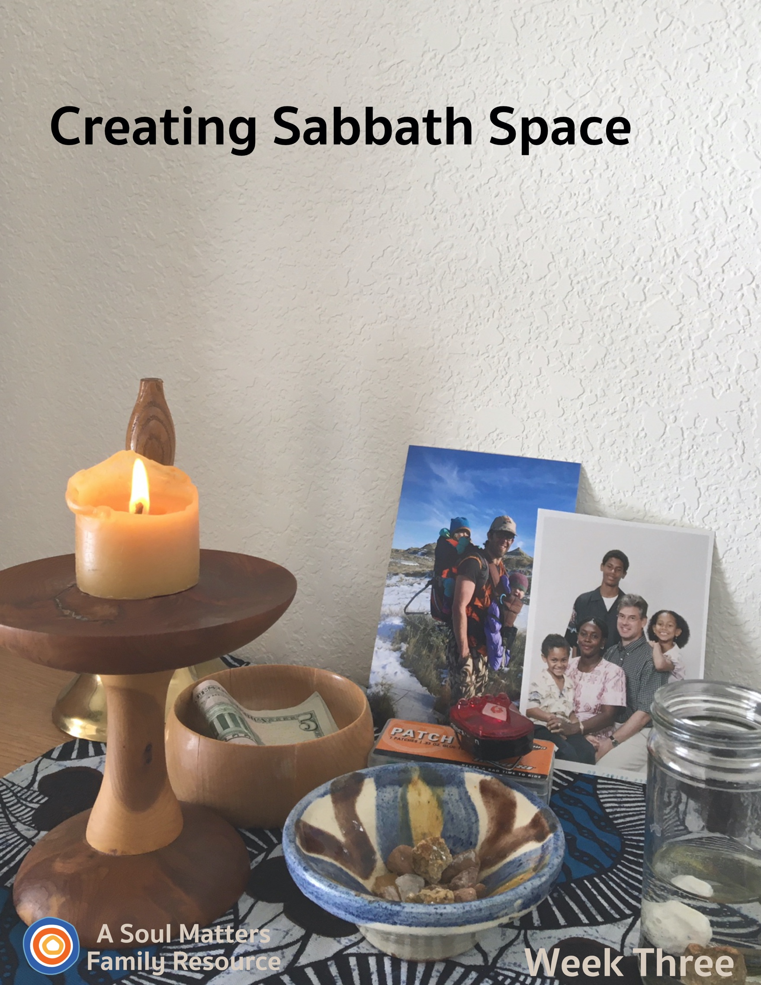

Sabbath Space
Week Three

Introduction

Welcome to Week Three of our “Creating Sabbath Space” adventure.

Each week you receive a packet that includes:
- Guidance for adding 1-2 new pieces to your family home altar, or “Chalice Home” as we also like to call it.
- A family worship guide developed to celebrate and deepen your connection to those additions to your Chalice Home.
- A couple of “after-worship” activities to continue your family Sabbath time of connecting and relaxing together.

This third week our focus turns to adding photos and drawings of family members to our home altars/chalice homes.

These elements remind us to honor the uniqueness and inherent worth of each family member and to hold them in our hearts. They are also a way of affirming our loved ones and telling them “there is no one like you!”

We encourage you to find your own special way to lift up this reminder about being thankful for family members’ uniqueness. It’s also an opportunity to remind your children about the overarching aim of our chalice home journey: To build a place that helps us remember and stay close to what is important, nourishing and sacred in our lives. Keeping these important things in front of us is especially vital during this time of sickness, separation and uncertainty.

After preparing for and then holding family worship, you are invited to continue your “family Sabbath” with the activities we’ve recommended.

Blessings as you celebrate the beauty that is your family and the beauty with which you bless each other.

Building Our Home Altar:
Week #3 Honoring Your Uniqueness

Preparing to Add Family Photos, Drawings, and/or Symbols

This week we will place photos, drawings or symbolic tokens of family members into the Chalice Home. As UU’s, we celebrate the amazing uniqueness and diversity present in families, extended families, and the beloved family members we call pets. Our pictures/drawings/symbols serve as a reminder that we are nourished by all the wonderful unique qualities of our family members.

Our family worship includes a time for you and your children to find these photos or make a drawing. If you don’t have photos available, or prefer not to draw, you can find some object that symbolizes what is unique about you. Again, the goal is to place a picture, drawing or object on the altar that captures something that is unique about each family member or captures each family member’s unique love/passion.

If you’ll be including drawings, you may wish to gather drawing materials beforehand. If there are special photos on a phone, have your printer ready to print them out. With all these extra photos, drawings and symbols added, your Chalice Home may stop looking so artfully arranged, and begin to reflect the jumbled mix of family presence. That’s great! Celebrate the imperfection. Remember, it is your Chalice Home and will look as unique as your family is!

In addition, during Sharing of Gratitudes and Grace you will be invited to share photos of additional extended family members who you wish to hold in your hearts.

Share Your Chalice Home with Other Families
Each week, we encourage you to share your ever-growing family altar/chalice home with the other UU families who are building one too. All you have to do is take a picture of your altar and then post it to Facebook or Instagram with the hashtag “#uuchalicehome.” Your church may also be collecting pictures online of the “chalice homes” of your church’s families. Be sure to ask your RE leader about that.

Using Your Chalice Home: Not Just for Sundays or Family Worship
Besides using it for Sunday morning as the focal point for Sabbath worship, consider
- using your altar to begin your day. It can be something as simple as lighting the chalice and reading a poem before or after breakfast.
- Or try it as a bedtime ritual, closing the day together.
- And each person can always visit it whenever they feel the need to center themselves.

Now, it’s time for Family Worship!
Family Worship: Week #3

Use this Worship Guide as is or tweak it to give it your own unique stamp. The ultimate goal is to foster family connection, so think of some creative ways to divide up the worship components. For instance:
- Have the youngest, who is able, light the chalice.
- Have the oldest offer the words of blessing.
- Take turns reading the meditation each week.
- Have the quietest family member ring the centering bell.

Centering Sound
Move from “regular time” to “sacred time” by sounding your bell, chimes, ringing bowl or ringing glass.

Optional words to go with your centering sound:

“To this quiet place of beauty, we come from busy things
Pausing for a moment for the deeper thoughts that quiet brings.”

Centering Music or Silence

- Option #1 for singing families: Love Grows One By One (Chorus Only) by Carol Johnson (Lyrics at https://www.youtube.com/watch?v=7UBOSZ11_ck)
- Option #2 for families who prefer to listen: Play some quiet music (we love Spotify’s Classic Yoga playlist and our own Soul Matters Playlist for coping with Covid-19)
- Option #3: If animals are important members of your family consider using this fun video as your opening song:: OK Go - White Knuckles https://www.youtube.com/watch?v=6lXVtCjJrz0
- Option #4: Silence for 30 Seconds.

Chalice Lighting

“We light this chalice for the warmth of love, the light of truth and the energy of action.”
- Mary Ann Moore

Or use your own or your congregation’s words.
For some extra fun, watch this chalice lighting using Claymation, created by Peter Bowden, used with permission, here.

The Giving Bowl
“We drop our coins (papers) in and fill the bowl. Serving others makes us whole.”

Add your monetary contribution for the group or organization you decided to give to (or provide slips of paper and invite family members to write or draw their way to help others on it.)

Adding Photos, Drawings or Symbols to Honor Your Uniqueness
Invite family members to think about something they love about themselves or love to do and find a photo (drawing or symbol) of themselves that best captures it. Include pets and extended family. As you place the photo/drawing/object you have collected, share why you chose it.
During the Sharing of Gratitudes and Graces, you can also add photos or drawings of family members who you would like to keep in your heart due to a concern or gratitude.

Sharing of Gratitudes and Grace

“We listen to each other; it is a holy act.
To share our joys and sorrows, with grace it flows on back.”

Invite each family member to pick up a rock and share something they are thankful for while dropping the rock into the bowl of water. The aim here is to make room to notice the good things all around us even though times are hard. Since this is a week of adding pictures to our altar, consider adding a picture of the person you are lifting up in gratitude with your rock.

After this first round of joys and gratitudes, have each family member choose another rock and share something or someone they have a concern for - someone or something they are holding in their hearts and prayers. This is a way to bring the struggles of others into our hearts, maybe a grandparent who is in danger of getting sick or hospital workers who are putting their health at risk for the sake of the rest of us or a group of people around the world who are also getting sick from the covid-19 virus. Again, since this is a week of adding pictures to our altar, consider adding a picture of the person you are lifting up a special concern for with your rock.

And don’t forget the rocks love being used in this ritual and they can be used as “double rocks” if there are more gratitudes and thoughts.

Meditation

For the reader: Pause for a few moments after each sentence, allowing enough time for your family members to fully complete the action you are asking of them or the thought you are offering them.

Before beginning the meditation: Find a comfortable place to sit, in a chair, or on the ground if you prefer, or maybe even on a cushion.

Third Week Meditation

Let’s begin by closing our eyes and taking a deep breath.
Pull your shoulders back and up. As you do so feel your spine straighten and strengthen.
Let your arms rest gently on the top of your legs, with your palms turned up.
Now tip your head back slightly and take two slow deep breaths.
Allow yourself to feel the air fill your lungs, like life pouring into you.

What a gift to feel so alive.
When else do you feel most alive? Most happy? Most yourself?
Take a moment to bring the picture of one of those moments into your imagination, one of those moments when you are most you, when you feel like you are doing one of your favorite things.
Maybe it’s when you’re playing a sport. Or your favorite musical instrument. Maybe you see yourself singing. Or playing a game with friends. Or telling a joke that makes others laugh. Or maybe you see yourself camping, or swimming or reading a book.
Can you picture yourself smiling? Focus on that image of you smiling. Allow it to put a smile on your face in this moment.

Now clear out those images of yourself and picture our family doing something fun together.
Maybe it is one of the times we went camping. Or maybe it’s a picture of us playing a family board game. Or even having a water balloon fight. Or just eating together.
Can you see each member of our family smiling? Laughing? Hold those happy faces in your mind for a moment.

Now take a deep breath and imagine the faces of other family members who are far away, who we haven’t been able to see for a while.
Grandparents. Uncles. Aunts. Cousins. Older Siblings no longer living at home.
If you could see them right now, what would you say to them? Imagine yourself telling them what you want to tell them.

After taking a slow deep breath, open your eyes, just a little bit, enough to see the family members near you.
Now reach out and take the hands of those on your right and left, until everyone in the family is holding hands, making a circle together.

On the count of three, let’s repeat three times: “I’m glad we have each other.”
1,2, 3… “ I’m glad we have each other.” “I’m glad we have each other.” “I’m glad we have each other.”

Amen
Setting an Intention

As you bring worship to a close, pause for a moment to think ahead about the coming week and make an intention/promise for how you want to act, what you want to remember or how you want to treat others.

Here’s this week’s intention/promise statement, for everyone to say together. Have one person state each phrase, with the rest of the family repeating it after them:

“In the coming week, / I will take the time / to tell my family members /
one thing / I think is awesome about them!

Words of Blessing

Spirit of Life,
We gather our loved ones close to us.
In all their wonderful uniqueness,
in all their wonderful ways of being.
May we hold on to what makes us “us.”
May we stay safe and well.
Blessed be. Amen.

Extinguishing the Chalice

“We gather the warmth of love, the light of truth, and the energy of action into our hearts.
Back into the world of do and say, carry it forward into the dawning day.
Go Now in Peace, Amen.”

View Katie’s YouTube video demonstrating how to add gesture to these words: https://youtu.be/GEF4Hdm08oM
Instructions: Use your hands in a gather/cupping gesture and bring them to your heart. Repeat after the “warmth of love,” “the light of truth,” and the “energy of action.”
Family Sabbath Activities
Sabbath is the idea of setting aside time for rest and connection with each other. It is a time of remembering and paying attention to what really matters, and the people in your life that really matter. So here are some activities to help you lean into the joy of just being together!
Sabbath Activity One: Ten Good Thoughts to Ten Good People

Make a list as a family of ten friends and relatives who you’d like to reach out to (or who might really need a reach-out) and what message you’d like them to receive. Maybe it’s an echo of your good thought or prayer for them in the “Gratitude and Grace” section above. Maybe it’s an inside joke. Maybe it’s simply a silly gif or emoji. You might like to send out all ten messages at once, a big blast of love from your device out into the universe! Or, you might want to text three on your Sabbath day, and then one a day throughout the rest of the week, spreading out the caring and making a kind of family spiritual practice out of bringing someone to mind and then gifting them with your well wishes.

Sabbath Activity Two: Sharing Stories about your Family

Reference: Stories that Bind Us; What are the Twenty Questions?
https://www.huffpost.com/entry/the-stories-that-bind-us-_b_2918975

Snuggle on the couch together and tell those classic family stories! There are 20 questions in the above blog post which capture how much children know about the stories told in their family. Use this “DYK” (Do You Know) scale to inspire the retelling of stories from your own family. The family Sabbath time is an ideal time to share these stories. Each family has some classic “Remember that time when…?” so don’t feel you have to rigidly stick to the DYK scale questions in the article.

As the authors say, “...In order to hear family stories, people need to sit down with one another and not be distracted. Some people have to talk and some have to listen. The stories need to be told over and over and the times of sitting together need to be multiple and occur over many years. The most convenient times traditionally have been family dinners, family trips in the car, vacations, birthday gatherings, etc. As Bruce Feiler notes, however, given the complexities of modern family life families can also sit and talk over a snack after school or before everyone goes off to work, or at any other time that they can focus on each other. These gatherings -- short or long -- are at the heart of the process by which the intergenerational stories can be told and learned and through which children can grow stronger and healthier. No quick fix. No simply learning the answers to the questions…”

Sabbath Extras
- Spend a little more time with your drawings of yourself. Or spend some more time arranging the pictures on your Chalice Home.
- Dig into your computer photo albums and create a slideshow of family pictures. Don’t forget to find a family theme song that lays in the background of your slide show.
- Dig into your computer photo albums and find all the pets that have been a part of your life. Take some time telling stories about each one. Maybe make a slideshow of just your family pets! (Parents, remember to go far back and include those pets you had as a kid!)
- Do a family photoshoot.
- Cook a favorite family meal together.

Cover Photo Inside Scoop

This packet’s cover photo is of Katie Covey’s personal Chalice Home.

The bike light and patch kit represent the cycle tours she and her husband love to ride together, since they met online on Cycling Singles.com. The photos are of her son, Brett, who is an ER nurse and of her brother, Ian, who is due to be evacuated from Nigeria any day.

The wooden Giving Bowl is another of Del’s creations on the lathe.
The glass container is a recycled spice bottle!
The striped rock bowl is an olive oil dish from Barcelona which their daughter brought home for them.

The chalice was made for Katie by her father, Del Tweedie, from a Juniper branch.
The school bell was given to her father for his service on the Tredyffrin/Easttown School Board in Devon, PA.

Share This Packet!
Feel free to share this packet as our gift to any UU congregation or other faith community to support their work of caring for so many during this pandemic.

© 2019-20 Soul Matters ALL RIGHTS RESERVED

Learn more about Soul Matters Congregational resources at

http://www.soulmatterssharingcircle.com
Check us out on Facebook or Instagram.
We also have song playlists on Spotify and YouTube

