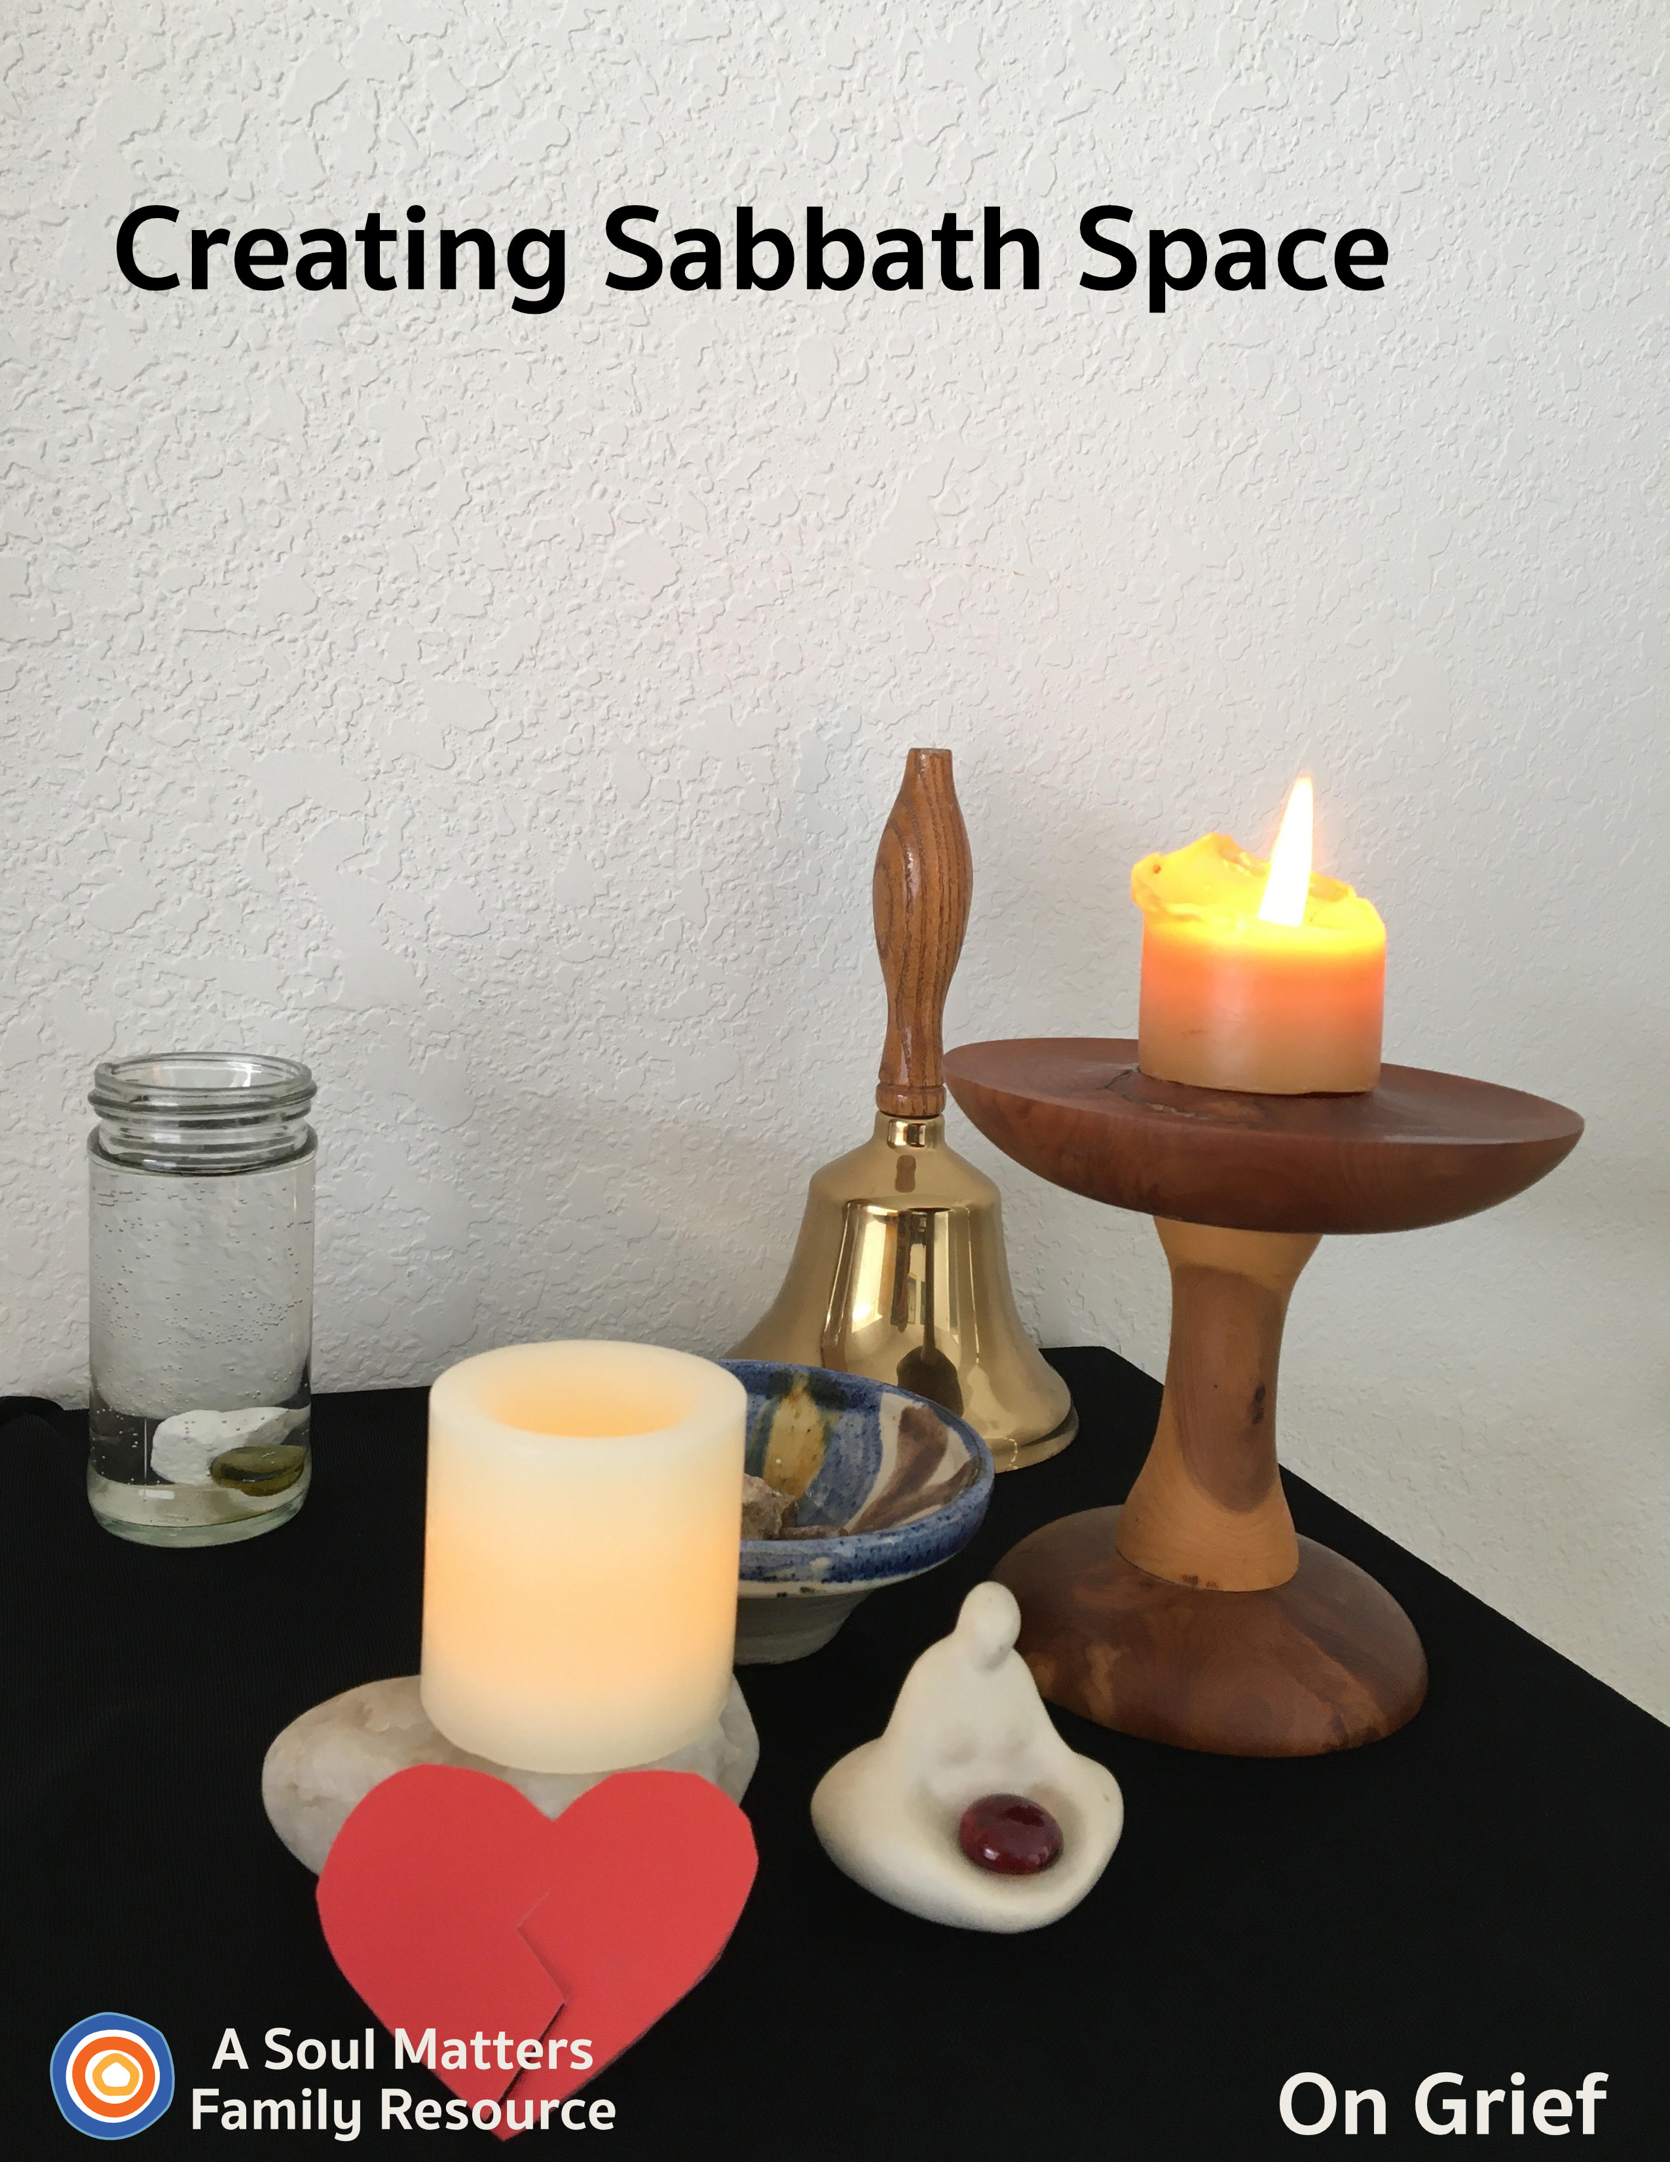
Creating Sabbath Space
Making Room for Grief

Introduction

This is a time of uncertainty and isolation, and it’s also a time of grief. Loss of life. Loss of jobs. Loss of getting to experience once-in-a-lifetime rituals like graduation. It all takes its toll. And most importantly, we need to make space to acknowledge and honor it. For this reason, we’re dedicating an entire packet to grief. It’s an optional packet that can be inserted into the flow of the other Sabbath Space installments whenever you need. Some will use this session early; for others, the best time will be at the very end. It’s entirely up to the needs of your family.

As human beings, we often busy ourselves in order to avoid or not feel grief. And so, psychology and religion tell us that the only true way to work through our grief is to clear the way and put all our distractions away. With this in mind, we invite you to change your altar for this week and pair it down to only its basic elements: Your chalice, ringing instrument, and grace and gratitudes bowl. Keep your other objects in a safe place. We will bring them back next week. After all, the ultimate goal is to end with a full and rich array of objects that represents the fullness and richness of your family.

This special packet includes:
- Guidance for adding items that symbolize the types of loss your family is grappling with.
- A family worship guide developed around these added items.
- A couple of “after-worship” activities to help your family work with and express the feelings about the losses you are experiencing, such as the death or illness of a loved one or loss of important experiences, such as graduation cancelled, loss of time with friends and loss of visits to beloved family.

These are the symbols of grief we will be adding to our altars/Chalice Homes this week:
- A black or dark cloth for the Chalice Home
- A broken heart
- Photos or memorabilia of the thing or person lost
- An extra candle
- A “This Home is in Mourning” sign for loss of a loved one

These parts of the Chalice Home Worship remind us that one of the best ways to nurture ourselves in grief is to honor the truth that none of us have to carry our grief alone.

After preparing for and then holding family worship, you are invited to continue the expressive and healing activities that we’ve recommended.

Preparing Our Home Altar for Grief & Loss

The Goal

The aim of our Chalice Home worship this week is to remember that none of us have to carry our grief and loss alone. We will make space to acknowledge the many types of loss your family might be experiencing, such as the loss of a loved one, grief over the loss of a special experience or sadness about being separated from beloved friends or activities.

Items to Gather Ahead of Time
- A black or dark cloth
- A heart - a cut out paper heart, a heart-shaped rock, or a clay or playdough heart
- Additional candle and matches
- Photos and memorabilia of the departed one or photo or memorabilia of what has been lost
- A box of tissues
- A sign that says, “This home is in mourning,” if you have lost a loved one to death.

All of these items will be added during the service. So make sure you’ve gathered them beforehand. Temporarily removing some of the items from previous weeks will also happen during the service. Doing this inside the worship experience will help symbolize the moment and movement of loss. Placing the items of grief on the altar together will help each person remember what is most important - that in loss and grief each of us is changed but no one has to carry the grief alone.

The Chalice Home will become a place to remember the departed or the things that have been lost. An additional candle will represent the addition of loss and grief, and it will be extinguished and re-lit. You will need several matches if they are wax candles.

For Families Who Have Lost a Loved One to Covid-19: Before the worship, make a sign for a window or door that says, “This home is in mourning.” One sign for mourning can be found in the UUA’s Grief Kit at https://www.uua.org/files/homeinmourningpdf. Or you can invite family members to create their own together.
Be sure to have a box of tissues nearby to catch the tears that will be falling.

If You Don’t Have Pictures: You will invite family members to bring photos and memorabilia of departed ones or a photo and/or memorabilia of something they have lost and are grieving for. If you don’t have such pictures or memorabilia, then make some time beforehand to make drawings that represent the loved one or a lost experience.

Share Your Chalice Home with Other Families
Each week, you are invited to share your ever-growing family altar/chalice home with the other UU families who are building one too. All you have to do is take a picture of your altar and then post it to Facebook or Instagram with the hashtag “#uuchalicehome.” Your church may also be collecting pictures online of the “chalice homes” of your church families' members. Be sure to ask your RE leader about that.

Using your Chalice Home: Not just for Sundays or Family worship.
Each person can visit it whenever they feel the need to center themselves and comfort their broken heart.

Now You’re Ready for Your Family Worship in a time of Grief...
Family Worship: Making Room for Grief

Use this Worship Guide as is or tweak it to give it your own unique stamp. The ultimate goal is to foster family connection, so think of some creative ways to divide up the worship components. For instance:
- Be gentle with each other. Take turns leading the worship. Allow tears as well as laughter. Be sure to have a box of tissues nearby.
- Have the youngest, who is able, light the chalice.
- Have the oldest offer the words of blessing.
- Take turns reading the meditation each week.
- Have the quietest family member ring the centering bell.

Centering Sound
Move from “regular time” to “sacred time” by sounding your bell, chimes, ringing bowl or ringing glass.

Optional words to go with the sound:

“To this quiet place of beauty, we come from busy things
Pausing for a moment for the thoughts that quiet brings.”

Centering Music or Silence

- Option #1 for singing families: #389 STLT Gathered Here (for the words and tune https://www.youtube.com/watch?v=WtBEf6dCbwM)
- Option #2 for families who prefer to listen: Play some quiet music ( Spotify’s Classic Yoga playlist) or this: Psalm 23 (Bobby McFerrin) on YouTube; or this: Angel by Sarah Mclachlan on YouTube or #389 STLT Gathered Here on YouTube
- Option #3 Silence for 30 Seconds.

Chalice Lighting

“We light this chalice for the warmth of love, the light of truth and the energy of action.”
- Mary Ann Moore
Or use your own or your congregation’s words.

Preparing the Space - Acknowledging the absence

“Losing that which is precious to us has moved us into grief. We feel lost and sad.
We especially need to be gentle with each other and allow the emotions of grief to be expressed.”

Invite the family to remove the Chalice Home items from their places and place a black or dark cloth. Then replace only the basic elements: the chalice, giving bowl, grace & gratitudes rocks and water container. Leave plenty of room for photos and memorabilia of the lost experiences or departed one.

For a departed one: Invite the family to take the “This home is in mourning” sign and place it in a window or front door together.

Adding a Candle and Memorabilia for Loss
First, invite the family members to add the photos, pictures and memorabilia that each have gathered to symbolize their particular losses. As you add your items, have family members name the loss their items represent. Keep this simple and focused just on naming; we will go into more detail and tell stories in a minute.
Second, add your broken heart symbol that you made or found earlier, to symbolize the grief of loss.

Third, add another candle.

Fourth, close with these words of blessing…

For the loss of a precious experience: Light the new candle and then say these words,

“We gather here in sadness to hold each other in grief over our losses.
We extinguish this light as a sign of how our heart is broken.”
Extinguish the candle.

For the death of a loved one: Light the new candle and then say these words,

“We gather here in sadness to hold each other in grief over the death of ____________ [name and role in the family i.e. Herb Smith, Dad to mom and Grandpa to Elle and John.]”
“We say goodbye to [Grandpa]”
Extinguish the candle.

Honoring Our Losses with Story

Invite family members into a time of sharing their stories of loss with these words:

“We listen to each other, it is a holy act

To share our joys and sorrows,
with grace it flows on back.
We honor the truth that none of us have to carry our grief alone.
Each of us carries the light of [possibilities/Grandpa] in our memories.”

Invite family members to take turns briefly telling a story about their loved one or the activity they are cut off from and grieving. Allow time to feel the loss. Make space for them to describe their broken heart, i.e. how they are feeling about what they are missing.

After sharing their story, drop a rock into the water.

Expect family members to want to share more than one story. Make room for that. So make sure a number of rocks are available or use the practice of “double rocks.”

Meditation

For the reader: Pause for a few moments after each sentence, allowing enough time for your family members to fully complete the action you are asking of them.

Before beginning the meditation: Find a comfortable place to sit, in a chair, or on the ground if you prefer, or maybe even on a cushion.

Special Instructions: Grab Your Rock: Before beginning the meditation, have each person take out the rock they dropped into the water bowl.

Grief Meditation

Begin by closing your eyes and taking a few deep breaths. Breathe in through your nose for the count of 3 and then release through your mouth at any pace that is comfortable.

Now turn your focus to the rock you have in your hand.
Keeping your eyes closed, run your fingers slowly over your rock.
Notice the places it has sharp edges.
Notice where there’s a chip out of it, or a scrape on it.

Now think of the sad thing you just talked about during our grief ritual.
How does that sadness of yours feel like your rock?
Does it feel sharp like something poking you?
Or feel more like there’s a hole in you, like the chip in your rock?

Now, take the real rock you have in your hand and set it on the ground.
Next, let’s use our imagination to create a picture of that rock in our minds.
Some people say carrying sadness around sometimes feels like carrying a rock around.
So let’s imagine that together.
Imagine that the rock in your imagination is your sadness.
And imagine it getting heavier. Sadness is like that; it can feel like it keeps getting heavier and heavier and heavier.
Can you feel it getting heavier?
Imagine that rock growing to twice its size.
Now imagine it growing to the size of a basketball.
Now imagine it growing almost as big as you.
Can you feel your arms starting to hurt from the weight of this giant rock?
Can you imagine your legs starting to shake from all the weight?

Now imagine your family coming to help you carry this giant rock.
As they help, can you feel the rock getting lighter?
Now picture your other family members coming to help you carry the rock too,
your aunts and uncles,
your cousins,
your grandparents.
Feel the rock growing even lighter. And lighter.
Now picture your friends coming to help too.
Now that rock doesn’t feel heavy at all.

That’s kind of how it is when we are sad, isn’t it? Our sadness feels really heavy until we share it with our family and friends. When we tell them we are sad, our sadness feels lighter. When they listen and then say kind things, our sadness shrinks.

To honor that, say - in your head, not out loud: “I’m so glad I don’t have to carry my sadness alone.”

Now slowly open your eyes.
Take a good look at our family sitting around you.
And now on the count of three, let’s say together three times “I’m so glad I don’t have to carry my sadness alone”

1,2, 3… “I’m so glad I don’t have to carry my sadness alone” “I’m so glad I don’t have to carry my sadness alone” “I’m so glad I don’t have to carry my sadness alone”

Setting an Intention

As you bring worship to a close, pause for a moment to think ahead about the coming week and make an intention/promise for how you want to act, what you want to remember or how you want to treat others.

Here’s this week’s prompt for your intention/promise:

“In the coming week, I will take time to grieve and be gentle with myself and you.”

Have each family member take a turn saying the sentence.

Words of Blessing

For the loss of a precious time:
Our blessing is a wish, that this wasn’t so.
To spare the pain and regret, anger and injustice that this sickness has caused.
Our blessing is to gently hold our broken hearts,
and remember that we don’t have to hold our grief alone.
Our blessing is a breath, as we accept the reality.
And another breath, and another, as we ready ourselves to move forward.
We move forward with this loss, which has changed us forever, it is part of our story now.
The story of what might have been and what is.
The story of what will be.
May we tell this story with gentleness for our broken hearts.
And may our tender tellings slowly mend that brokenness and make us whole.
Amen. Blessed Be.
- the Soul Matters Team

For a departed one:
Blessing for Life and the End of Life by Rev. Dr. Natalie Fenimore, used with permission
https://www.uua.org/worship/words/blessing/blessing-life-and-end-life

We offer blessings for life and the end of life.
Blessings for the dying.
Blessings for the caregiver, holding love and carrying burden.

Blessed is the Body.
Youth claimed by death.
Elder claimed by death.
Blessed is all creation moving toward one ending in order to begin again.

Let us
Bless the wake, the gathering, the gathered —shiva
The food bought and cooked and delivered whether eaten or not
Bless the toasts
The drinks crashing down throats
The drinks shared with the ground in remembered friendship
Blessed are the stories told with tears and with loud, loud, loud laughter

Bless the hair cut short; the hair grown long in mourning

Blessed is the black for mourning
Blessed is the white worn for mourning
Blessed is the body wrapped for grieving
Blessed is the showing of pain
Blessed is the celebration of life

Bless the ashes
Bless the dust
Bless the grave

Bless the gravedigger
Bless the dirt and the feel of it in the hands

Bless the stones on the grave
the flowers
the headstone
the monument
Bless the inscription
Bless the Naming of the Dead

Blessed are the memories

Bless those who feel
Hurt and Hate
Anger and Sorrow
Fear and Confusion
Compassion and Love

Blessings to our Knowings of Death
May All Be Blessed
May All Be Held
Blessings on Life's Journey
Amen

Extinguishing the Chalice

“We gather the warmth of love, the light of truth, and the energy of action into our hearts.
Back into the world of do and say, carry it forward into the dawning day.
Go Now in Peace, Amen.”

View Katie’s YouTube video demonstrating how to add gesture to these words: https://youtu.be/GEF4Hdm08oM

Instructions: Use your hands in a gather/cupping gesture and bring them to your heart. Repeat after the “warmth of love,” “the light of truth,” and the “energy of action.”

Family Sabbath Activities
Sabbath is the idea of setting aside time for rest and connection with each other. It is a time of remembering and paying attention to what really matters, and the people in your life that really matter. Here are some activities for healing and support during this time of grief.
Sabbath Activity One:
Who would never say...

This fun game invites you to bring your beloveds--as well as some well-known fictional, historical, or political characters and figures--into your mind, and maybe your phones! It begins when one player imagines a person, figure, or character--and then thinks of the most Uncharacteristic thing that person would ever say. The speaker then says or texts that sentence.

For example, “Who would NEVER say, ‘The military is just for cis boys. I’ll just sit this one out.” (The speaker might be thinking of the Disney character Mulan.)

Or, “Who would NEVER say, ‘Voldemort? We go way back! I’m a big fan!’” (Harry Potter)

Or, “Who would NEVER say, ‘Nah, I’ve got enough tennis balls, thanks; don’t need anybody to throw another one.’” (The family dog, Fido!)

The first one to correctly guess whom the speaker was thinking of offers the clue next time.

If it feels natural to do so, include a “Who would NEVER…” sentence from a beloved friend or family member who has died. In this way, you will be keeping that beloved’s memory fresh and new in your minds.

Sabbath Activity Two:

Scratch Art for Loss

Example here: https://www.youtube.com/watch?v=EiW1ywCXAIM
Loss and grief are well represented with the black crayon which covers the color. And just like with grief and loss, the color in life will slowly re-emerge.

Supplies: paper, crayons in various colors, black crayon, pin or paper clip.

First create a random scribble of colors or a specific picture of something you can’t do right now but will be able to again when the isolation is over with crayons, then cover it entirely with black crayon. Finally, take an opened paper clip or push pin and gently “scratch off” the black crayon making a new picture, revealing the color below.

Sabbath Activity Three:
Salt Dough Free-form (and Re-form) Art

One way you might have made the broken heart for your altar was with salt dough, a simple and inexpensive medium for sculpting and building. If you make a big batch, you’ll have enough to create your heart altar piece, and then some leftover to play with. Art therapists use salt dough to help people express their thoughts, feelings, celebrations, and worries. The dough will keep fresh in an airtight container for several weeks, giving all your family members the opportunity to make, unmake, and remake objects and figures that help them process the grief and other feelings of our shared moment.

Sabbath Extras

- Make a card with a broken heart to comfort one who is missing a precious time, such as a Senior who would have had a Graduation Ceremony and Prom. Offer your words of support and comfort.
- Watch the Queen of England’s recent message during the pandemic to her people, meant to reassure and inspire. At 92, she qualifies as one elder who can help us understand how to live through hard times. See her message on the BBC at https://www.bbc.com/news/uk-52176222
- A video of a children’s book about death to watch: Badger's Parting Gifts by Susan Varley https://www.youtube.com/watch?v=tRTRABhJTbo

Cover Photo: The Inside Scoop

This packet’s cover photo is of Katie Covey’s personal Chalice Home, reworked for grief.

The black cloth is one of Katie’s tank tops.
The white rock is heart shaped, found during a recent walk.
The little compassion statue is her constant reminder of all the love and support that surrounds her. The statue showed up during the dissolution of Katie’s 32 year marriage.

The glass container is a recycled spice bottle!
The striped rock bowl is an olive oil dish from Barcelona which their daughter brought home for them.
The chalice was made for Katie by her father, Del Tweedie, from a Juniper branch.
The school bell was given to her father for his service on the Tredyffrin/Easttown School Board in Devon, PA.

Share This Packet!
Feel free to share this packet as our gift to any UU congregation or other faith community to support their work of caring for so many during this pandemic.

© 2019-20 Soul Matters ALL RIGHTS RESERVED

Learn more about Soul Matters Congregational resources at
Soulmatterssharingcircle.com
Check us out on Facebook or Instagram.
We also have song playlists on Spotify and YouTube

