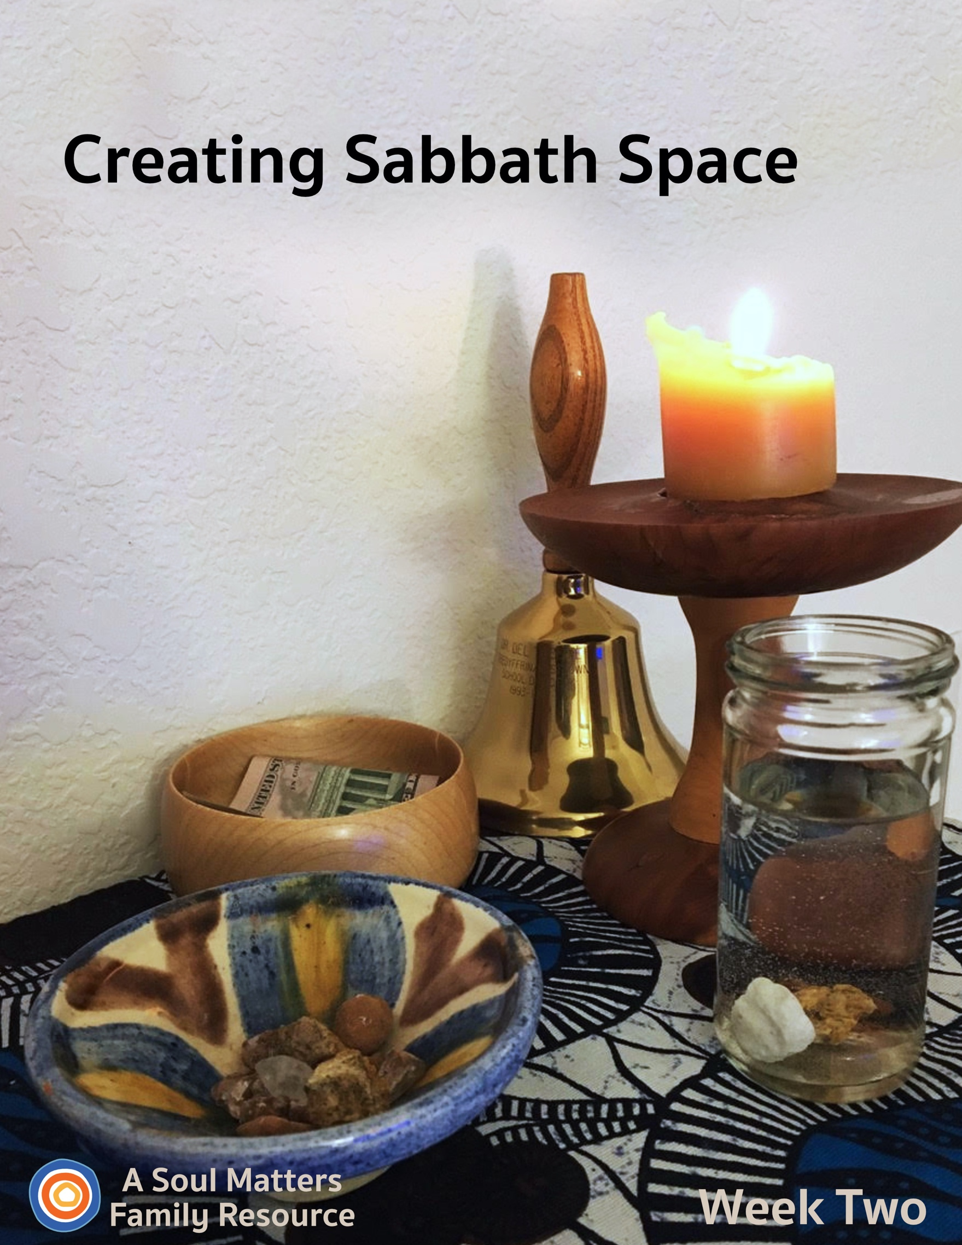

Sabbath Space
Week Two

Introduction

Welcome to Week Two of our “Sabbath Space” adventure.

Each week you will get a packet that includes:
- Guidance for adding 1-2 new pieces of your family home altar, or “Chalice Home” as we also like to call it
- A family worship guide developed celebrate and deepen your connection to those additions to your altar
- A couple of “after-worship” activities to continue your family Sabbath time of connecting and relaxing together

This second week our focus turns to adding an offering container and a gratitudes & grace water glass to our home altars/chalice homes.

Both of these elements remind us that one of the best ways to nurture yourself is to think about and care for others.

We encourage you to find your own special way to lift up this other-center message to your children. It’s also an opportunity to remind them about the overarching aim of our chalice home journey: To build a place that helps us remember what is important, nourishing and sacred in our lives. Keeping these important things in front of us is especially vital during this time of sickness, separation and uncertainty. It’s a reminder that even though we may be cut off from the people and activities we love, we remain spiritually connected to them all the time.

After preparing for and then holding family worship, you are invited to continue your “family Sabbath” with the activities we’ve recommended.

Blessings as you engage this precious work of nurturing the connections that sustain us all.

Building Our Home Altar:
Nurturing Ourselves by Caring for Others

Week 2: Creating Connections to Others in Our Chalice Home

Item One: Preparing to Add Your Giving Bowl

Your Giving “Bowl” doesn’t have to be a bowl. It can be piggy bank you already have, a piggy bank you make, a giving jar or even an offering shoebox. The point is to find or create a meaningful container to put money into each week for an organization or effort your family cares about. Our worship service will invite your children to go and find your offering bowl/box/bank. So if you want to get creative and make your own, you will need to carve out some time beforehand.

Another Task Before Your Sabbath worship: Discuss who the recipient of your family offering will be. If a monetary offering is not an option for your family, you might think of a way to give to and support the recipient(s) in creative ways like:
- a letter of encouragement,
- a chalk drawing of encouragement on a sidewalk,
- or a special greeting to folks on a walk (with physical distance, of course!)
Instead of putting money in your giving bowl/box, just write these intentions on slips of paper and put them into the container.

Item Two: Preparing to Add the Rocks and Water Bowl for Gratitudes and Grace

The Gratitudes and Grace ritual is similar to a “Joys and Sorrows” ritual which some congregations practice during the service. Instead of candles, we invite your family to take turns dropping rocks into a bowl or glass of water. By using the elements of rock and water, the Chalice Home echoes the solidity and fluidity of our gratitudes and grace that we experience.

The first rock is the gratitude rock. As each family member takes turns dropping one or two rocks in the water, they are invited to share something they are thankful for from the past week. It might be a rainbow or a special word of comfort. It might be a warm bed or a moment of understanding they received from someone.

Then a second rock is added for something that is worrisome or someone who is struggling. It’s a way to name the things and people we are holding in our thoughts, hearts and prayers. It might be oneself, or someone who is sick or sad. It might be someone the family knows or a group of people struggling far away.

We encourage the practice of “double rocks,” as desired. That means that if there are further gratitudes and graces of which a family member is reminded during the sharing, then rocks have enough solidity to be taken out of the bowl of water again, and dropped in again with another sharing. The rocks love being part of the ceremony again and again.

For this first Gratitudes and Grace sharing, your child/children will be invited to go and find some rocks as part of the worship service, as well as a bowl to hold them and a bowl or glass of water to drop them into. This is the delight of offering home worship. The gathering and building of the altar by everyone will help each family

member feel connected to the chalice home, as well as invite movement instead of just sitting. Allow it to be imperfect. You can wash the rocks together later, or know how much water to fill next time. It is the building and sharing that is important. For future worship services, you can either re-use the rocks by removing them from your water container or your family can make time during the week to load up on more rocks to add.

Share Your Chalice Home with Other Families
Each week, you are invited to share your ever-growing family altar/chalice home with the other UU families who are building one too. All you have to do is take a picture of your altar and then post it to Facebook or Instagram with the hashtag “#uuchalicehome.” Your church may also be collecting pictures online of the “chalice homes” of your church’s families. Be sure to ask your RE leader about that.

Using your Chalice Home: Not just for Sundays or Family worship.
Besides using it for Sunday morning as the focal point for Sabbath worship, consider using your altar to begin your day. It can be something as simple as lighting the chalice and reading a poem before or after breakfast.

Or try it as a bedtime ritual, closing the day together.

And each person can always visit it whenever they feel the need to center themselves.

Now, it’s time for Family Worship!
Family Worship: Week #2

Use this Worship Guide as is or tweak it to give it your own unique stamp. The ultimate goal is to foster family connection, so think of some creative ways to divide up the worship components. For instance:
- Have the youngest, who is able, light the chalice.
- Have the oldest offer the words of blessing.
- Take turns reading the meditation each week.
- Have the quietest family member ring the centering bell.

Centering Sound
Move from “regular time” to “sacred time” by sounding your bell, chimes, ringing bowl or ringing glass.

Optional words to go with the sound:

“To this quiet place of beauty, we come from busy things
Pausing for a moment for the thoughts that quiet brings.”

Centering Music or Silence

- Option #1 for singing families: STLT #402 From You I Receive by Joseph and Nathan Siegal (Lyrics at https://www.youtube.com/watch?v=k7a0Lei2OCA)
- Option #2 for families who prefer to listen: Play some quiet music (we love Spotify’s Classic Yoga playlist and our own Soul Matters Playlist for coping with Covid-19) or this: STLT #402 From You I Receive on YouTube
- Option #3: a fun song about sharing: https://www.youtube.com/watch?v=60Ki-Mg4WVM (with lyrics)
- Option #4: Silence for 30 Seconds.

Chalice Lighting

“We light this chalice for the warmth of love, the light of truth and the energy of action.”
- Mary Ann Moore

Or use your own or your congregation’s words.
For some extra fun, watch this chalice lighting using claymation, created by Peter Bowden, used with permission, here.

Adding the Giving Bowl
“We drop our coins (papers) in, and fill the bowl. Serving others makes us whole.”

Invite family members to find and add your giving container to your Chalice Home. Then add your monetary contribution for the group or organization you decided to give to (or provide slips of paper and invite family members to write or draw their way to help others on it.)

Adding the Rocks and Bowl for Sharing of Gratitudes and Grace

“We listen to each other, it is a holy act.
To share our joys and sorrows, with grace it flows on back.”

Invite family members to find rocks, at least enough for 2 rocks for every family member. Also find a bowl or glass cylinder filled ¾ of water. And finally a tray or bowl to hold the rocks.

Offer two rounds of sharing. First invite each family member to pick up a rock and share something they are thankful for while dropping the rock into the bowl of water. The aim here is to make room to notice the good things all around us even though times are hard. After this first round of joys and gratitudes, have each family member choose another rock and share something or someone they have a concern for - someone or something they are holding in their hearts and prayers. This is a way to bring the struggles of others into our hearts, maybe a grandparent who is in danger of getting sick or hospital workers who are putting their health at risk for the sake of the rest of us or a group of people around the world who are also getting sick from the covid-19 virus. And don’t forget the rocks love being used in this ritual and they can be used as “double rocks” if there are more gratitudes and thoughts.

Meditation

For the reader: Pause for a few moments after each sentence, allowing enough time for your family members to fully complete the action you are asking of them or the thought you are offering them.

Before beginning the meditation: Find a comfortable place to sit, in a chair, or on the ground if you prefer, or maybe even on a cushion.

Second Week Meditation

With your eyes open, let’s begin by putting your hand on your chest. Now take in and blow out 3 slow breaths and pay attention to your chest as it rises and falls.

Now put your hand or hands on your belly. Again take in and blow out 3 slow breaths and pay attention to how your belly pushes out and then back in.

Now that we are calm and centered, take a look at the rocks we just dropped into the water. Do you remember how they floated down? Do you remember how they decided on their own where they wanted to land?

Sometimes kindness is like that. As we let it loose, we never really know where it will land or how deeply it will touch someone.

Now close your eyes.

Take a moment to think back to a time when someone was kind to you.
Maybe you were sad and someone told you a joke. Maybe you lost something and someone helped you find it. Maybe someone was mean to you and this kind person helped you feel better.

How did it feel to be given kindness?

Some say kindness feels like floating. Instead of sinking down, it holds us up, just like when we lay back in water and float.
Take a moment to imagine yourself floating.
Do you feel the cool water all around you?
Do you feel the warm sun on your face?
In your picture in your head, can you see yourself smiling?

Who else do you want to smile? Who do you know is sad and you hope feels better?

A lot of people are sad right now because of the coronavirus.
Take a moment to imagine all those doctors and nurses and ambulance drivers that are taking care of those people who are sick.
Picture them standing together.
Now imagine them slowly starting to smile, happy because people are starting to get well.

Now imagine people in hospital beds starting to get well. Picture them with smiles on their faces too.

Lots of parks and streets and schools are empty right now. Use your imagination to picture those parks and streets and schools filling up again.
Can you see people smiling? Can you see them have fun together?

Now pay attention to your mouth. Are you still smiling?
Notice how it feels to smile.
Notice how your lips curl upward and seem to touch your cheeks.
Notice how your forehead is relaxed and your eyelids feel light.

Now on the count of three, let’s repeat three times, “May the whole world be happy and safe.”

1,2, 3… “May the whole world be happy and safe” “May the whole world be happy and safe” “May the whole world be happy and safe”

Now slowly open your eyes.
And take a moment to look around at your family and give each of them a smile and wink.

Amen

Setting an Intention

As you bring worship to a close, pause for a moment to think ahead about the coming week and make an intention/promise for how you want to act, what you want to remember or how you want to treat others.

Here’s this week’s prompt for your intention/promise:

“In the coming week, I will ___________________ to be of service to others and grow my own self.”

Have each family member take a turn filling in the blank to the sentence.

Words of Blessing

Spirit of Life,
Accept these gifts from our hands.
From you I receive, to you I give.
Together we share, by this we live.*
May we feel the nourishing connection between us.
Blessed be. Amen.

*Inspired by hymn #402 in Singing the Living Tradition

Extinguishing the Chalice

“We gather the warmth of love, the light of truth, and the energy of action into our hearts.
Back into the world of do and say, carry it forward into the dawning day.
Go Now in Peace, Amen.”

View Katie’s YouTube video demonstrating how to add gesture to these words: https://youtu.be/GEF4Hdm08oM
Instructions: Use your hands in a gather/cupping gesture and bring them to your heart. Repeat after the “warmth of love,” “the light of truth,” and the “energy of action.”
Family Sabbath Activities
Sabbath is the idea of setting aside time for rest and connection with each other. It is a time of remembering and paying attention to what really matters, and the people in your life that really matter. So here are some activities to help you lean into the joy of just being together!
Sabbath Activity One: Secret Service

This is a 24-hour challenge for each member of the family to give of something they absolutely have in abundance--caring. Challenge each person to surreptitiously do one small act of kindness for each other member of your family. They might offer the bigger portion of a shared, favorite food item; write or draw a sweet note of appreciation and place it on another person’s pillow; or pick up and put away something that the other person had left out. Younger children might need help with their tasks, but will doubtless love the sneaking-around part. If you like, at the next meal you share together after 24 hours, each person can “fess up” about their good deeds, and share how it felt to offer one another service and caring during the previous day.

Sabbath Activity Two: Home Cairns

Have you ever been out in nature, maybe near a river or a path through the woods, and noticed stacks of rocks? One word for those stacks of rocks is “cairns.” Sometimes, park rangers, trail maintenance crews, and others put those stacks there to communicate to other travelers that at the cairn, the traveler needs to pay special attention; for example, maybe the path takes an unexpected turn there. The cairns help people not get lost. However, it has become very popular for anyone who feels so inspired to make a rock cairn along a trailside, or at a pretty spot out in nature. Park rangers discourage us from doing that, because it confuses the message or warning a thoughtfully placed cairn might offer. Also, many of us go out in nature to experience a space that is not crafted by our fellow humans. Stacks of rocks in a scene that was already beautiful, just as it was, can be intrusive to another’s hoped-for experience of nature.

But, rock stacking at home can be great fun! In your own space, with rocks, glass pebbles, or even blocks or other toys, make stacks as high as you can, or as artfully as you can, or in as unexpected a place as you can think of. You can make a family cairn at the entrance to your home, or one on a sunny windowsill. You can mix and match the items that you use. Or you can simply make one while at a table, and take it down again when you’re finished. (This is a good practice to do outdoors, too!)

Sabbath Extras
- Spend a little more time with the fun song about sharing and see if you can learn it: https://www.youtube.com/watch?v=60Ki-Mg4WVM (with lyrics)
- Here’s another sweet tune that will put a smile on your face. Watch together at:
https://www.youtube.com/watch?v=SJM-u6IABGQ&feature=youtu.be&fbclid=IwAR0U4nrDbbYfKpaAbVtoq8qbdNutUnifkYQUwh0c4-hzghUoU-qAGJFA44k
- Take turns reading aloud these true stories of kindness and generosity https://www.rd.com/true-stories/inspiring/extraordinary-generosity/

Cover photo is of Katie Covey’s personal chalice home.
The chalice was made for her by her father, Del Tweedie, from a Juniper branch.
The school bell was given to her father for his service on the Tredyffrin/Easttown School Board in Devon, PA.
The wooden Giving Bowl is another of Del’s creations on the lathe.
The glass container is a recycled spice bottle!
The striped rock bowl is an olive oil dish from Barcelona which their daughter brought home for them.

Share This Packet!
Feel free to share this packet as our gift to any UU congregation or other faith community to support their work of caring for so many during this pandemic.

© 2019-20 Soul Matters ALL RIGHTS RESERVED

Learn more about Soul Matters Congregational resources at
http://www.soulmatterssharingcircle.com
Check us out on Facebook or Instagram.
We also have song playlists on Spotify and YouTube

