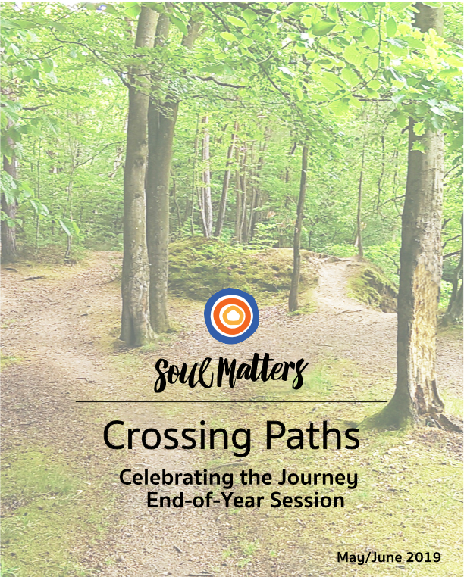

CONTENTS

 | Welcome |  | 2
 | Final Session |  | 3
 |  | What We Want to Take With Us,  Part One: “What Stuck” | 6
 |  | What We Want to Take With Us  Part Two: “How We Walked Together” | 9
 | Alternatives and Add Ons |  | 13
 | Handouts
 |  | Handout #1 - Pin the Paths on the Mountains – Paths | 14
 |  | Handout #2 - What Sticks to Your Life Journey | 16
 |  | Handout #3 - 8 Welcoming Practices and Themes | 17

Welcome to the End… It’s Just the Beginning !

Welcome to the Crossing Paths Closing Session and the celebration of where we have been, and where it will take us.

We’ve been on quite an adventure! Our journey has introduced us to 9 different faiths and taken us along the path of 9 monthly themes. Often review sessions like these focus on rehashing all we’ve learned. Our approach is different. Instead of just reviewing the new information that’s been placed in your heads, we focus on how you’ve been personally changed. It’s about identifying the gifts you’ve received and discerning how they might stay with you in your journey ahead.

To do this, we invite you to play with the metaphor of things sticking to you. Through reflection questions and fun activities, we ask the youth “What stuck to you?” and “What do you want to keep a tight grip on for the rest of your lives?” Maybe your youth will develop a meditation practice. Or cultivate an attitude of simplicity. Maybe they are inspired to create a worship service featuring a rock band or organize a UU pilgrimage for youth and adults alike. With this session you will get a glimpse of how your youth’s faith may be forever changed. And all because of this journey you went on with them!

Some process notes: Get ready to have fun! In particular, brace yourself as a facilitator for the “Cheetos Toss” game. You can thank us later. :-)

Also get ready to be serious. The session is filled with fun and games, but right alongside that are sacred moments when the youth are invited to share how this experience has altered their living and loving.

On this note of shaping lives, we hope you take some time as facilitators to feel and appreciate the great gift you’ve given your youth. Facilitation is a significant ministry. You’ve mid-wifed meaning and helped the youth have experiences unlike anything they get in the other parts of their lives. What a privilege! What a gift! We thank you and are so grateful you’ve let us be a small part of that.

Katie & Scott
Katie Covey - Soul Matters Director of Religious Education
Rev. Scott Tayler - Soul Matters Team Lead

Final Session

Purpose
- Review and share what impacted us most
- Express gratitude for sharing the journey

Preparation & Leader Notes

Dinner and Drive Time Tips (Email to parents prior to the meeting):

Before:
- Talk with your youth about the 8 practices of welcoming and the monthly themes we covered. In our meeting, the youth will be asked to pick one of the practices that they most want to “carry with them” and one theme that best captures a quality they want to live into. Encourage them to think about this ahead of time and reflect on it with you. The list of practices and themes is attached to this email. (attach Handout #3)
After:
- Have your youth show you their tattoos. They represent the practice and theme they picked. Also ask them about the “Cheetos Toss” game. Be careful if they tell you they’d rather show you rather than explain it to you!
For You:
- Be prepared for the session to last 20 minutes over the hour.
- Join us for the family gathering time after our session. [Leader note: use this space to ask them to bring food or money to help with lunch]

Pre-Session To Do List:
- Send out the Dinner and Drive Time Tip. See above.
- Be prepared for this session to last 20 minutes over the hour.
- Create this week’s graffiti board. Core question: What is your favorite thing about the religions we have explored??
- Make sure you have the technology needed to play the YouTube videos that are part of this session.
- Make copies of Handouts
  - #1 Paths (one copy to cut up)
  - #2 What Sticks to Your Life (one per person)
  - #3 8 Practices and Themes (one per person)
- Prepare the “Pin the Religion on the Mountain” game.
- Prepare the “Cheetos Toss” Game. (Cheetos, shower caps, shaving cream, tape)
- Choose your Tattoo options and gather supplies.
- Set up the “Many Mountains, Many Paths, Many Tacos” Family Celebration, optional (request family volunteers)
- Invite a guest who knows how to create designs with henna, optional.
- Create a scrapbook or slideshow of photos from the year, optional. (Request a volunteer.)

Session

Entering - Graffiti Board Writing
As youth enter the room invite them to engage the graffiti board a final time. Encourage symbols, words, drawings. This time the graffiti board question is about the year-long journey itself. Explain to the youth they can write words that express how they feel about the year, draw images of their favorite moments or sketch symbols of their favorite religions.

This Session’s Core Question:
What is your favorite thing about the journey we’ve been on together?

Centering - Worship (10 minutes)

Preparation: Buy and be ready to hand out pipe cleaners. They will use them to re-create one of the favorite fun moments.

Centering Sound
Invite everyone to calm and center themselves. Use whatever ringing vessel you have chosen (chimes, bowl, bell.) Ring the bell/bowl/chimes. Once the sound ends, pause for a moment of silence and then end by saying “Amen” or blessing words of your own.

Lighting the Chalice
“We light this chalice in gratitude for the path we share, a path that guides us
back to our deepest self,
back to each other,
And back to life’s gifts and joy.”

Welcome
Suggested welcome script:

“Welcome to our last session together. We’ve been on quite a journey. Today we’re going to reflect on the gifts we received from our time together and share which aspects of our journey we want to integrate into our lives. In other words, we’re going to explore what we want to carry with us.

During the time we shared, we learned a lot, and we’ve had a lot of fun. Our centering song captures that feeling of fun and joy. As we listen, let’s think of a time during our sessions or visits when you had the most fun. And don’t just think of it, re-create it! Here’s a bunch of pipe cleaners for you to re-create that favorite fun scene of yours.

Music For Centering (two options to choose from)

Happy - C2C / Keone & Mariel Madrid Choreography/ URBAN DANCE CAMP
https://www.youtube.com/watch?v=h_bX0T76X8U

Happy - Pentatonix (Pharrell Cover)
https://www.youtube.com/watch?v=uJ4diEohODE

Thematic Check-in
Invite the group to share the time they had the most fun, and their pipe cleaner sculpture of it.

Closing Words
“In the rest of our time together and in the days ahead, May the ropes be with us. May we stay close to our inner and truest selves. May we keep connected to each other. May we remember to lean into life’s joy. Blessed be. Amen”

Extinguish the Chalice
Leader’s note: Extinguish it now if you have an open flame which, if left lit, might cause an accident or be the focus of pyro-play. Extinguish it during the final closing if you are using a tea light.

What We Want to Take With Us - Part One (35 min.)

“What Stuck?”

Introduction

This first set of activities is designed to help the youth reflect on which aspects of their Crossing Paths experience they most want to remember and integrate into their lives. It is divided into three sections, focusing on the religions, the 8 practices of welcoming and the monthly themes. Again, we encourage you to use the metaphor of things sticking to you.

Suggested Leader Script:
“We’ve studied a bunch of religions. We’ve also used our 8 practices of welcoming and explored our congregation’s monthly themes. Like other adventures in life, some parts of the journey stick with you (and sometimes “on” you) more than others. That’s what today is about: deciding what stuck with us the most and what we want to hold onto and ensure sticks to us we move forward in life.”

The Knowledge that Stuck with Us Most (10 min.)

Explain

Knowledge of each religion is one of the central things that will stick with the youth. To remember all the religions that were covered and to test their knowledge of the religions studied, invite the youth to play again the “Pin the Religion on the Mountain” game that they played all the way back in the first session.

Engage: “Pin the Religion on the Mountain”

Pull out the paper paths you cut out ahead of time from Handout #1. Invite the youth to draw nine mountains on a chalkboard, whiteboard, or paper and label them with the names of the nine regions you have explored:
Hinduism
Judaism
Christianity
Buddhism
Islam
Unitarian Universalism
Megachurch
Quaker

Pick nine youth or ask for nine volunteers. Have them turn their backs to the mountain pictures and then give each youth one of the slips of paper that have the religious problems and solutions written on

them (“The Paths” from Handout #1). Explain that the goal is to pin the problem and solution path to its corresponding religious mountain.

After giving them the strips of paper and explaining the goal, take them one-by-one and blindfold them and twirl them around 3 times. Then send them off on their journey as they try to pin (or tape) the path they are holding on the correct mountain. Invite the other group members to help by shouting out directions.

After they are all done, take the blindfolds off and note how the strips are not perfectly pinned in the same place on each mountain or not on the right mountain at all. Invite all the youth to work together to place the paper paths on the correct mountain.

Note that the imperfect placement reminds us that our understandings of other religions are always “a bit off target” and not “on the mark.” Which means humility and on-going exploration is important. We’ve all still got a way to go. We always need to remain open to “course corrections.”

2. The Religious Practices that Stuck with Us Most (15 min)

Explain

During Lake Sundays, we reflected on the practices of each religion and asked the youth how they wanted to integrate similar experiences into their lives. Invite the youth to do this again by sharing Handout #2 and asking them to check off all the practices they are interested in having stick with them.
Use the below activity to add a bit of fun to the effort!

Engage - Cheetos Toss Game

Distribute Handout #2 to each person.
Describe the game first so the participants know how many Cheetos they can collect.
Suggested script: “We, your leaders, will wear a shower cap, covered with shaving cream. Your goal is to toss and have stick as many Cheetos as you can into the shaving cream on our heads. You will be placed behind this line (create a line of tape fairly close by, since Cheetos don’t throw far.)
Here’s the rub: You only get as many Cheetos as the number of practices you check on the “What Will Stick to Your Life Journey” chart. Your reward? The pleasure of this crazy game! If there are any Cheetos left in the bag, we can eat them.

3. The Welcoming Practices and Themes that Stuck with Us Most,

and Made the Biggest Mark (10 min.)

Explain

Let the youth know that you hope they will carry all of the 8 practices of welcoming and the monthly themes into their daily living. Remind them that the goal of the 8 practices and themes was to “leave a mark on them.” Use the below activity to help them share which of the 8 practices and monthly themes most “left an imprint.”

Engage

Suggested Leader Script:
“Our 8 practices of welcoming and our monthly themes have been important aspects of our journey together this year. The 8 practices not only helped guide us on our visits but also will serve as tools when we engage others and encounter diversity. The monthly themes also helped us think about what kind of people we want to be and what values we want to develop in ourselves. In other words, the 8 practices and themes have left an imprint on us.

To honor this, we are going to take some time to each name one welcoming practice and one theme that influenced us the most. And to symbolize the way they have made a mark on us; we’re going to use henna ink (or other option) to give ourselves tattoos that represent our choices.”

Process Instructions: Tattoos
Distribute Handout #3 “8 Practices and Themes” to each person.
Invite them to circle one from each list that has most made a mark on them.
Invite them to create a design on scratch paper, then draw it on their skin. It may be a symbol or a word, or both.
Tattoo Options
Choose an option below.
Henna Tattoos
- Make sure to use natural henna without chemicals, such as Henna Cones and test on each person’s skin to make sure there is no reaction.
- If there is a youth or adult in the congregation with experience drawing mehendi or designs, invite them to help the group.
- The henna should dry completely before being washed off.
Marker Tattoos
- Use washable markers to create symbols, words or designs and draw on the skin.

Alternative Option for those not wanting to use tattoos:
Hand Motions Game
- Have everyone move into a circle. Anyone can begin the game by saying their name and demonstrating a [physical] motion to go with it representing their favorite theme and practice. i.e. My name is Katie. I am a person of “creativity” (she makes a flying motion with her hands) and I practice “lightheartedness” (hands over heart.)
- When the person is done, the entire group repeats back their name and their two motions, i.e. You are Katie. You are a person of creativity (make a flying motion with their hands and you practice lightheartedness (they put hands over heart.)
- Then, the second person (on either side of the first) introduces themselves and does two motions. The entire group repeats that name/motions and then the first name/motions. This will continue until each person has given their name and done their motion, and the entire group has repeated everyone’s name and motions.

What We Want to Take With Us - Part Two (25 - 35 min)

“How We Walked Together”

Introduction
Part one focused on what we studied and learned. This second set of activities focuses on how we went about this journey of learning. It’s about celebrating the way we walked together. The below activities lift up five key characteristics of our Crossing Paths approach and the reminder that goes with those characteristics.

Explain to the youth that this next set of activities celebrates HOW the group journeyed together, focusing on five key characteristics of how you traveled together. Also explain that they will repeat the phrase “We did it…!” as a way of playfully lifting up each characteristic. Tell them you hope all of their journeys will have some of these characteristics.

1. We did it… TOGETHER! (5 min)

Explain

Talk about all the ways community and friendship were important to this year’s journey. Highlight and honor the support, respect, encouragement and safe space that the group members offered each other. Note that life is the same. Just as we needed each other to make the Crossing Paths journey, nobody makes it through life’s journey alone. We need each other as we face challenges and new experiences. To help remember this, invite them to play the “Human Knots” game.

(Remember to name the youths’ families and church community as key partners on their journeys.)

Engage: “The Human Knot Game”

To play the human knot game, start by moving into a circle with your hands by your sides. Then, have everyone grab someone else's hand in each of theirs, and make sure no one grabs their neighbor's hand. Double check that no one is holding the same person's hands twice. Once you've done this, you should have a giant knot. Take turns moving and bending until the group untangles the knot together. And remember to never let go of each other’s hands!

More info: https://www.wikihow.com/Play-the-Human-Knot-Game

2. We did it… WITH FUN! (5 min)

Explain
Talk about how much fun you had with the youth and how fun and play are important to learning. Share a couple examples of your favorite fun moments. To honor your hope that they remember to always include fun with learning, invite them to think of times that were fun for them personally and times when the group laughed together.

Engage
Invite the youth to share memories of when they laughed and had the most fun together.

3. We did it… BY LISTENING CAREFULLY! (5 min)

Explain
Lift up the many ways listening played a key role during the year, such as:
- Listening with respect and confidentiality to each other and thus providing each other with safe space (listening with care)
- Learning appreciative inquiry skills (listening with curiosity and gratitude)
- Learning to respond to different opinions with curiosity rather than argument/debate
- While listening, letting other people’s stories remind you of your own memories rather than not really listening and just waiting for you chance to interrupt and talk.
Stress what a gift it is to have people listen without judgement and feel heard.

Express you hope that they will continue to offer careful listening and help others feel heard. As a way of celebrating and committing to this, play the following game.

Engage: “Whisper Down the Lane” (aka “The Telephone Game”)
Here’s a classic game that requires very careful listening!
How to Play (adapted from https://icebreakerideas.com/telephone-game/ ):
Getting Started: Players must sit in a circle or line up in a straight line. They need to be close enough that whispering is possible, but not so close that players can hear each other whisper.
Begin the Game: The first person in the line or circle whispers a phrase into the ear of the person to their right.
The Game Continues: Players whisper the phrase to their neighbors until it reaches the last player in line.
The Conclusion: The last player says the phrase out loud so everyone can hear how much it has changed from the first whisper at the beginning of the circle or line.
Additional Rules: The word or phrase can only be whispered once, so players must pay close attention. Only one player – the first – should know what the phrase is. The facilitator of the game may wish to have the original phrase or word written down. The phrase should never be a too familiar; you want to make sure it changes as it is whispered. It helps to make up silly or nonsensical phrases such as: guppy in a shark tank; candy crunching coconut lovers; red roses with thorny stems; door knobs and door jambs with hasps and hinges.

4. We did it… BY BEING OPEN TO CHANGE! (10 min or 2 min)

Explain:
The point of Crossing Paths is to help us grow. So being open to expanding and changing our minds was very important. Stress that Unitarian Universalists believe that growth happens best as we explore ideas different than our own and allow them to change and deepen us. As humans, we don’t like change. But our faith pushes us to see change as a gift.

To remember and honor this, play the following game.

Engage: “Honey If You Love Me, Won’t You Please, Please Smile?”
This game invites the group to try keeping a straight face and not change as others try to make them change by using silly phrases. Because of the silly phrases, it is slightly embarrassing and causes discomfort. That is an analogy for how we must endure discomfort as we open ourselves to change.
The group starts in a circle with one person in the middle. This middle person tries to get others to laugh by stepping in front of people and saying, “Honey if you love me won’t you please, please smile.” The person on the outside must respond without smiling or laughing saying, "Honey, I love you, but I just can't smile." The person in the middle can do various things, without touching anyone, to get another person to smile. If the person does smile, then they will become the center person.
Alternative Game (if you have less time): Here’s a quick game/illustration about honoring the hard work of change. Invite the group to “Cross their arms” - folding their arms together, as if they were bored or waiting for something. Once they have completed this task, ask them to fold their arms the other way, reversed of what they just performed. It is a struggle!
When people cross their arms, they do so naturally, without even thinking about it. When they are asked to fold them the other way, they, for the most part, stop, refold their arms again and then try to figure out which arm was on top, which arm moves first and so on. Changing is hard! Adapted from https://www.isixsigma.com/training/training-materials-aids/change-game-engaging-exercises-teach-change/

5. We did it… AS UNITARIAN UNIVERSALISTS! (10 min)

Explain

Suggested Script:
“We’ve spent the year not just exploring other religions, but also deepening our relationship with our own religion. As our Chalice Lighting and Closing Words reminded us each week, our UU faith is about helping us reconnect with our deepest self, each other and life’s gifts. I hope our time together has not only helped you experience moments of connection but also inspired you to help heal the disconnections, divisions and isolation you see out in the world.

I’ve loved the metaphor of ropes we’ve used. I hope you will keep your thin rope, representing the connection to your deepest self (* as suggested - parachute cord on a carabiner for their backpack) and let it remind you of our time together. And because the idea of ropes and connection have played such a central role in our journey, I want to invite us to use them as we finish up our time together.”

Engage
Use the long rope or bring in a long rope for this reflective exercise. The rope needs to be long enough so that it will outline the circumference of the circle of participants.

Invite the youth to think of a time during their Crossing Paths journey when they felt most connected to themselves or each other.

Have the group sit in a circle and take turns sharing their most connected moment by finishing the sentence: “I am grateful for our time together and I felt most connected when…”

Have the first person that shares, hold the end of the rope as they share. After they share, have them pass the end of the rope to the person sitting next to them but also have them continue to loosely hold on to the rope, so that as youth share the rope follows everyone around the circle and in the end leaves everyone holding the rope and being connected by it.

Finish the reflection by sharing any final comments or gratitude you have. And then, while everyone is still holding the rope, read the Closing Words.

Closing Words
“In the rest of our time together and in the days ahead, May the ropes be with us. May we stay close to our inner and truest selves. May we keep connected to each other. May we remember to lean into life’s joy. Blessed be. Amen”

Extinguish the chalice if you haven’t done it earlier.

ALTERNATIVES & ADD-ONS
The below options can be used as alternative exercises to those
above or as add-ons if you have longer meeting times.
Consider a longer time for this final session in order to celebrate with the families.

Eating! - “Many Mountains, Many Paths, Many Tacos!” Family Celebration

Invite the group and their families to celebrate the diverse journey you took by “eating your way up the mountains!” Playfully compare tacos to the “religious pluralism” approach we took to the religions we explored. Tacos have many parts; so do religions. And those components differ radically depending on the one building the taco. For instance, there are many kinds of shells (hard, soft, flat) and many kinds of filling (beef, chicken, tofu). All religions have similar components (view of the divine, sacred stories, founders, rituals), but each of those components radically differ. All of it reminding us that every taco - and every religion - is unique in and of itself.

Head to the kitchen to eat the tacos.

Here are some additional notes to help you play with the idea of tacos representing religious pluralism. Have fun with it! But be careful not to do too much teaching. Make the general point and then let this mostly be a time of fun and connection.

Shells = Each religion’s understanding of the problem and the path.
- Just as there are a variety of shells (hard, soft, corn tortillas, chips), there are a variety of views about the problems in life and the solutions to those problems. Separation/Connection for UU; Self-sufficiency/Submission for Islam; Sin/Salvation for Christianity; Suffering/Nirvana for Buddhists; Wandering/Liberation for Hinduism; Exile/Return for Judaism
Fillings = Divinity
- Multiple types of filling (beef, chicken, veggie, tofu). Also many views of divinity: One God for Muslims, Jews and Christians; No God for Buddhists; Many Gods and Goddesses for Hindus; Your Choice for UU’s.
Toppings = Sacred Texts, Rituals, Clothing, Etc.
- UU’s - many texts; Hindu - Vedas and Upanishads; Christians - Bible; Jews - Torah; Muslims - Quran and Hadith; Buddhists - Tripitaka (Pali Canon), Mahayana Sutras and the Tibetan Book of the Dead
- Buddhist - saffron robes for monks; yarmulkes for Jews; Hijab for some Muslim women; sari for some Hindu women; Casual for many UU’s
Sauces = Key People, Founders, Exemplars
- Buddha for Buddhists, Jesus Christ for Christians, Muhammad for Muslims, no one founder for UU’s and Hindus, Abraham for Jews.

Scrapbook or Slideshow
If you have been collecting photos throughout the year, as suggested, take some time before this last meeting to create a scrapbook or slideshow. Online companies, like Shutterfly, offer photo album software. Or you might invite a parent volunteer to create the scrapbook. You can create a digital slideshow using Google Slides, Prezi, or PowerPoint. (Consider projecting it during the Taco Bar!) Save the slideshow link and invite congregants and other family members to view it at home or show it in worship to the rest of the church community. Be aware of photo permission and refrain from including the names of the kids in any captions, for online distribution.

We would love to have photos and slideshows to share with the larger Crossing Paths and Soul Matters community. If you are willing to get the needed permissions, we’d love to have you share it with us!

Handout #1

Pin the Paths on the Mountain - Paths
Use the wording below to make your own nine larger strips of paper, one strip for each mountain/religion. The idea is for each strip of paper to contain the “problem,” “solution” and the symbol, with enough space on the top of the strip for tape so the strip can be stuck to the wall. Do not include the name of the religion on the strip. Make these “path strips” as simple or fancy as you like. You can make it even harder by not including the symbol.

Unitarian Universalism

Separation → Connection

Judaism

Exile → Return

Christianity

Sin → Salvation

Buddhism

Suffering → Enlightenment (Nirvana)

Islam

Self-Sufficiency → Submission

Hinduism

Wandering (Samsara) → Liberation (Moksha)

Megachurch

Personal Sin → Become Born Again

Quaker

Disconnected from Inner Light → Stillness & Silence

Handout #2 - What Will Stick to Your Life Journey?
Place a check next to each practice you think will stick in your life or that you hope sticks with you on your life journey. In other words, which of the practices we explored do you want to remember and do in a similar way.

Islam
___ Find a phrase that helps you be grateful more often, similar to the way Muslims say “Bismillah” before an important action or activity.
___ Fasting and remembering those less fortunate as a spiritual practice.
___ Set aside a percentage of your allowance or birthday money for those less fortunate like Muslims do with the practice of Zakat.
___ Go on pilgrimages like the Muslim practice of Hajj.

Quaker
___ Spend more time in silence listening for your “inner voice” and “inner light.”
___ Honor the wisdom of the group by using the practice of consensus.
___ Add simplicity to your life.

Buddhism
___ Practice meditation regularly.
___ Eliminate extremes in your life like Buddhists do with their practice of the “Middle Way.”
___ Place compassion high on your list of values.
___ Pay attention to the “strawberries” in your life, from the story of the Tiger and the Strawberry.
___ Try not to be so attached to and worried about specific desires and hopes.

Megachurch
___ Find or help create worship services that have large group experience and rock band music.
___ Get more comfortable with telling people about your UU faith and inviting them to come to church with you similar to way Evangelicals do.

Hinduism
___ Think about life as being full of many Gods (many different kinds of holy forces).
___ Develop a chanting practice like the Hindu OM chant
___ Use statues or tokens (like the statues of Ganesh the elephant God or Hanuman the monkey god) to remind you of important things.

Christianity
___ Get better at admitting when you do something wrong and working to change your behavior similar to the way Christian think about repentance as “turning away.”
___ Do a better job of keeping your eyes out for a way to heal the world every day, as in the parable of the Good Samaritan.

Judaism
___ Practice one day “to do nothing” and put down worry similar to the Sabbath idea of rest.
___ Do a better job of keeping your eyes out for a way to “repair the world” everyday similar to tikkun olam.
___ Do a better job of using humor to get you through hard times.

___ TOTAL. Count up your check marks and grab that many Cheetos!

Handout #3

The Eight Practices of Welcoming Difference

&

Our Themes

Eight Practices

1. Be fully present
2. Be curious
3. Be open to being changed
4. Be comfortable with discomfort
5. Be an appreciative listener
6. Be light-hearted
7. Be gentle (allow and heal mistakes)
8. Be yourself

Themes

What does it mean to be...

September: A person of Vision

October: A person of Sanctuary

November: A person of Memory

December: A person of Mystery

January: A person of Possibility

February: A person of Trust

March: A person of Journey

April: A person of Wholeness

May: A person of Curiosity

Crossing Paths Authors:

Katie Covey, Director of Religious Education, Soul Matters Sharing Circle

Rev. Scott Tayler, Team Lead, Soul Matters Sharing Circle

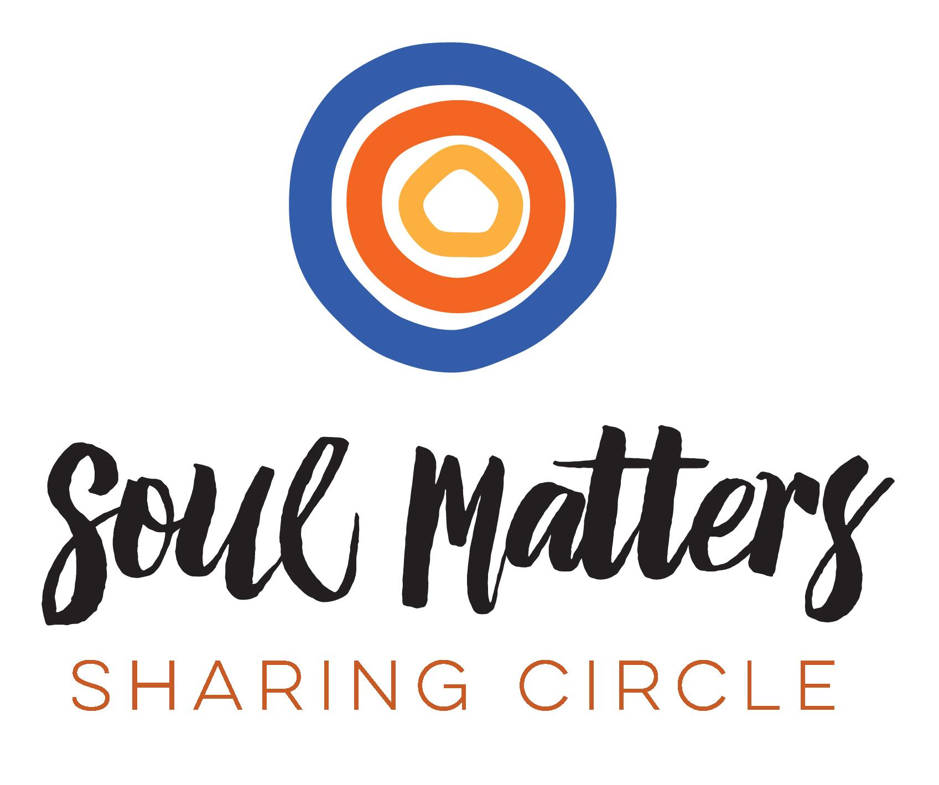

© 2018-19 Soul Matters ALL RIGHTS RESERVED

Crossing Paths is for use only by congregations who have purchased
the curriculum from Soul Matters.

