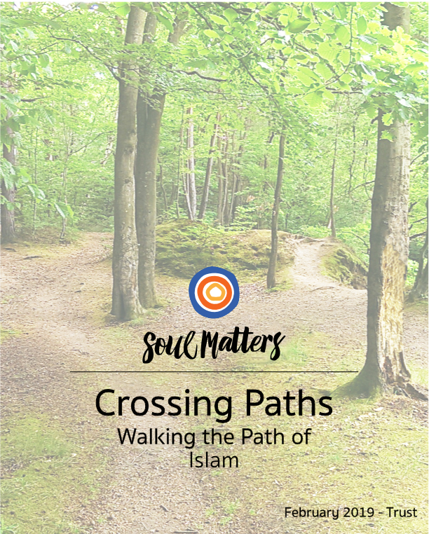

CONTENTS

 | Welcome |  | Page 2
 | Weekly Sessions
 |  | Map Sunday  Getting a View of The Terrain - Islam | Page 3
 |  | Tack Sunday  Islam & The Theme of Trust | Page 14
 |  | Summit Day  The Visit | Page 25
 |  | Lake Sunday  Reflecting on The Visit | Page 29
 | Handouts
 |  | Handout #1 - Arabic Letters | Page 34
 |  | Handout #2 - Guessing Game | Page 35
 |  | Handout #3 - 8 Practices | Page 37
 |  | Handout #4 - Interview Questions | Page 38

Welcome

Welcome to the Crossing Paths packet for February and our exploration of Islam. In addition to exploring Islam, this packet engages our youth with February’s theme of “What Does it Mean to be a People of Trust?”

As we developed the packet, we especially appreciated the opportunity to understand the contributions of Islam to Western Civilization during its Golden Age during the 8th - 14th centuries. We hadn’t realized how the Moors introduced hospitals, universities, surgery, optics and more to Europe. Islam and its gifts were a major force that helped Europe out of the Dark Ages. While it’s not as well-known as it should be, Islam kickstarted the Renaissance! We feel grateful to pass on this learning to our youth since it powerfully challenges the negative stereotypes about Islam as a force “out to destroy culture.”

A major part of this month’s session focuses on the Five Pillars of Islam. This provided us with a wonderful opportunity not just to connect with our monthly theme but also to explore the fascinating similarities between Islam and UUism. We hope that, like us, these similarities help you see our faith in a new and deeper light.

Thanks, as always, for letting us be your partners and walk these journeys with you in spirit!

Katie, on behalf of the entire Soul Matters team
Katie Covey
Soul Matters Director of Religious Education
soulmattersre@gmail.com

Week 1

Map Sunday

Purpose
- Introduce youth to some of the basic beliefs and practices of Islam, using our Crossing Paths’ binoculars/lenses

Leader Preparation & Notes

Remembering Humility
As always, remember that the aim of Map Sunday is to “get a glimpse” of each religion. There is no way to capture the fullness of these rich religions in a session or two. So as a leader, you will need to help your youth remember that there is still a lot about each religion left to explore and we need to be humble about what we are learning. It might be helpful to remind your youth about our second practice of welcoming: “always be curious” - i.e. always be open and never assume you understand something fully.

Islamic Contributions to Civilization
This month provides an opportunity to counter messages about Islam as a religion of destruction. Muslims continue to endure the painful injustice of being labeled terrorists and having their religion painted as violent and wanting to destroy other ways of life and “civilizations.”. This session provides an antidote to this unfair characterization. In contrast to the negative images out there, we explore the tremendous creative contributions of Islam to western civilization. The Islamic “Golden Age” was an amazing time of creativity in the arts and sciences.

Background:

Top Two
- British Muslims condemn London attack
https://www.youtube.com/watch?v=tTKfBMWebGE
- Creativity and Islam
http://mvslim.com/weve-all-got-talents-creativity-in-islam/

Digging Deeper
- This Ramadan See without Labels (creative Coke ad)
https://www.youtube.com/watch?v=84OT0NLlqfM
- Clever Pepsi Ad for Ramadan (not to be outdone!)
http://www.adweek.com/creativity/pepsis-clever-multiscreen-ramadan-ad-unfolds-across-3-phones-at-once/

Background Resources
These short videos and articles are recommended background information for leading the session and grounding yourself in Muslim history and core beliefs. If you want an even broader exposure to the tradition, you can read ahead and explore the Leader Background Resources in the other sessions.

Top Two
- A Successful Day at a Mosque with Zach Anner
https://www.youtube.com/watch?v=8irL7tDORXY
- Introduction to Islam/Belief/Oprah Winfrey
https://www.youtube.com/watch?v=wgP_OSOS3IA

Digging Deeper
- How Islam Began - in 10 minutes
https://www.youtube.com/watch?v=PDxKxnVZtgo
- Islam - with Stephan Prothero
https://www.youtube.com/watch?v=1FfKN2Sf7Ac
- FTD Facts: 11 Surprising Fact about Islam
https://www.youtube.com/watch?v=ZPu4NL43jXI
- Exploring Islam with Children
https://www.uuworld.org/articles/exploring-islam-children

Dinner and Drive Time Tip (Email to parents ahead of time):

Before:
- Watch the below video with your youth and discuss your reactions. What did you learn? What surprised you about the Muslim religion? How were you challenged or intrigued?
  - A Successful Day at a Mosque with Zach Anner
https://www.youtube.com/watch?v=8irL7tDORXY

After:
- In our worship time this week, we will explore how Muslims invite Allah(God) to guide and be present in their actions using the phrase “Bismillah” before those actions. It’s a means of acting more intentionally and with your values front and center. Learn more here ( https://www.youtube.com/watch?v=oimOhjmyyOI -minutes 1:50-3:13) and here (https://www.youtube.com/watch?v=Kdt-miOhGwI) . Engage your youth in a discussion about the ways you’ve centered yourself before important actions or decisions. Ask them what they thought of the practice of reciting Bismillah.

Invite your youth to share some of the Islamic contributions to Western civilization we will learn about. They will play a Guessing Game. We’ve invited them to play it with you. Ask if they brought home the game page and have them lead you through the guessing game.
- Learn about the life of Muhammad. Each of these cartoon biographical stories about Muhammad is about 10 minutes long. The group will watch the first with suggestions to watch the remaining ones at home if they are interested. Or find the book Muhammad by Demi to read.

Prophet Muhammad(saw) Part 1: https://youtu.be/WEEORXFj-lo

Prophet Muhammad (saw) Part 2: https://youtu.be/LO3WUk1b7fk

Prophet Muhammad (saw) Part 3: https://goo.gl/mtzZ8Z

Prophet Muhammad (saw) Part 4: https://goo.gl/iA1uED

For You:
Spend some time expanding your own understanding of Islam. Here are some great places to dig in:
- FTD Facts: 11 Surprising Fact about Islam
https://www.youtube.com/watch?v=ZPu4NL43jXI
- Introduction to Islam/Belief/Oprah Winfrey
https://www.youtube.com/watch?v=wgP_OSOS3IA
Digging Deeper
- Watch the PBS special “The Life of Muhammad” https://rmpbs.pbslearningmedia.org/resource/de01fec8-ead4-44ad-956d-264199688ba5/the-life-of-muhammad/
- Islam - with Stephan Prothero
https://www.youtube.com/watch?v=1FfKN2Sf7Ac

Pre-Session to Do List:
- Send out the Dinner and Drive Time Tip. See above.
- Create this week’s graffiti board. Core question: What is Islam?
- Make sure you have the technology needed to play the videos that are part of this session.
- Make copies of Handout #1- Arabic letters, one for each pair to share.
- Locate supplies for the games you choose, such as soap, oranges, rice, chess, paper.
- Make copies of Handout #2 - Guessing Game, one for every pair, plus extras to send home so the parent(s) can try it.

Session

Getting a View of the Terrain:

Islam

Entering - Graffiti Board Writing

As youth enter the room invite them to engage the graffiti board. Encourage symbols, words, drawings. These can be words or images, anything that represents what youth know of Islam or experiences youth have had with Islam.

This Week’s Core Question:
What is Islam?

Optional Variation - Weave the Graffiti Board into Worship instead. If you want a sensory component to worship, you can move the Graffiti Board activity, as above, to the reflection portion of the worship below. You will need to set up the graffiti board and markers in the center of the circle ahead of time.

Gathering & Centering - Worship (10 min)

Centering Sound
Invite everyone to calm and center themselves. Use whatever ringing vessel you have chosen (chimes, bowl, bell). Ring the bell/bowl/chimes. Once the sound ends, pause for a moment of silence and then end by saying “Amen” or blessing words of your own.

Lighting the Chalice
We light this chalice in gratitude for the path we share, a path that guides us
back to our deepest self,
back to each other,
And back to life’s gifts and joy.

Welcome & Lead-In to Centering
Leader talking points, in script form:
- Welcome to Map Sunday and our exploration of this month’s religion: Islam.
- Map Sunday is when we “survey” the religion and use our “binoculars/lenses” to get a glimpse of it before we make our visit and experience it directly, and more fully.
- A core belief of Muslims is living by the will of Allah (God) and living in a way that keeps them close to Allah (God) at all times.
- One way some Muslims remind themselves of this is by using the phrase “Bismillah” (“In the name of God”) before or during actions they take. Here’s how it is explained: “The central idea here is that whatever we do, every step that we take, every breath that we breathe, is done for, because of, and through the essence of, the One who has created us… Thus, this beautiful word bismillah is a magnificent reminder of our relationship to our Creator and our relationship to all of creation.” - https://wahiduddin.net/words/bismillah.htm

- (Leaders can also check out https://www.youtube.com/watch?v=oimOhjmyyOI (minutes 1:50 - 3:13)
- The core idea here is that God is there to help and guide them.
- To honor this, we will listen to a song celebrating “Bismillah.”
- To connect with the idea, while we listen to the song, let’s think of a time when we needed extra help to get by. Perhaps it was a time when you received help from a friend or family member. Or maybe it was something in a book or song. Let’s listen and reflect.
- [If you are doing the Graffiti Board inside worship rather than at the beginning of the session, use these words to introduce that component] “ As you listen and reflect on the time you received help, take turns going up to the graffiti board to add words, drawings and symbols of what you know about Islam.”

Music for Centering

Bismillah: https://www.youtube.com/watch?v=Kdt-miOhGwI

Thematic Check-in
Invite the group to share, in a few sentences, when they needed extra help to get by and a friend, family member, book or song helped them. It could be a time when something was stuck for them and they benefited from a friend’s insight. Or when a parent helped sort out a fight with a sibling. Or when they could only focus on the half-empty part of a situation and someone helped them widen their eyes to the half-full side of things.
After the sharing, leader expresses gratitude for everyone’s sharing.

Closing
“In the rest of our time together and in the days ahead, May the ropes be with you. May we stay close to our deepest and truest selves. May we keep connected to each other. And may we remember to lean into life’s joy. Blessed be. Amen”

Extinguish the Chalice
Leader note: If you use a real flame, our advice is to extinguish it now to prevent accidental tipping over or pyro play with hot wax. If you use a tea light, you may wish to extinguish it at the end of the session during the closing words.

Taking in the Terrain

A Glimpse of Islam through the Crossing Paths Binoculars

Introduction
Explain that the focus of today is to “get a glimpse” of the world of Islam. Stress that there is no way to capture the fullness of these rich religious traditions in a session or two. So today is about impressions and partial views and learning a bit about the Muslims before our visit. Remember our second practice of welcoming: “always be curious” - i.e. always be open and never assume you understand something fully.

Sizing Up the Terrain (5 min.)
The Origin and Size of Islam

You can keep this simple or get creative. The easiest and most time-efficient approach is to share the basic facts verbally. If you want to take it to the next level, consider placing a large sheet of paper on the wall and writing the basic stats on it. This will allow the youth to visually compare the size and location of the various religions. Also consider getting a map for your room to capture and compare the size and location of the various religions.

When
“The origin of Islam can be traced back to 7th century Saudi Arabia. Islam is thus the youngest of the great world religions. The prophet Muhammad (circa 570-632 A.D.) introduced Islam in 610 A.D. after experiencing what he claimed to be an angelic visitation. Muhammad dictated the Qur'an, the holy book of Islam, which Muslims believe to be the preexistent, perfect words of Allah.”
- https://www.allaboutreligion.org/origin-of-islam.htm

How Many?
“Adherents of Islam constitute the world's second largest religious group. According to a study in 2015, Islam has 1.8 billion adherents, making up about 24% of the world population. Most Muslims are either of two denominations: Sunni (80-90%, roughly 1.5 billion people) or Shia (10–20%, roughly 170-340 million people).” - https://en.wikipedia.org/wiki/Islam_by_country

While second largest, Islam is the fastest growing religion in the world, with it growing in the last century from 12% to 22% of the world’s population. In contrast, Christianity declined in the last century from 35% to 33% of the world’s population.

In comparison, there are about 200,000 UUs in the U.S.

Where
“Islam is the dominant religion in the Central Asia, Indonesia, Middle East, South Asia, North Africa, the Sahel and some other parts of Asia. The diverse Asia-Pacific region contains the highest number of Muslims in the world, easily surpassing the Middle East and North Africa.”
- https://en.wikipedia.org/wiki/Islam_by_country
Check out this map that shows the population of Muslims around the world: http://www.pewforum.org/2009/10/07/mapping-the-global-muslim-population/

Symbol (5 min.)

Explain

Leader Resources (Background and support for leaders so they can explain in their own words):

The star and crescent is the best-known symbol used to represent Islam. The symbol is not Muslim in origin, it was a polytheistic icon adopted during the spread of Islam, and its use today is sometimes controversial in the Muslim world. The crescent and star are often said to be Islamic symbols, but historians say that they were the insignia of the Ottoman Empire, not of Islam as a whole.
- http://religious-symbols.net/islam-symbols.html
- https://www.thoughtco.com/the-crescent-moon-a-symbol-of-islam-2004351

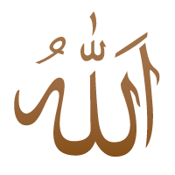
The words "Allah" in Arabic script or characters can be regarded as visually representing Islam as a symbol.
- http://religious-symbols.net/islam-symbols.html

Top Two
- The Art of Arabic Calligraphy
https://www.youtube.com/watch?v=mLqP9ZLVmbQ
- Why is Writing So Important in Islamic Art - Metropolitan Museum of Art
https://www.youtube.com/watch?v=8nx6Cm1DdW0

Digging Deeper
- Why Islam forbids images of Mohammed - CNN
https://www.cnn.com/2015/05/04/living/islam-prophet-images/index.html
- Islam - Religious Studies
https://www.youtube.com/watch?v=1FfKN2Sf7Ac (minutes 8:25-9:47)

Engage

Your Arabic Name

The Quran is written in Arabic. It is written from right to left, instead of left to right. The calligraphic symbol of Allah is one of the main symbols of Islam. Try your hand at Arabic calligraphy by writing your name:

Use this online translation form making a name into Arabic calligraphy then copy it onto paper.
http://www.firdaous.org/write-name-arabic-calligraphy.htm

or

Write your name in Arabic, using Handout #1, at the end of this packet:
- Write your name from right to left: i.e. SCOTT becomes TTOCS; KATIE becomes EITAK.
- Write your name according to the sounds in your name instead of just the letters because there are no Arabic letters for C, G, I, O, P, Q, V, and X. i.e. TTOCS becomes TTAKS; EITAK becomes YTAK.
- Match the Arabic Letters in Handout #1 to the letters in your name.
- Adapted from “Holidays and Holy Days” by Charlene Brotman and Barbara Marshman

Activities - Exploring Islam (40 min)

Activity #1: The Prophet Muhammad

Explain
Introduction for Leaders
The Prophet Muhammed is the prophet of Islam. He is not revered as a son of God, but as God’s messenger.
The Prophet Muhammed is not pictured in art, in contrast to Christianity, where artists have drawn imagined images of Jesus.
“... there are no specific drawings of the prophet and his family. This is because the Islamic tradition, like the Jewish tradition, has always followed the ten commandments, in particular, “Thou shalt not create graven images.” As a result of following this commandment, Islamic art developed avenues of artistic expression other than the human form, taking numbers and geometry, plant and animal life to their highest form of human expression.” - from the Introduction to “Muhammad” by Demi

Muslims say “Peace Be Upon Him” after his name. The letters you sometimes see after the prophet’s name, like “saw” or “PBUH” mean “Peace Be Upon Him” in Arabic or English and is a shortcut indicating that a Muslim should repeat them after saying the prophet’s name as a sign of respect. Non-Muslims are not required to say it. It is a sign of respect to say “The Prophet Muhammad” because Muhammed is also the most common Arabic name.

- Bio of the Prophet Muhammad https://www.biography.com/people/muhammad
- Top Ten Things You Should Know about the Prophet Muhammad https://stepfeed.com/10-things-you-should-know-about-prophet-muhammad-3272

Engage
Tell the story of the life of the Prophet Muhammad using the video or the book, below.

Prophet Stories For Kids in English | Prophet Muhammad (saw) Videos
Each of these videos is about 10 minutes long. Watch the first to begin the story of Muhammad. Suggest that they watch the remaining three at home. Or read the book, following.
Prophet Muhammad (saw) Part 1: https://youtu.be/WEEORXFj-lo
Prophet Muhammad (saw) Part 2: https://youtu.be/LO3WUk1b7fk
Prophet Muhammad (saw) Part 3: https://goo.gl/mtzZ8Z
Prophet Muhammad (saw) Part 4: https://goo.gl/iA1uED

Muhammad (Book)

by Demi (Author, Illustrator)
https://www.amazon.com/Muhammad-Demi/dp/0689852649/ref=sr_1_1?s=books&ie=UTF8&qid=1544217007&sr=1-1&keywords=Muhammad+demi

“Born in Mecca in the year 570, Muhammad grew into a sensitive and thoughtful man who believed deeply in the worship of one true god.
In his fortieth year, Muhammad experienced a revelation from the angel Gabriel that he, Muhammad, was the messenger of God. Over the next twenty-three years, he received many such revelations, all of which were written down by scribes at the time of revelation to become the Koran, the sacred scripture of Islam, a religion that is practiced by nearly one-quarter of the world's population and holds as its most sacred tenet that there is no god but God.
Through a clear text and stunning illustrations based upon those of traditional Islamic expression, the award-winning artist Demi here introduces the remarkable life of the Prophet Muhammad for young readers.” - Amazon. Great book!

Prophet Muhammed saw Coloring Page (possible craft to use while reading the book, above.
http://coloringkids.org/islamic-coloring-pages/prophet/
Create some calligraphic art of the name of the prophet.

Activity #2: Islamic Contributions to Civilization

How can we counter the inaccurate negative messages that violent terrorists represent all Muslims? To address this, we offer the creative contributions to civilization by Islam, during the Islamic “Golden Age.” We offer this amazing time of inventing and creating hospitals, universities, science and philosophy as a way of understanding Islam besides what is in the news about terrorists.

Explain
Introduce the creative contributions as an antidote to the perception of Islam as a religion of terrorism and violence.

Leader Background
- Top 10 Islamic Contributions
https://www.youtube.com/watch?v=e6SIcHMF9Y0
- Overcoming Historical Amnesia; Muslim Contributions to Civilization
https://www.huffingtonpost.com/craig-considine/overcoming-historical-amnesia_b_4135868.html

Digging Deeper
- Contributions of Muslims to World Civilizations https://www.manvilleschools.org/site/handlers/filedownload.ashx?moduleinstanceid=8384&dataid=4775&FileName=Chapter%2010%20-%20Muslim%20Contributions%20to%20World%20Civ.pdf

Engage

Guessing Game - Creative Islamic Contributions to Civilization
Invite the group to divide into pairs. Pass out Handout #2 Guessing Game, at the end of this packet, to each pair, asking them to identify the items they think came from Islamic culture. There is a surprise catch which you can unveil after they’ve made guesses: every item, except one, comes from Islamic Empire during its Golden Age, 8th c. to the 14th c. The only exception is Chocolate. Chocolate is credited to the Olmec people of Latin America.

Leader note: Make extra copies of the Handout so the middle schoolers can take it home and try it out on their parent(s). This suggestion is included in the “Drive Time Tips” for Parents.

Watch a Rap about Contributions to Western Civilization

Muslim Contributions to Civilization RAP
https://www.youtube.com/watch?v=Udi8bek3s7c

Games to Play to Celebrate Islamic Contributions to Western Civilization
Play any of several games dedicated to the Islamic inventions and contributions:

Soap bowling. Soap Relay
http://www.youthwork-practice.com/games/Soap-Games.html

Soap fishing, Squeezing the soap, Soap consumption, Soap Relay, Cling wrap track.
http://www.games4youthgroups.com/games-with-less-material-12.html

Games with oranges

Knee Trembler
https://www.youtube.com/watch?v=DjybTSnlWfI

Orange Relay
http://stumingames.com/2014/09/orange-relay/

Other Games/Activities with Islamic inventions and introductions
  - Rice Game
https://youthgroupgames.com.au/games/254/rice-model-competition/
  - Chess

Graffiti Board - Filling in the Gaps (3 min.)
Invite the youth to add a picture or word to the graffiti board, picking one thing that engaged them most about today’s session. What did they learn about Islam that they think is most important to add.
Remember to use markers that are a different color than was used to fill or the board at the start of the session, so you can continue to track learning over the sessions.

Looking Ahead - What to do ahead of time or expect (2 min.)
Thank the youth for their participation this week. Note one thing that you particularly appreciated or enjoyed about the session you just did with them.

Remind the youth what is happening next week and make sure they know what they have to do ahead of time. Note one thing that you are particularly looking forward to.

Closing Words (1 min)
“In the days ahead, May the ropes be with you. May we stay close to our deepest and truest selves. May we keep connected to each other. And may we remember to lean into life’s joy. Blessed be. Amen

Week 2

Tack Sunday

What does it Mean to be a People of Trust...
from a Muslim Perspective?

Purpose
- Explore the connection between our monthly theme of Trust and Islam.

Dinner and Drive Time Tips (Email to parents prior to the meeting):

Before:
- Watch a movie with your youth with an Islamic theme:

The Kite Runner (PG-13) http://www.imdb.com/title/tt0419887/

Wadjha (PG) www.imdb.com/title/tt2258858/

Children of Heaven (PG) http://www.imdb.com/title/tt0118849/

He Named Me Malala (PG-13) http://www.imdb.com/title/tt3065132/
After:

In our worship, we will talk about Islam and our monthly theme of trust. We will explore how trust shows up in Islam through the third pillar of Islam: Zakat, or charity. We will discuss how their faith, Allah and those suffering trust faithful Muslims to follow through on the promise of making charity central in their lives. To help our youth think about how they might also be trusted to do the same, we will ask the youth to place a ribbon on their wrist as a promise to work with their family to find a way to fulfil our obligation to those who are struggling and suffering. So, talk with your youth about this promise exercise and consider helping them follow through this month on that promise. You might also want to watch the video we use in connection with this worship: https://www.youtube.com/watch?v=FKV2oeS4vw8
For You:
- As an antidote to the negative stereotyping of Muslims, become familiar with the story of Malala Yousafzai:
  - Malala Yousafzai, 16, and Her Miraculous Story of Surviving Being Shot by the Taliban https://www.youtube.com/watch?v=CXvs1vwi
  - Top 5 facts about Malala https://www.youtube.com/watch?v=GDF2jIbSgn8
  - BBC - Malala’s Story https://www.youtube.com/watch?v=FnloKzEAX7o

Pre-Session to Do List:
- Send out the Dinner and Drive Time Tip. See above.
- Make sure you have the technology needed to play the YouTube videos that are part of this session.
- PREPARE AHEAD OF TIME for worship: Gather ribbon or yarn long enough for each group member to wrap and tie around their wrist.
- Poster or Whiteboard with markers for creating the five pillars board
- Prepare for any of the optional suggestions for games and activities at the end of each pillar, if you have time.
  - Food for the little fast.
  - A youth who has been on a UU Pilgrimage to Boston.

Session

What does It Mean to be a People of Trust…

from a Muslim Perspective?

Entering - Graffiti Board Writing

Same Core Question: What is Islam?

As youth enter the room, direct them to check out the graffiti board as a way to remind themselves of what they’ve been learning. Using a new color for the markers, invite them to add a new item or embellish an item they’ve already put up.

Gathering & Centering - Worship (10 min)

PREPARE AHEAD OF TIME: Gather ribbon or yarn long enough for each group member to wrap and tie around their wrist.

Centering Sound
Invite everyone to calm and center themselves. Use whatever ringing vessel you have chosen (chimes, bowl, bell). Ring the bell/bowl/chimes. Once the sound ends, pause for a moment of silence and then end by saying “Amen” or blessing words of your own.

Lighting the Chalice
We light this chalice in gratitude for the path we share, a path that guides us
back to our deepest self,
back to each other,
And back to life’s gifts and joy.

Welcome

Suggested Script/Talking Points:
- Welcome to Tack Sunday and to our continued exploration of this month’s religion: Islam. Today we are going to explain - or “tack up” with - how Muslims think about the monthly theme we are exploring here at our church: Trust
- One of the ways trust shows up in Muslim spirituality is through the third pillar of Islam, “Zakat,” which can be translated into English as charity or an obligation to care for the poor and suffering. Muslims promise to Allah and each other to make this a central value of their lives. Their faith and those suffering trusted them to follow through on that promise.
- To get a sense of how important and deeply felt this is among Muslims, our worship today will focus on a song call “Forgotten Promises” by the musician, Sami Yusuf. He’s been called “Islam’s Biggest Rockstar” and the United Nations appointed him a UN Global Ambassador Against Hunger. In this song he calls Muslims and all of us to be trustworthy and fulfill the promises we make as people of faith to those who are hungry and suffering around the world.
- As you listen to and meditate on the song, here’s a piece of ribbon. As you listen to the song think of a way to make a promise to have your family volunteer at or give money to a local food pantry, homeless shelter or other social service organization this winter. Once you’ve thought about what kind of organization you want to support, place the ribbon on your wrist as a reminder and promise that you will work with your family to follow through.
- So, here are your promise ribbons and now let’s listen to the song.

Music for Centering

Forgotten Promises: https://www.youtube.com/watch?v=FKV2oeS4vw8

Thematic Check-in
Invite the group to share, if they are comfortable, what they thought about as they listened to the song and what organization or type of organization they are thinking of promising their support to.

After the sharing, leader expresses gratitude for everyone’s sharing.

Closing
“In the rest of our time together and in the days ahead, May the ropes be with you. May we stay close to our deepest and truest selves. May we keep connected to each other. And may we remember to lean into life’s joy. Blessed be. Amen”

Extinguish the Chalice
Leader note: If you use a flame, our advice is to extinguish it now to prevent accidental tipping over or pyro play with hot wax. If you use a tea light, you may wish to extinguish it at the end of the session during the closing words.

The Problem in the World & The Solution (30 min)

Problem:

Self-sufficiency - pride or self-reliance

Solution:

Submission (to Allah)

“Islam” means “submission” God is in charge; you are not!

Leader Resources (Background and support for leaders so they can explain in their own words):

The Five Pillars of Islam

https://www.youtube.com/watch?v=mv2I9ROwwEs
- Introduction to Islam
https://www.youtube.com/watch?v=wgP_OSOS3IA (minutes 1:35-2:50)
- The Five Pillars - The Pluralism Project
http://pluralism.org/religions/islam/introduction-to-islam/the-five-pillars/

Leader Notes:
For Muslims, the journey of faith is largely one of growing and maintaining your trust in Allah. Some have pointed out that the root word for Islam, “al-Silm,” means “submission” or “surrender.” Submitting to God can sound like one is just agreeing to serve under God’s authority. But for Muslims it is more complicated and richer than that. The Muslim relationship to Allah/God is not just one of saying “Yes, God, I honor that you are in charge.” but also “Allah, I promise to remember to trust in your guidance and support.”

It’s in this sense that Muslims are very much a people of trust. For them, having faith that they can release themselves into Allah’s hands and depend on Allah for guidance is a central practice.

And you can see this theme of trust woven through the central practices of Islam, called the Five Pillars. So today’s session is dedicated entirely to exploring those five pillars and lifting up how trust shows up in each one.

Presenting the Five Pillars on a Poster Board
It’s hard to remember five big and complicated ideas. So to help your youth keep track as you present the Five Pillars, we encourage you to use a visual. Simply get a poster board (or use a whiteboard if you have one) and draw five large but simple pillar shapes across the board. Then write the name, English translation and phrase connected to trust below each pillar:
- Shahada: Testimony or Witness - “Declaring Your Trust”
- Salah: Prayer - “Reviving Your Trust”
- Zakat: Charity - “Responding to God’s call to trust and depend on each other”
- Sann: Fasting & Ramadan - “Trusting Oneself to Faithfully Fast”
- Hajj: Pilgrimage - “A Journey Guided by a Trust in Allah”
With this board in front of the group, start with a general introduction about how “trusting Allah for wisdom and support is central to Islam” and then use the following five sections to explain the Five Pillars one by one.

The First Pillar - Shahada (Testimony or Witness)
“Declaring Your Trust”

Explain & Theme Connection

Leader Resources (Background and support for leaders to explain in their own words)
- Shahada from the Berkeley Center: https://berkleycenter.georgetown.edu/essays/shahada
- An example Shahada: https://www.youtube.com/watch?v=-43DvXauUyU

Making a Theme Connection:
After using the above resource to explain the basics of Shahada, be sure to connect it to our theme of trust by stressing that the Shahada is both a declaration of belief and a declaration of trust. It is not just saying, “I believe that Allah is one and Muhammad is Allah’s messenger.” It is also a way of saying, “I will place my trust in Allah as the source of life and support and I will place my trust in Muhammad as the primary source of wisdom about Allah and faith.”

Making a UU Connection:
Instead of just downloading more information and asking the youth to passively receive it, ask your youth where they see similarities and differences between our faith and Islam on this topic. (“So how are we UU’s similar or different when it comes to this idea of Shahada?”) To help you guide them as they offer answers, we’ve created the below cheat sheet:

We are different because…. UUs support individual freedom when it comes to belief and don’t have any creed or testimonies that we require all members to confess.

We are similar because... UUs do talk about "living our values," "bringing our values into our daily living" and having people “know us by our actions.” We have promises we aspire to, our 7 principles, and 6 sources we use to shape our living. So in this sense, we do witness and testify to our values and declare our trust in the UU sources all the time. We just do it with our actions less than our words. We share more with the pillar of Shahada than we might think!

Leader Note: After you’ve finished presenting and discussing, consider walking up to the poster board and coloring in the pillar image of the pillar you just finished discussing. Doing this each time will help your youth keep track of where you’re at in the discussion. You might also invite the youth to color in each pillar as you go along.

Optional “Further Engagement” Activity if you have Extra Time:
Get a first-hand look at a young woman reciting her Shahada and beginning her faith journey. Show the video below then engage in discussion.

Reciting my Shahada: https://www.youtube.com/watch?v=-43DvXauUyU

Game Break!!

This session on the Five Pillars is packed full with a lot of learning about the Five Pillars and the theme of trust. So to insert energy and fun right away, we recommend stopping after the first Pillar for a “Trust Game Break.”

Having explained that the Five Pillars are all about trusting Allah and having Shahada is a declaration of one’s trust in Allah, tell the youth that you want to help them lean into the experience and feeling of trust. We can talk all we want about what Muslims think, but nothing beats gaining a sense of what their faith feels like. Saying “I place my trust in Allah” is very different than the spiritual experience of letting go and emotionally “falling into Allah’s dependable arms.”

So to help your youth have that experience of letting go and trustfully falling into arms greater than yourself have some fun and play with these trust games on our UUA’s website:
https://www.uua.org/youth/library/adults-ministry/deepfun/stretching

There are a number of games listed at this link, scroll down the ones on trust, which are:

Trust Walk Variations

Trust Fall

Trust Carry

NOTE/CAUTION: Lifting/carrying/supporting participants is a serious activity, along with remembering that anyone can choose to not participate, you MUST make sure a group is ready for the activity so as to have no one dropped.
Remember anyone can opt out if they don’t feel comfortable. This, like other activities has the ability to trigger those who have experienced trauma. Make sure you explain the activity, so people know what they are getting into.

The Second Pillar: Salat (Prayer)
“Reviving Your Trust”

Explain & Theme Connection

Leader Resources (Background and support for leaders to explain in their own words)
- What is Salat? Daily Prayer in Islam
https://www.mprnews.org/story/2016/02/01/explaining-daily-prayer-in-islam
- BBC - Muslim Prayer Movements
http://www.bbc.co.uk/religion/galleries/salah/

Making a Theme Connection:
Use the above resources to explain Salat generally, and then go on to connect it to our monthly theme by pointing out how this daily prayer practice is a way of reviving and maintaining one’s trust in God throughout the day. It’s easy to lose faith in and focus on God as a dependable source of support. Salat’s practice of asking one to pause multiple times throughout the day helps keep that focus and trust strong.

Making a UU Connection:
Instead of just downloading more information and asking the youth to passively receive it, ask your youth where they see similarities and differences between our faith and Islam on this topic. (“So how are we UU’s similar or different when it comes to this idea of Salat?”) To help you guide them as they offer answers, we’ve created the below cheat sheet:

We are different because… Prayer means many things to many people. UUs have an especially diverse understandings of prayer, so we don’t have certain prayers or prayer practices that are shared by all.

We are similar because… One thing most people agree upon is the importance of taking time each day to remember to be mindful, grateful, humble and trustful. For many Muslims, this is what praying 5 times a day is all about: taking time to stop and restore your trust in and connection to the divine and your values. While we may not stop 5 times a day, many UU’s have a regular prayer or meditation practice that they do weekly or daily.

Leader Note: After you’ve finished presenting and discussing, consider walking up to the poster board and coloring in the pillar image of the pillar you just finished discussing. Doing this each time will help your youth keep track of where you’re at in the discussion. You might also invite the youth to color in each pillar as you go along.

Optional “Further Engagement” Activity if you have Extra Time:

Discussion
Invite the youth to name some ways they pause one or more times a day (or during the week) to restore their mindfulness, gratitude or trust in life or themselves. Giving examples: dinner prayer or gratitudes, going to church, time alone, posting things online you’re thankful for, singing your favorite song, telling your family you love them before you leave the house, etc.

Activity
Using the Muslim Prayer Movements, invite the group to try the postures of Muslim Daily Prayer.

The Third Pillar: Zakat (Charity)
“Responding to God’s call to trust and depend on each other”

Explain & Theme Connection

Leader Resources (Background and support for leaders to explain in their own words)
- BBC - Zakat: http://www.bbc.co.uk/religion/religions/islam/practices/zakat.shtml
- What is Zakat?: https://www.youtube.com/watch?v=3xXWP-BZh3w
- Islam - Stephan Prothero, on obligation to and Allah’s preference for the poor (minutes 11:56-13:13)
https://www.youtube.com/watch?v=1FfKN2Sf7Ac

Making a Theme Connection:
Use the above resources to explain Zakat generally, and then go on to connect it to our monthly theme by pointing out how Zakat is the way Muslims respond to God’s call to trust and depend on each other.

Making a UU Connection:
Instead of just downloading more information and asking the youth to passively receive it, ask your youth where they see similarities and differences between our faith and Islam on this topic. (“So how are we UU’s similar or different when it comes to this idea of Zakat?”) To help you guide them as they offer answers, we’ve created the below cheat sheet:

Start by stressing that Zakat is about more than charity and “helping others less fortunate.” It is part of the Muslim belief that “all things belong to Allah” and emerges from Islam’s belief that those blessed with advantages have an obligation to the poor. Islam is especially critical of amassing wealth for oneself or using wealth as a sign that you are better than or harder working than others. (http://islam.ru/en/content/story/rich-man-poor-man).

Then go on to ask your youth where they see similarities and differences with UU belief:

We UUS are different because… UU’s wouldn’t describe pledging or our money as “belonging to God.”

We are similar because… UU’s also believe we have a responsibility to share our money with others, even an “obligation” to share. We call it pledging, and the UUA suggests anywhere from 2 - 10% as a fair share contribution. https://www.uua.org/finance/apf/pacifc-western-midamerica/contribution-guide. Many UU congregations require it from members.

Leader Note: After you’ve finished presenting and discussing, consider walking up to the poster board and coloring in the pillar image of the pillar you just finished discussing. Doing this each time will help your youth keep track. You might also invite the youth to color in each pillar as you go along.

Optional “Further Engagement” Activity if you have Extra Time: Do the Math
Talk about the UU perspective that pledging and charity is an expression of gratitude for what we have, not just about one being generous. Consider sharing your own understanding of why you pledge to your church and how it connects to your own belief in responsibility toward others or the idea that all things belong to “God.”
Then Invite the youth to calculate how much would they give if they were Muslim and paid Zagat on their allowance or the money they get for their birthdays or at holidays? Zagat is 2.5%.
How much would a Muslim pay who makes the average US wage of about $60,000.? What is that number equivalent to? What might that require one to give up for the sake of others?

The Fourth Pillar: Sann (Fasting - Ramadan)
“Trusting Oneself to Faithfully Fast”

Explain & Theme Connection

Leader Resources (Background and support for leaders to explain in their own words)
- Ramadan - Religion Facts
http://www.religionfacts.com/ramadan
- What is Ramadan and Why Do Muslims Fast?
https://www.youtube.com/watch?v=Y8768sLIi6g
- What is Ramadan? What does it mean to you?
https://www.youtube.com/watch?v=pDs12nC6mng

Making a Theme Connection:
Use the above resources to explain Ramadan and fasting generally, and then go on to connect it to our monthly theme. Acknowledge that the theme of trust is not really central to Ramadan and Fasting. Ramadan is more about refocusing one away from worldly things to spiritual things and cleansing one’s heart and mind. And yet, it would seem that pulling off such a disciplined and serious month-long practice certainly shows a lot of trust in oneself. Additionally, one promises oneself and God not to cheat on the fast. There’s surely a lot of trust in that!

Making a UU Connection:
Instead of just downloading more information and asking the youth to passively receive it, ask your youth where they see similarities and differences between our faith and Islam on this topic. (“So how are we UU’s similar or different when it comes to this idea of Sann?”) To help you guide them as they offer answers, we’ve created the below cheat sheet:

We are different because… UUs don’t formally practice fasting.

We are similar because… At its core fasting is a way to connect with those less fortunate and think about the way we can be better people. So while we don’t fast as a regular practice, we UUs do have our own ways of remembering and being in solidarity with those less fortunate, such as special offering plates, social justice work and volunteering. We also have our own way of remembering to be our better selves. In fact you might say coming to church once a week is our regular practice of strengthening each other to live up to our values. And like fasting, it also is about giving up worldly activities to shift our focus toward spiritual issues.

Leader Note: After you’ve finished presenting and discussing, consider walking up to the poster board and coloring in the pillar image of the pillar you just finished discussing. Doing this each time will help your youth keep track. You might also invite the youth to color in each pillar as you go along.

Optional “Further Engagement” Activity if you have Extra Time:
Try it: Bring out some food. Invite the group to discuss if they have ever fasted and what it was like? Invite them to put off eating the food in front of them until the very end of the session. It is a minor challenge compared to fasting from sunup to sundown for a whole month!

The Fifth Pillar: Hajj (Pilgrimage)
“A Journey Guided by A Trust in Allah”

Explain & Theme Connection

Leader Resources (Background and support for leaders to explain in their own words)

- What is the Muslim Holy Pilgrimage aka Hajj
https://www.youtube.com/watch?v=Rn8s35VKidE
- Hajj in 3 minutes
https://www.youtube.com/watch?v=I0jsF_xsODI

Digging Deeper
- The Hajj to Mecca explained: https://www.youtube.com/watch?v=29HpUaJpwvI
- Why is Mecca having an 80BN makeover? : https://www.youtube.com/watch?v=8UhljjFEa-I

Making a Theme Connection:
Use the above resources to explain Hajj generally, and then go on to connect it to our monthly theme. Acknowledge that trust is not a major theme of Hajj. However, because all the activities involved in Hajj are about honoring, reflecting on, proving and restoring one’s trust in Allah, you might say that this is one big journey of trust! At the end of it, one’s connection to and trust in God is surely stronger. Indeed that’s the entire point. Or another way of thinking about it might be to say that Hajj is a journey completely guided by a trust in Allah!

Making a UU Connection:
Instead of just downloading more information and asking the youth to passively receive it, ask your youth where they see similarities and differences between our faith and Islam on this topic. (“So how are we UU’s similar or different when it comes to this idea of Hajj?”) To help you guide them as they offer answers, we’ve created the below cheat sheet:

We are different because… UU’s are aren’t expected to engage in one particular pilgrimage.

We are similar because… Some congregations have their youth groups always make a trip to Boston, the headquarters of the UUA, or sometimes to Walden Pond.

Leader Note: After you’ve finished presenting and discussing, consider walking up to the poster board and coloring in the pillar image of the pillar you just finished discussing. Doing this each time will help your youth keep track of where you’re at in the discussion. You might also invite the youth to color in each pillar as you go along.

Optional “Further Engagement” Activities if you have Extra Time:
- Invite youth who have made the trip to Boston to share their impressions. If none have, invite an older youth in.
- Discuss what other travel have youth participated in which might be interpreted as a pilgrimage? For instance, going to see a volcano might be a pilgrimage for someone interested in geology. Visiting a planetarium might be a pilgrimage for an astronomer. Going to a K-Pop concert might be a pilgrimage.
- Play the Journey Game: https://doitandhow.com/2012/05/16/im-going-on-a-trip-game/

Graffiti Board - Filling in the Gaps (3 min)
Invite the youth to add a picture or word to the graffiti board, picking one thing that engaged them most about today’s session. What did they learn that they think is most important to add?

Remember to use markers that are a different color than was used to fill or the board at the start of the session, so you can continue to track learning over the sessions.

End the Little Fast
If you did the optional activity for Sann, then invite the group to partake in the food that has been set out for Sann.

Looking Ahead - What to do ahead of time or expect (5 min)
Thank the youth for their participation this week. Note one thing that you particularly appreciated or enjoyed about the session you just did with them.

Remind the youth that next week is THE VISIT! Share a bit about where you are going, go over logistics and stress any rules that will need observed-e.g., let them know about clothing expectations.

Tacking up our Eight Practices of Welcome
Hand out the list of the Eight Practices of Welcome, Handout #3. Remind the youth that we are using them during our visit next week and will be reviewing how well we do. So ask them to please make time to think about them during the week. Which one do you particularly need to remember and work on for yourself?

Choosing an Interview Question (either now, or before you leave for your visit on Summit Sunday)
If you are able to include a conversation with a leader as part of your visit, we suggest that you bring questions for the youth to ask. We have included the Interview Questions at the end of this packet as part of the preparation for the visit, labeled Handout #4. We suggest that you ask the youth which question they would like to ask. Be flexible to allow youth to ask their own questions, paraphrase the question from the Handout in their own words or ask it straight out.
(Remember that we also recommend sending the list of questions ahead of time to the faith leaders you are going to interview. This will allow them to prepare. You might also want to let them know that the youth will be taking turns asking their favorite questions from the list or ones they have generated themselves.)

Closing Words (1 min.)
“In the days ahead, May the ropes be with you. May we stay close to our deepest and truest selves. May we keep connected to each other. And may we remember to lean into life’s joy. Blessed be. Amen”

Week 3

Summit Day

(The Visit)

Purpose
- Get a direct experience of the Muslims with a visit.
- Engage and use our Eight Practices of Welcoming.

Preparation & Leader Notes

Dinner and Drive Time Tips (Email to parents prior to the meeting):

Before:
- Talk to your youth about the 8 practices of welcoming and how they might use them in their visit.
- Remind youth to bring an offering. We recommend an amount of $_____.
- Remind your youth about dress requirements. [Leader note: tailor this bullet to the visit]
After:
- Ask your youth to share their favorite part of the visit.
- Reflect with them on your own experiences with and understanding of Muslims. Share your assumptions and stereotypes and ask your youth how their experience relates to those assumptions and your past experiences.
For You:
Spend some time countering the negative messaging about Muslims with these resources::
- Meet the Global Muslim Peace Movement
https://www.huffingtonpost.com/qasim-rashid/meet-the-global-muslim-pe_b_5563494.html
- 10 Muslim peace activists proving negative stereotypes wrong
https://www.globalcitizen.org/en/content/10-peace-loving-muslims-to-be-thankful-for/
- Catholic nun and Muslim Imam work together for forgiveness and peace
https://www.youtube.com/watch?v=0tzSPf7fyCo
- Mehdi Hasan | Islam Is A Peaceful Religion | Oxford Union
https://www.youtube.com/watch?v=Jy9tNyp03M0

Pre-Visit to Do List:
- Arrange for and prepare the drivers. Make sure the drivers:
  - Have the address of the destination and a phone number to call if there are problems.
  - Have a list of who is in their car and their emergency contact numbers.
  - Are familiar with and comply with congregational safety guidelines, such as a license and proof of insurance on record.
- Send the Interview Questions to the faith leader, optional.
- Make sure to collect signed permission slips from group members, with all relevant contact information and emergency numbers. Make a copy to leave at the church, and a copy to bring on the trip.
- Let parents know the approximate time of return and post it on the door of your meeting room.
- Prepare to post a “We Will Return Soon” note in case someone comes late, such as “Sorry we missed you. The Crossing Paths group is visiting _______. We will return at _____.
- Bring offering money for each group member or remind them to bring some
- Consider purchasing or bringing a gift for your host. Perhaps an interfaith poster or calendar.

- Make sure you have collected and clarified all the rules & expectations for your visit. You will share this information before you leave your church on Summit Sunday. Rules and expectations include:
  - the name of the faith community you are visiting. (e.g., First Congregational Church of…)
  - the religion’s name for their house of worship. (e.g., temple, church, mosque…)
  - what the religious leader is called and how they should be addressed (e.g., “They are call a minister and they should be addressed as Rev. Jones or Pastor Jones.”)
  - other behaviors that should be observed (e.g., expect dress, silence in certain spaces, when one can and when one shouldn’t participate in a ritual, etc.)
  - When and if it is appropriate to take pictures with phones. (Remember that we want to have some select moments when photos are gathered so they can be used in the end of year scrapbook or video)

Session - Visit

Before You Go
Before you leave, gather as a group at your home church and do the following:

Choosing an Interview Question (if you didn’t do this on Tack Sunday previously)
If you are able to include a conversation with a leader as part of your visit, we suggest that you bring questions for the youth to ask. We have included the Interview Questions at the end of this packet as part of the preparation for the visit, labeled Handout #4. We suggest that you ask the youth which question they would like to ask. Be flexible to allow youth to ask their own questions, paraphrase the question from the Handout in their own words, or ask it straight out.

Remembering to be a Good Guest:
Leader reviews basic information and guidelines about how to be respectful during the visit:

1. Share the name of the faith community you are visiting. (e.g., First Congregational Church of…)
2. Share the religion’s name for their house of worship. (e.g., temple, church, mosque…)
3. Tell them what the religious leader is called and how they should be addressed (e.g., “They are called a minister and they should be addressed as Rev. Jones or Pastor Jones.”)
4. Review other behaviors that should be observed (e.g., silence in certain spaces, when one can and when one shouldn’t participate in a ritual, etc.)
5. Make sure everyone’s dress is appropriate and honors the expectations of the tradition you are visiting. If someone has forgotten, address the situation according to the understandings you’ve made ahead of time.
6. Share when and if it is appropriate to take pictures with phones. (Remember that we want to have some strategic moments when photos are gathered so they can be used in the end of year scrapbook or video)
7. Share expectations about texting and use of smartphones.
8. Remind them that they are guests and will be representing Unitarian Universalism to your hosts
9. Go over the travel plans and rules:
- Assign participants to a car and make sure they know to return in the same car.
- Be respectful of their drivers and cars.
- Give emergency contact numbers to drivers.

Packing Up Our Eight Practices: Gather in your church foyer or parking lot before you go. Stand together in a circle and share a blessing based on the Eight Practices of Welcoming. We recommend that you print out this blessing, so the youth have the Eight Practices physically available. Here’s one version of a blessing you could do. Do it as a group by each person taking turns reading one line:

Leader: Let us take a breath and pause before we go.
[PAUSE IN SILENCE]

With our feet firmly grounded here at our church home, we are grateful.
Here we find community and comfort.
Here we also encounter the call to go out, explore and become more..

On our journey today, let us take our practices and values with us
so we can notice and receive all the gifts offered to us.
May we remember to...

Be fully present
Be curious
Be open to being changed
Be comfortable with discomfort
Be an appreciative listener
Be light-hearted
Be gentle when mistakes are made
And, be ourselves
With all these commitments tucked tightly in our hearts and heads,
Amen, Let’s go!

The Visit
Have a great time!

Don’t forget about collecting pictures for our future scrapbook/memory wall/video project. At the very least get a picture of the youth standing in front of the house of worship.
Have the youth text or email you 1-2 of their favorite pictures that they took. Save for the spring scrapbook/memory wall/video project.

After the Visit (just before everyone heads home)

Looking Ahead - What to do ahead of time or expect (1 min.)
Thank the youth for their participation. Praise something about how the youth handled themselves. Note one thing that you particularly appreciated or enjoyed about the visit.

Remind the youth that next week is Lake Sunday. Lift up anything they need to do or think about ahead of time.

Closing Words
“In the days ahead, May the ropes be with you. May we stay close to our deepest and truest selves. May we keep connected to each other. And may we remember to lean into life’s joy. Blessed be. Amen”

Week 4

Lake Sunday

(Reflecting on Our Visit)

Purpose
- Reflect on the visit.
- Review our use of the Eight Practices of Welcoming

Preparation & Leader Notes

Dinner and Drive Time Tips (Email to parents prior to the meeting):

Before:
- Talk with your youth about what they plan to write on the Thank You Card that will be sent to the faith community they visited last week. This will help them prepare, give them a chance to reflect more on the visit and better enable them to write something meaningful.

After:
- Ask your youth to share which of the 8 Practices of Welcoming were hardest for them personally.
- Ask them to share something about the graffiti board. They have been adding new thoughts to it to each week. Ask them how the board has changed? What’s interesting about how it has changed and grown? How does it show that the group’s understanding of Islam has evolved?

For You:
- Talk with your spouse/partner or a friend about how your own view of Islam has evolved over the month as a result of your conversations with your youth.

Pre-Session to Do List:
- Get a thank-you card for everyone to sign.
- (optional) Invite a guest with a Muslim background or experience, perhaps identified in the Parent Orientation, or from a request to the congregation at large. Share Handout #4 with them and let them know the youth will be asking them the questions listed, optional.
- (optional) Make plans to attend the adult service or part of the service as a way of exploring the monthly theme of Trust.

Session

Entering - Graffiti Board Writing
Using the same graffiti board from past weeks, invite those entering to add words, pictures or impressions that represent what stuck out for them about last week’s visit.

Gathering & Centering - Worship (10 min)

To Prepare: - Set out the Thank-You Card and markers or pens.

Centering Sound
Invite everyone to calm and center themselves. Use whatever ringing vessel you have chosen (chimes, bowl, bell). Ring the bell/bowl/chimes. Once the sound ends, pause for a moment of silence and then end by saying “Amen” or blessing words of your own.

Lighting the Chalice
“We light this chalice in gratitude for the path we share, a path that guides us
back to our deepest self, back to each other, and back to life’s gifts and joy.”

Welcome
Suggested welcome script: “Welcome everyone to Lake Sunday! Lake Sunday is about “coming back from our journey - back down the mountain - and reflecting on our trip” I’m so excited for us to talk about our visit and notice all the gifts the visit gave us. In addition, please write your name and one of the things you will remember on our Thank-You Card for [faith leader/place of worship] as we share this song called “Grateful.”

Music for Centering

GRATEFUL: A Love Song to the World | Empty Hands Music | nimo feat. daniel nahmod
https://www.youtube.com/watch?v=sO2o98Zpzg8

Closing Words
“In the rest of our time together and in the days ahead, May the ropes be with us. May we stay close to our inner and truest selves. May we keep connected to each other. May we remember to lean into life’s joy. - Blessed be. Amen”

Extinguish the Chalice
Leader note: If you have an open flame, we suggest extinguishing it at this point to prevent accidents and pyro-play. Otherwise, consider extinguishing it during the Closing at the end of the session.

Reflecting on the Visit (30 min)

Questions to guide the discussion:

Initial Reactions

1. What surprised you? What was completely new? What didn’t you expect?

2. What was the most interesting part? What was “cool”? When were you having the most fun?

3. What didn’t you fully understand? What confused you? What do you want to learn more about (Leader note: Answer the questions/confusions if you can. Or see if the group can help. If time, look up the answer on a computer/phone. If no time for that, encourage the youth to look it up with their parents or promise to look it up for them)

Personal Application

How did the trip and our past few weeks of learning make you think about your own life differently?

Lead the group in discussion about their personal takeaways. Invite them to think about how the visit and past few weeks gave them a challenge for their own life. Here are some possible questions to help them with their reflection:
- Are you curious about trying out fasting as a spiritual practice? Would you like some of us to try it out together and explore what a UU version might look like?
- How has this month made you rethink your assumptions and stereotypes about Muslims?
- What is one thing about Muslims that you now want others to know?
- Do you want to be more serious about setting aside a percentage of your allowance or birthday money for those less fortunate as Muslims do with the practice of Zakat?
- Has the Muslim practice of Hajj made you excited about doing a UU pilgrimage?
- What is your favorite Islamic contribution to western civilization?
- What was your favorite game we played this month and why? What lesson did it drive home for you?

Leader Note: Consider sharing your own personal takeaways first to model and help them think about this. How did the visit and learning invite you to think differently or want to make a change or add something more to your life?

Activity #1 - Game

Kabaddi - played in India and Southeast Asia (Muslim)
Kabaddi can be played anywhere outdoors: in your yard, in a field, on the playground. All you need are 2 teams of people (preferably each with at least 3 players), and rope or chalk dividing the playing field into 2 separate territories. The teams line up about 20 feet back from the center line, on their corresponding sides. Teams take turns between offense and defense.
A player from one team stands near the center line. To begin the game, this player runs into the opposing territory and tries to tag one of his opponents. While doing this, the player must keep yelling “kabaddi-kabaddi-kabaddi-kabaddi-kabaddi-kabaddi” the entire time she is on the opponent’s territory, without taking a breath, until she makes it back to her side. Everyone she touches is out.
The opponents can try to capture that player and prevent her from getting back to her side. If she does not make it back to her original side before she runs out of breath (i.e. if she stops saying kabaddi-kabaddi-kabaddi) then she will be out.
Get a group of kids with good vocal chords and a lot of energy and have a go at kabaddi! https://kidworldcitizen.org/a-popular-playground-game-in-india-kabaddi/

Activity #2 - Game

Sepak Takraw or Hacky Sack
https://en.wikipedia.org/wiki/Sepak_takraw
“...considered more of an art as there is often no opposing team, and the point is to keep the ball aloft gracefully and interestingly.”
This version sounds very much like Hacky Sack, played in the U.S. except with a rattan ball.
Watch this Pro Game:
http://digg.com/video/hacky-sack-volleyball-sepak-takraw

Engaging the Graffiti Board - Stepping back and seeing how far we’ve come! (10 min)

- Gather around the graffiti board or take it down and bring it into the circle.
- Pause to see if there are any last things to add.
- Invite reactions and discussion
- What strikes you as you look at all the colors? Were there some weeks where we seemed to learn more than others? Are there more words than pictures? What does that mean?
- Is there anything on the board that needs to be corrected? Any “understanding” that was incomplete or misunderstood?
- What 2-3 things seem to best describe the essence of the Muslims for you? If you had to explain the Muslims to someone else, which 2-3 items on the board would you talk about?
- Take some selfies! Individual and as a group. Remember to remind the youth that we will be using these pictures in the spring to create a scrapbook, memory wall or video to document our journey this year.

Eight Practices Review (10 min)
Remind the youth that Crossing Paths is not just about visiting and learning about other religions. It’s also about learning skills and practices to better engage new people and new ideas throughout our entire life. So explain that you are reviewing how well the group used the 8 Practices not just to “grade ourselves” but also to push ourselves to develop them as “life practices.” The 8 Practices are included below, in Handout #3.

There are a number of ways to review the practices:
- As a group: Have the group evaluate itself as a whole by going through the list one by one and asking the group to share when they did each practice well and when they could have done it a bit better.
- As individuals: Ask each person to pick one practice they feel they did well and one practice they wish they had done better and want to work on. Take turns having each youth share their answers.

Looking Ahead - What to do ahead of time or expect
Thank the youth for their participation this week. Note one thing that you particularly appreciated or enjoyed about the session you just did with them.

Remind the youth what is happening next week and make sure they know what they have to do ahead of time. Note one thing that you are particularly looking forward to.

Closing Words
“In the days ahead, May the ropes be with you. May we stay close to our deepest and truest selves. May we keep connected to each other. And may we remember to lean into life’s joy. Blessed be. Amen”

Extinguish the chalice if you haven’t done so earlier. Invite any participants to sign the thank-you card if they haven’t done so.

Add-Ons for Groups with More Time

Option #1 - Interview
If you have time, consider inviting a congregant with a background in Islam to visit and talk with the youth. You can do this after or before you reflect on your visit - both have advantages and disadvantages. Use Handout #4 “Interview Questions.”

Option #2 - Attend the Adult Service on Trust
“Visiting” your own worship service can enrich the experience tremendously. If you usually meet during the service, consider changing and expanding your schedule for Lake Sunday, attending the service first then staying after to do the Lake Sunday session. You can go even deeper with this by asking your minister or ministers to come talk with the youth after the service about what they appreciate about Islam and how they see us being similar and different when it comes to belief and their understanding of what it means to be a people of Trust.

Handout #1

Arabic Letters

From Holidays and Holy Days by Charlotte Brotman and Barbara Marshman

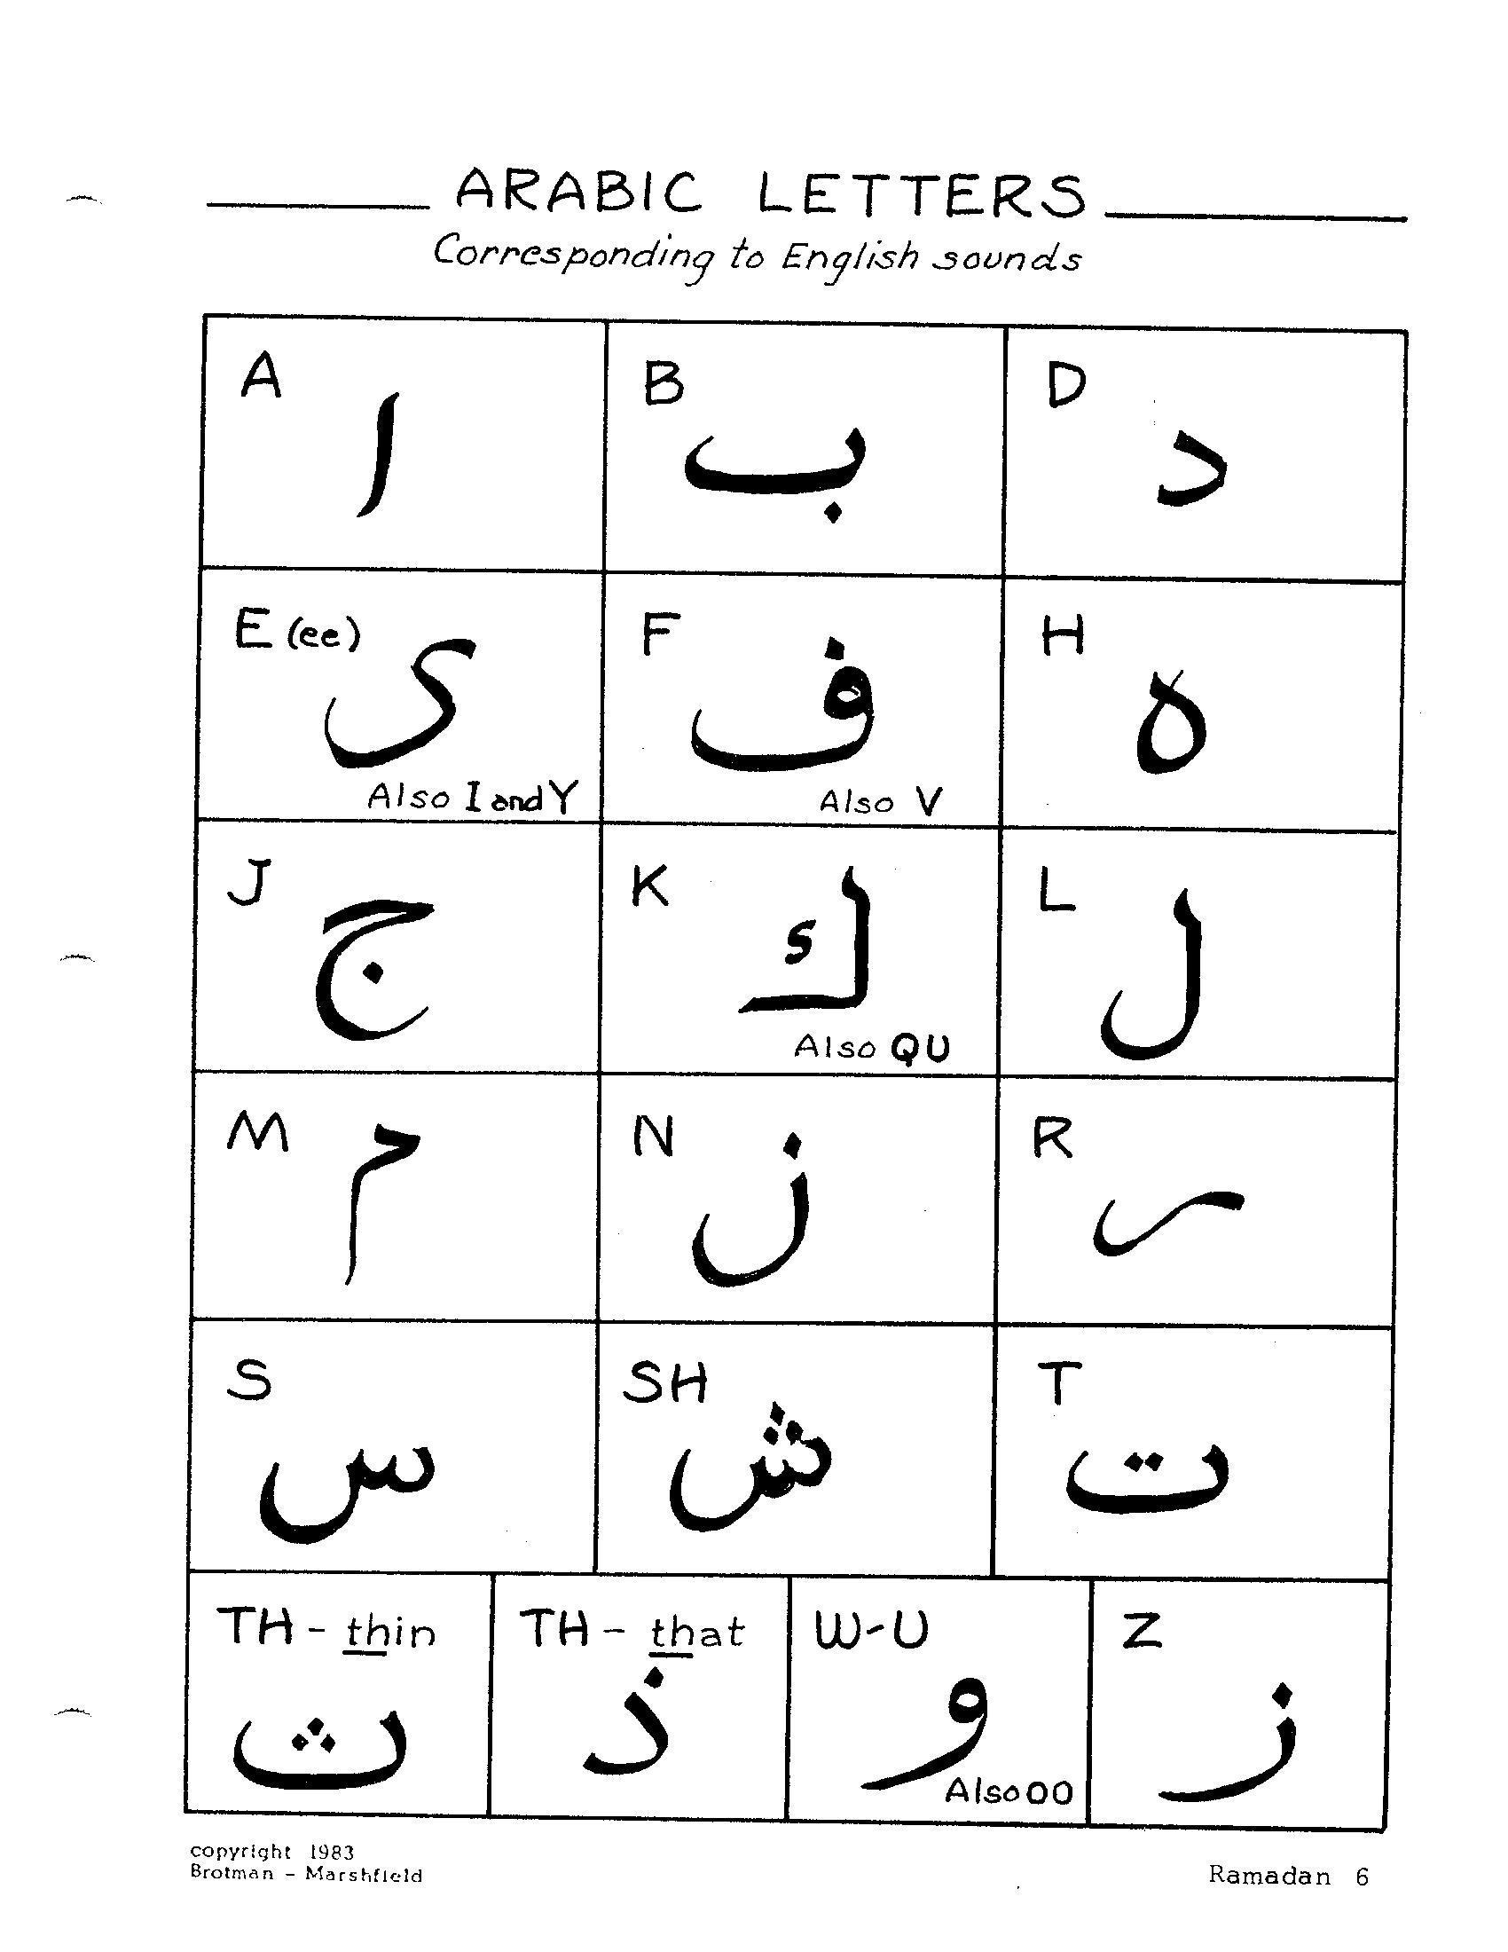

Handout #2

Guessing Game - Islamic Contributions to Civilization
Which of the following were introduced by the Islamic Empire during their Golden Age, pulling Europe out of the Dark Ages?

Invented or Introduced | Yes | No | Maybe?
Soap
Musical scale
Hospitals
Oranges
Algebra
Optics
Medical forceps
Chess
Chocolate
Rice
Arabic Numerals
Coffee
Paper
Universities
Violin
Toothbrush
Flying Machine
Medical stitches
Mechanical crank
Surgery

Answers:
All of the items except chocolate were introduced or invented by the Muslims. The Olmec people of Latin America are credited with the invention of chocolate.

Handout #3

The Eight Practices of Welcoming Difference

1. Be fully present
2. Be curious
3. Be open to being changed
4. Be comfortable with discomfort
5. Be an appreciative listener
6. Be light-hearted
7. Be gentle (allow and heal mistakes)
8. Be yourself

Handout #4

Interview Questions

- Were you raised Muslim, or did you become one later in life? If you were raised a Muslim, what in particular has kept you involved? If you became a Muslim later, what in particular drew you to it?

- Did you attend Arabic school? What was it like?

- What is your favorite passage from the Koran, Islamic morality tale or historical Muslim story?

- Have you ever gone on the Hajj? What was that like?

- What’s your favorite thing about Ramadan? Do you celebrate it in any unique way?

- When did you do your Shahada? How did you do it? In front of your faith community? Your family? Others? Were you nervous? Excited?

- At our church, we are talking this month about what it means to be a person of Trust. What does “Being a person of Trust” mean to you? How has being a Muslim influenced that?

- What are the major misconceptions out there about Muslims? What do you wish others better understood?

- Is there a particular Muslim belief or perspective that you think is especially relevant to our culture and political climate right now?

- What’s your favorite thing about being a Muslim?

Some Resources to Remember:

Soulful Home Family Guides
Invite your parents to explore the themes at home with their entire family
by subscribing to our monthly parent guides, Soulful Home.
Here’s the link to the Soulful Home page on our website:
https://www.soulmatterssharingcircle.com/soulful-home.html.
Here’s a link to a PDF flyer you can share with families.

Inspiration Facebook Page
To keep you inspired as a group leader, check out our
Soul Matters Facebook inspiration page:
https://www.facebook.com/soulmatterssharingcircle/
Consider also sharing it with your youth and their families!

Soul Matters Spotify Music Playlists
Discover musical inspiration on each of our monthly themes through our playlists:
https://www.soulmatterssharingcircle.com/spotify-lists.html
A great source of inspiration and connection for you, the youth and their families!

Crossing Paths Authors:

Katie Covey, DRE of Soul Matters Sharing Circle

Rev. Scott Tayler, Team Lead and Founder of Soul Matters Sharing Circle

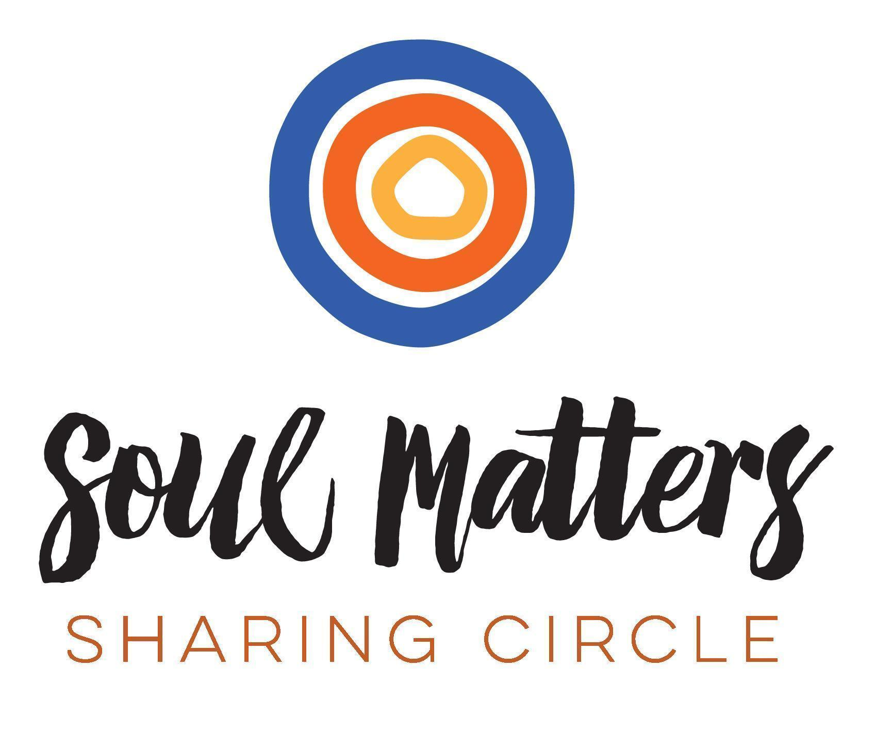

© 2017-18 Soul Matters ALL RIGHTS RESERVED

Crossing Paths is for use only by congregations who have purchased
the curriculum from Soul Matters.
To purchase, see our website: http://www.soulmatterssharingcircle.com

