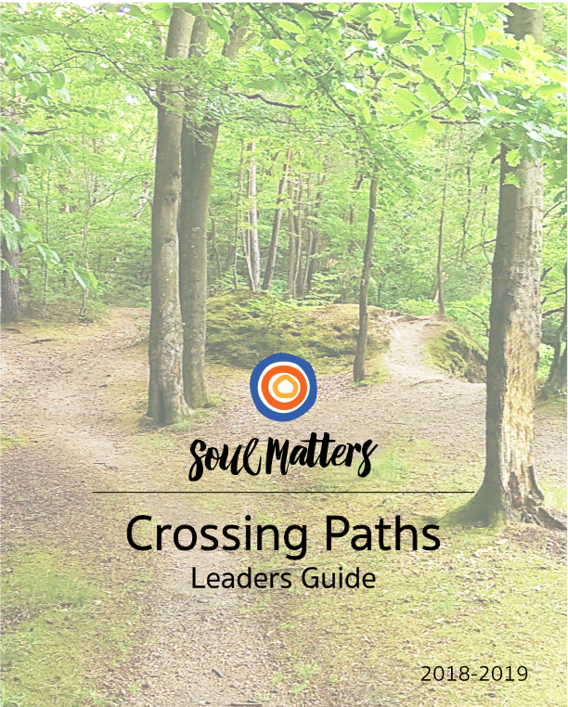

CONTENTS

Welcome Page 2

Unique Elements Page 3

Scheduling Charts Page 8

Planning Visits and Trips Page 8

Welcome to Crossing Paths

Welcome to the journey. This leader’s guide provides you with an overview of the Crossing Paths program and some tips to support you along the way. We want you to feel prepared.

We also want to say thanks. You are offering your youth a great gift. Interfaith relationships and conversations are desperately needed in our culture right now. This year of exploration will not only enrich the spiritual lives of your youth, it will empower them to bring healing to the world. In the face of religious voices that try to divide, we need perspectives that help us connect to and celebrate each other.

You are also helping your youth deepen their own faith. Crossing Paths is not just about encountering other faith traditions. It is designed to help youth mature as Unitarian Universalists. Along the way, they will be challenged to think theologically, learn distinctive UU spiritual practices and strengthen their relationship with their home church community. This is a journey into the world; it is also a journey back home. You are helping give the gift of identity and community. Thanks for offering your time, talent and care to make that gift possible.

We hope you also find this gift of deepened identity. This is your journey too. As you teach the participating youth, you will be blessed with new perspectives and insights. As you help the youth engage spiritual practice, your own spiritual life will deepen. As you go out to meet others, your love and appreciation for your UU home will grow.

Thanks for making this path available to your youth. May that path be a blessing to you as well.

Unique Elements of Crossing Paths

Crossing Paths joins the long line of visit-based UU curriculum going back 70 years. Church Across the Street was published in 1947. More recently, we’ve seen Neighboring Faiths (1997) and Building Bridges (Tapestry of Faith). Our Soul Matters version distinguishes itself by aligning each visit and faith tradition with our monthly Soul Matters themes. So not only will your youth learn about other faith traditions, but they will also learn how those faith traditions engage the same themes and questions that their home church is wrestling with that month. Thematic ministry is a powerful way of exploring spiritual questions; Crossing Paths enables us to use it to explore and deepen our relationships with other faiths.

Beside engaging monthly themes, Crossing Paths has a number of other unique components - eight of them to be exact. Understanding them is crucial to effectively leading your youth on this journey. Let’s look at them one by one.

1. Approach - Religious Pluralism

Crossing Paths is rooted in religious pluralism. Put simply, this is a view that treats every religion as a unique system. Some models of interfaith engagement emphasize the unity or commonality of all religions. This view might be summed up by the phrase “One Mountain; Many Paths.” This perspective argues that there is a fundamental shared goal behind all the diverse forms of religions. They are simply different “paths” toward the same goal or purpose. This is not the perspective of Crossing Paths.

Crossing Paths celebrates the values that religions share, but it emphasizes their uniqueness. Every world faith tradition was born in response to a distinct human struggle. We honor religions best when we work to understand the particular challenge and aspiration each religion has devoted itself to. So instead of using the metaphor of “One Mountain; Many Paths,” Crossing Paths invites us to see the religious landscape as “Many Mountains, Many Paths.”

To learn more about this approach of religious pluralism, we recommend the work of religious scholar Stephen Prothero. A good place to begin is with his online videos. You can view them here, here and here. However, it’s also important to recognize that this approach of celebrating religious uniqueness is not just captured in the work of scholars; it is also ingrained in our faith’s “Six Sources.” From our beginning, we’ve looked to our sibling faith traditions as each having something unique to offer us and the world.

2. Weekly Flow - The Adventure of the Climb

This mountaineering metaphor is woven throughout our entire program and shapes the Sunday schedule we follow. In a sense, we climb one mountain each month. And climbing requires the same steps each time:
- familiarizing yourself with the map of the terrain,
- preparing your gear,
- making the climb
- and then sitting back to take it all in.
This four-fold flow shapes the structure and names of the Sundays in each month.
Here’s an overview:

Map Sunday
This is the first Sunday of each month. During it, youth begin to learn about the basic beliefs of religion they will visit in a couple of weeks. In other words, this is the Sunday the group looks over the “map of the terrain.” It is important to note that this doesn’t just involve learning a bunch of stats and facts. This is an adventure after all. So we take an experiential learning approach, using ritual, fun activities and sensory experience.

Tack Sunday
Next comes “Tack Sunday.” You can’t head out on a journey until your gear is packed. So this Sunday is all about “tacking up.” Having reviewed the basics components of the focus religion on Map Sunday, the group now adds to their “backpack” an awareness of what the religion says about the monthly theme. Alongside that, the youth also explore how Unitarian Universalism engages the theme. The goal is to begin a conversation that the group will continue the following week with their interfaith hosts. This is also the week that the group reviews (and tacks up with) the 8 key skills or practices that they will use every time they visit a new faith community. We say more about that in the below section called “The Eight Practices of Welcoming.”

Summit Day
Third comes the big day: the visit. It’s the day of the climb so to speak. We call this “Summit Day” rather than “Summit Sunday” to honor of the fact that some religions don’t meet on Sunday.

Lake Sunday
No trip is complete without the chance to sit back and reflect on where you’ve been. So on the fourth Sunday, the group “sits by the lake” so to speak and processes their takeaways from their trip the week before. This is a chance to review what was learned and think about what one wants to keep and take with them on the rest of their journey. These visits come with gifts. This session help youth name and integrate those gifts into their own spiritual life.

3. Session Flow - Worship that Leads into Experiential Learning

Just as our month of Sundays has a regular flow, so do our weekly sessions. Sessions begin with a “graffiti board.” This is a way of capturing existing knowledge and initial impressions. Over the weeks, evolving impressions and new learnings are added to the graffiti board, visually capturing the youths’ growth in knowledge and changing perspectives. This provides the youth with a meditative space to begin seeing connections between the religion and their daily living. After filling out the graffiti board, youth move into a time of centering and small group worship. This allows youth to experience the monthly theme and the focus religion, not just talk about it. Then the group moves into activities and more experiential learning. Finally, sessions end with a graffiti board activity which adds learnings from the day, a look ahead at what’s coming next week and closing words that ground them in our UU theology.

4. Faith Traditions - Flexible Options and Scheduling Suggestions

Ten months does not allow us to cover all of the world religions. So based on the monthly themes and the faith communities near you, a select group of faith traditions are chosen. Crossing Paths packets cover a variety of religions for you to choose from. We create two different theme-based packets for each religion, so you have two different months during which you can schedule your visits. Our 2018-19 Scheduling Chart spells out the themes for each month and the various religions that are paired with those themes/months. Here’s the list of faith traditions that we are developing packets for this year:

- Unitarian Universalism
- Judaism
- Mainline Protestantism
- Christian Evangelicalism (Mega Church)
- Catholicism
- Quakerism
- Black Church Traditions
- Islam
- Buddhism
- Hinduism
- Humanism (Coming 2019-20)
- Earth-Centered (Coming 2020-21)

5. Lenses and “Binoculars”

When mapping the terrain, you need lenses or “binoculars” that help you see the entire landscape. Similarly, Crossing Paths focuses in on the various religions through various categories each month. In keeping with our mountaineering theme, we call these categories “lenses” or “binoculars.” Here’s our list:

The Problem (The human struggle that the religion organizes itself around)

The Solution / The Path (What the religion offers in response to that “problem.”)

Symbols
- Basic Stats (size, location, founding date)

In addition, we use the following components/lens to inform the choices for the experiential rituals, games and activities.

Central Spiritual Practice

Understandings of Divinity

Key Figures (founder, reformers, exemplars, major figures)

Holy Days

Sacred Text

Central Stories

Introspective Spiritual Practice (Mindfulness practice/meditation/mystic practice)

Dress (stole, robe, Yakama, etc.)

Sounds (chanting, hymns, songs)

Taste (communion wafer, bitter herbs at Passover, UU coffee hour cup of joe)

Movement (dance, processional, etc.)

Touch (practices of laying on of hands, greeting, blessings with holy water, etc.)

6. The Eight Practices of Welcoming

Crossing Paths is not just about learning facts about other religions. It is also a way of developing spiritual practices that youth can carry with them throughout their entire lives. Welcoming and reaching across difference is at the heart of Unitarian Universalism. We invite and enable people to lean into that work of welcoming difference in a number of ways. Crossing Paths focuses on eight of those methods, or practices. They are skills that the group brings with them to every visit; they are also skills and practices that we hope the youth will take with them into all of their relationships and interactions. Here’s the list:

1. Be fully present
2. Be curious
3. Be open to being changed
4. Be comfortable with discomfort
5. Be an appreciative listener
6. Be light-hearted
7. Be gentle (allow and heal mistakes)
8. Be yourself

7. Theology of Connection and the Three Lifelines

We work hard to help the youth understand the unique theology of each religion. It’s especially important to us that our youth understand that UUism has a distinct theology as well. To make our unique UU theology clear, Crossing Paths uses a theological framework we call “the theology of connection.” Put simply, UU’s over time have tended to focus on the problem of “spiritual separation.” When we look out at the world, what has struck us and broke our hearts most is the way the world separates us from our deepest self, life’s gifts and needs greater than our own. Repairing these three sacred connections has long been the work of our faith. So you might say we offer people three “lifelines” or “ropes” to restore connection We use this language of lifelines, sacred ropes and “healing spiritual disconnection” throughout the program. It is a powerful and accessible way for our youth to
understand what makes UU’s theologically unique. We are grateful that other religions offer the world such gifts as forgiveness, enlightenment, liberation and salvation. We want our youth to understand that UU’s also offer the world a unique gift: spiritual reconnection to our deepest selves, each other and life’s gifts.

We lift up this theology of connection every week through the presence of three symbolic ropes on our worship table. We also teach the youth how our chalice reflects the three lifelines:
- The flame represents our inner light and connection to our deepest self.
- The cup represents the container of community and our connection to each other.
- The circle around the chalice symbolizes life itself and the way it surrounds us, heals us and offers us a sense of belonging and home.

We also playfully weave this theology into the Crossing Paths chalice lighting and closing words each week, for instance repeating “May the Ropes be with you.”

8. Family-Centered Support

This is not just a journey the youth are taking. Crossing Paths equips parents to walk the path with their youth. In every session, we suggest conversation tips that leaders can send to parents every week. Since conversation with youth often occurs when you have them captive at the dinner table or while driving them to events, we call these weekly suggestions, “Dinner and Drive Time Tips.” We also make suggestions about how parents can learn about each religion on their own and do some personal spiritual work related to the monthly themes!

Scheduling Charts

As mentioned earlier, Crossing Paths packets cover a variety of religions for you to choose from. We also create two different theme-based packets for each religion, so you have two different months during which you can schedule your visits. Our 2018-19 Scheduling Chart spells out the themes for each month and the various religions that are paired with those themes/months. It also offers “calendar connections” so you can be aware of the holy days that are near your visits. Additionally, we offer our thinking about why we paired certain religions with certain monthly themes. This Scheduling Chart is accessible on a public google doc, found at:

https://docs.google.com/document/d/1AdfJkdwCatcDGP-CXGaeAfHmQxv_VJoZtVXhfs5b2J4/edit?usp=sharing

Planning Visits and Trips

There’s no escaping it: Crossing Paths involves a lot of logistics. Planning trips, organizing travel and coordinating with hosts means there are dozens of details to keep track of. In each packet, we offer planning tips and reminders. Here are some general suggestions for you to keep in mind as you begin to wrap your mind around the responsibility of organizing visits.

Contacting Faith Communities and Structuring the Visit

- Be clear about purpose. Explain the purpose of Crossing Paths in simple terms: “Interfaith learning and relationship building.” Lift up UUism’s embrace and celebration of religious pluralism.
- Be clear about your request. Share your hope that the group can attend a religious service but offer the option of a building tour at another time if service attendance is inappropriate or inconvenient.
- Be clear about the nature of the conversation. Inquire about the possibility of meeting with a leader or community member after the service or tour to hear more about the basic beliefs and practices of their faith. Ask them what format they are most comfortable with. We offer suggested interview questions which invite the sharing of personal stories not just facts.
- Bring up the monthly theme. Share the theme your congregation is focusing on that month and invite them to share their faith’s take on the theme.
- Ask how your group can be respectful guests. Are there any “do’s or don’ts”? Discuss whether or not it might be helpful to recognize the presence of guests in the service, and anything the host would like of the group.
- Offer alternative visit times. Use the Crossing Paths Schedule to identify the two months that best fit the rotation.

Preparation Tips
- Go over the Eight Practices of Welcoming with the youth. Consider handing out a copy of the list.
- Distribute copies of the list of the lenses/binoculars. Consider translating the list into question form.
- Bring offering money for each group member or remind them to bring some

Traveling Tips
- Review your safety requirements with drivers.
- Make sure to collect signed permission slips from group members, with all relevant contact information and emergency numbers. Make a copy to leave at the church, and a copy to bring on the trip.
- Let parents know the approximate time of return and post it on the door of your meeting room.
- Post a “We Will Return Soon” note on your classroom door in case someone comes late, such as “Sorry we missed you. The Crossing Paths group is visiting _______. We will return at _____.

Happy Trails!

There you go. Consider yourself tacked up. We can’t wait for you to unfold the maps and lean into the journey!

Crossing Paths Authors

Katie Covey, DRE of the Soul Matters Sharing Circle

Rev. Scott Tayler, Team Lead of the Soul Matters Sharing Circle

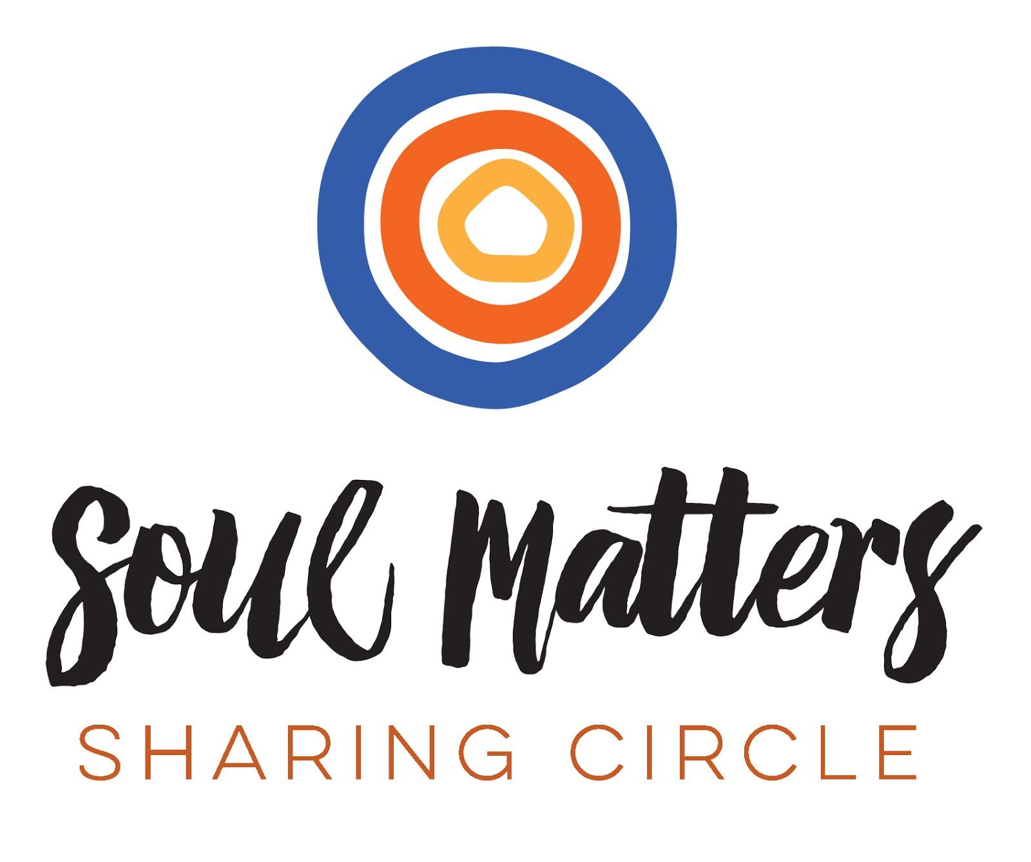
© 2018-19 Soul Matters ALL RIGHTS RESERVED
Packets are for use by congregations who have purchased from Soul Matters.
Learn how to purchase our resources and join at http://www.soulmatterssharingcircle.com
Follow us on Facebook at https://www.facebook.com/soulmatterssharingcircle/

